**THE SMOKING CESSATION CLINIC**

Developed and Written by MARK PILIPSKI.

FOR MORE INFORMATION CONTACT:

Mark Pilipski

**MARKOV PRESS**

**P.O.Box 588**

**Westbrookville, NY 12785**

Published by MARKOV PRESS

**This text is available FREE in several formats at www.markovpress.online**

**If you find the information within this text helpful to you,**

**please tell your friends about this book,**

**especially those who may benefit and improve their lives by quitting smoking.**

Copyright ©1990, 2001 by Mark Pilipski, Box 588, Westbrookville, NY 12785

All rights reserved. No part of this book may be reproduced in any form or by electronic or mechanical means including information storage and retrieval systems without permission in writing from the author except for those pages designated in the text for duplication as part of the course materials for the lectures and activities presented herein and brief quotes of passages by reviewers and students.

**A note for readers of this text:**

This outline and the classroom sessions repeat several important points. If you are reading the text and not attending the regular sessions, please reread sections of the text whenever advised to do so. This course is designed to take about six weeks to complete. Many readers will finish and become nonsmokers in less time. Some will require more time than the six weeks. Most people will find that these six weeks are just enough time to learn to quit smoking. If you finish early, good for you. If you require more time, just keep at it by following the instructions presented here and you will succeed.

The outline headings are capitalized on the pages to allow you to find a subject easily for review.

**BEFORE YOU CONTINUE TO THE FOLLOWING PAGES:**

**DO NOT SMOKE WHILE YOU READ THIS BOOK!**

**IF YOU SINCERELY WISH TO STOP SMOKING, YOU MUST**

**START BY ACCEPTING THAT YOU WILL NOT SMOKE**

**WHILE YOU ARE READING THIS BOOK.**

**Smoking is a learned behavior.**

**No one is born with the instinctive ability to smoke.**

**Thus, if you can learn to smoke**

**you can be retaught and learn not to smoke.**

Please note that we have made this book available to everyone on the web for FREE at **http://www.markovpress.online**. It is FREE but if you can help us, we’ll do our best to help you and many others. Our only goal here is to help people quit smoking and allow them to live full and happy lives. If you find the information within this text helpful to you, please tell your friends about this book, especially those who may benefit and improve their lives by quitting smoking. We do ask that if you feel this information is helpful and if you would like to support this work, you may send $1 (or whatever you think is appropriate) to help cover our administrative costs to:

“Smoking Cessation Clinic,”

Markov Press,

Box 588,

Westbrookville, NY 12785

**Table of Contents**

PREFACE

SESSION I 8

INTRODUCTORY LECTURE

Anatomy and physiology of the lungs

How they work

Why they don't work

Course outline

Five more sessions

Lecture, activity and progress review each session

Psychological evaluation / Why do you smoke?

Pulmonary function testing/how are your lungs?

Motivation and modification of habits

Tobacco and smoke

Distribution of materials(hand-outs) for course and self-study

SESSION II 21

Re-introduce the author/speaker.

Brief outline of the goals of these sessions

What is tobacco smoke?

ACTIVITY -

Psychological evaluation

Then suggest quitting cold-turkey

LECTURE -

Why do you smoke ?

Quitting/ cold turkey

Withdrawal - What to expect

Plan of action

Reasons to quit ( APPENDIX IV )

List for you

Post two lists

one at your bedside

the other in a common place

List for me

Keeping a daily record of your smoking habit

Record every cigarette

Graph sheet (one per pack)

Exercise as an alternative activity

Drink a lot of water

Important - Even if you don't want to - Come backSESSION III 33

LECTURE -

Poem by Rudyard Kipling - The Betrothed

Cancer, theories and practice

Normal cells

Ionizing radiation

alpha, beta, and gamma

Toxic chemicals

Asbestos and smoking

Chemotherapy

Surgery

Related to inhaled particles and smoking

Review of things to do

Post a list of reasons to quit

Keep a record of your smoking habit

Exercise regularly every day

Drink lots of water or juice

Breathing exercises

Autosuggestion and hypnosis

ACTIVITY -

Vital capacity testing

Breathing exercises

Eliminate the peak two hours of smoking

Change brands

SESSION IV 54

LECTURE -

Heart and lungs, a team

Diet and smoking habits

ACTIVITY -

Review the results of the two hour abstinence

Exchange and discuss participants' progress

Share common successes and problems of cessation

Eliminate the minimally needed cigarettes

SESSION V 69

LECTURE -

Lung diseases

Habitual behavior

Effects of smells

Walking as a daily exercise

ACTIVITY - You have just quit smoking!

SESSION VI 89

LECTURE -

Learned behavior/Behavior modification

Breathing exercises

Other cessation methods

ACTIVITY -

Review progress

Distribute list of other area programs

Quitting on the Web

APPENDIX I - PSYCHOLOGICAL QUESTIONNAIRE 104

APPENDIX II - HELPFUL HINTS 109

APPENDIX III - CIGARETTE LOG 114

APPENDIX IV - REASONS TO QUIT 115

APPENDIX V - ADDITIVES USED TO FLAVOR CIGARETTES 116

APPENDIX VI - WEEKLY SUMMARY SHEET 117

APPENDIX VII - TEMPLATE 118

APPENDIX VIII - SMOKING AND VITAMINS 119

APPENDIX IX - DOWNLOADING THIS BOOK FOR FREE 126

LIST OF FIGURES PAGE

FIGURE #1 - broncho-pulmonary tree 9

FIGURE #2 - normal and obstructed airways 10

FIGURE #3 - cross-section and side view of airways 11

FIGURE #4 - enlargement of three epithelial cells 12

FIGURE #5 - respiratory bronchioles and alveoli 13

FIGURE #6 - inhaled dust 15

FIGURE #7 - inhaled dust - large amounts 16

FIGURE #8 - effect of toxic particles in cells 17

FIGURE #9 - hemoglobin 19

FIGURE #10- normal cell and parts 35

FIGURE #11- DNA beads 35

FIGURE #12- radiation types - alpha, beta, gamma 36

FIGURE #13- asbestos/smoking risk of dying chart 39

FIGURE #14- spirogram 45

FIGURE #15- flow-volume loop 46

FIGURE #16- heart - four chambers 54

FIGURE #17- lungs - heart - body 55

FIGURE #18- artery - capillaries - vein 56

FIGURE #19- electrocardiograph 57

FIGURE #20- open, blocked and squeezed tube 70

FIGURE #21- inhalation - exhalation 71

FIGURE #22- normal vs. asthmatic 72

FIGURE #23- normal vs. restricted volumes 73

FIGURE #24- emphysematory lung tissue 75

FIGURE #25- normal vs. emphysema 76

**PREFACE**

Dear Reader,

Having spent most of the last thirty years working in hospitals initially as a respiratory therapist and, presently, in pulmonary research, as one may imagine, I have seen many patients with lung problems.

A quick figuring with my pencil provides a number of about one hundred thousand (100,000) patients with whom I've worked directly, treated, taught, or reviewed and analyzed their pulmonary function. This number represents an impressive amount of people. But more impressive than this and at the heart of the matter is the fact that of all these sick and ailing people very few were nonsmokers.

The vast majority of people with lung problems are smokers. This is what strikes me most as I review my career. This simple observation drives me to write this book and construct these sessions in hope that some will heed its message and avoid the diseases that await smokers in their later years.

Breathing Easier,

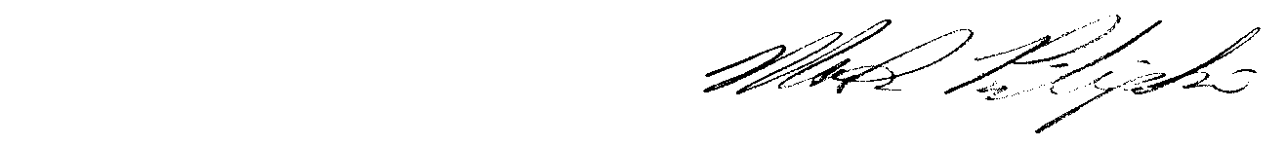 Mark Pilipski

SESSION I

INTRODUCTORY LECTURE

ANATOMY AND PHYSIOLOGY OF THE LUNGS

HOW THEY WORK

WHY THEY DON'T WORK

Look at yourself in a mirror, or look at someone else. Somewhere within your chest you have lungs. How big are they? How much work do they perform? Most of us know that our lungs are vital to our lives but we are usually ignorant about exactly what they do and how they work.

The average man has a Total Lung Capacity of about seven liters (two gallons) of air. This means that if you took in a deep breath, somewhere in your chest you would have about two gallons of air. The average woman's lungs are a bit smaller. The size of your lungs is proportional to your height. If you are tall your lungs are big. If you are short your lungs are small.

You breathe about 15 to 20 times each minute. Each breath you take moves about a half liter (one pint) of air in and out of your lungs. This means that you move about ten liters (10 l.) or 2.5 gallons

20 x 0.5 liter = 10 liters

or 20 x 1 pint = 2.5 gallons of air each minute of your life.

Let's think about this for a minute. We breathe

10 liters of air every minute

600 liters of air every hour

14,400 liters of air every day

5,259,800 liters of air every year of our lives.

This means that a forty year old person has moved over 200 million liters of air in and out of his lungs, and has taken almost half a billion breaths. We could round all these numbers and say that in a lifetime (about 80 years) you take more than one billion breaths.

If we were able to follow a breath of air into the lungs we would pass through the mouth or nose to the trachea. Your trachea or windpipe is a small tube about one centimeter in diameter and four or five centimeters in length. It is about the size of a standard piece of blackboard chalk.

Use your finger to touch your neck just under the point of your chin. Now, slowly slide your finger down your neck. In the middle of your neck you will feel a bump. This is your voicebox or larynx. Say a few words and feel the vibrations at your finger tip. The larynx sits atop the trachea. All the air you breathe every minute of your life passes through this single tube called the trachea. It's easy to understand how someone can choke on a piece of food and have all his air blocked. Children, because their airways are smaller than adult airways ,are especially subject to choking on food, peanuts for example, or small objects such as buttons.

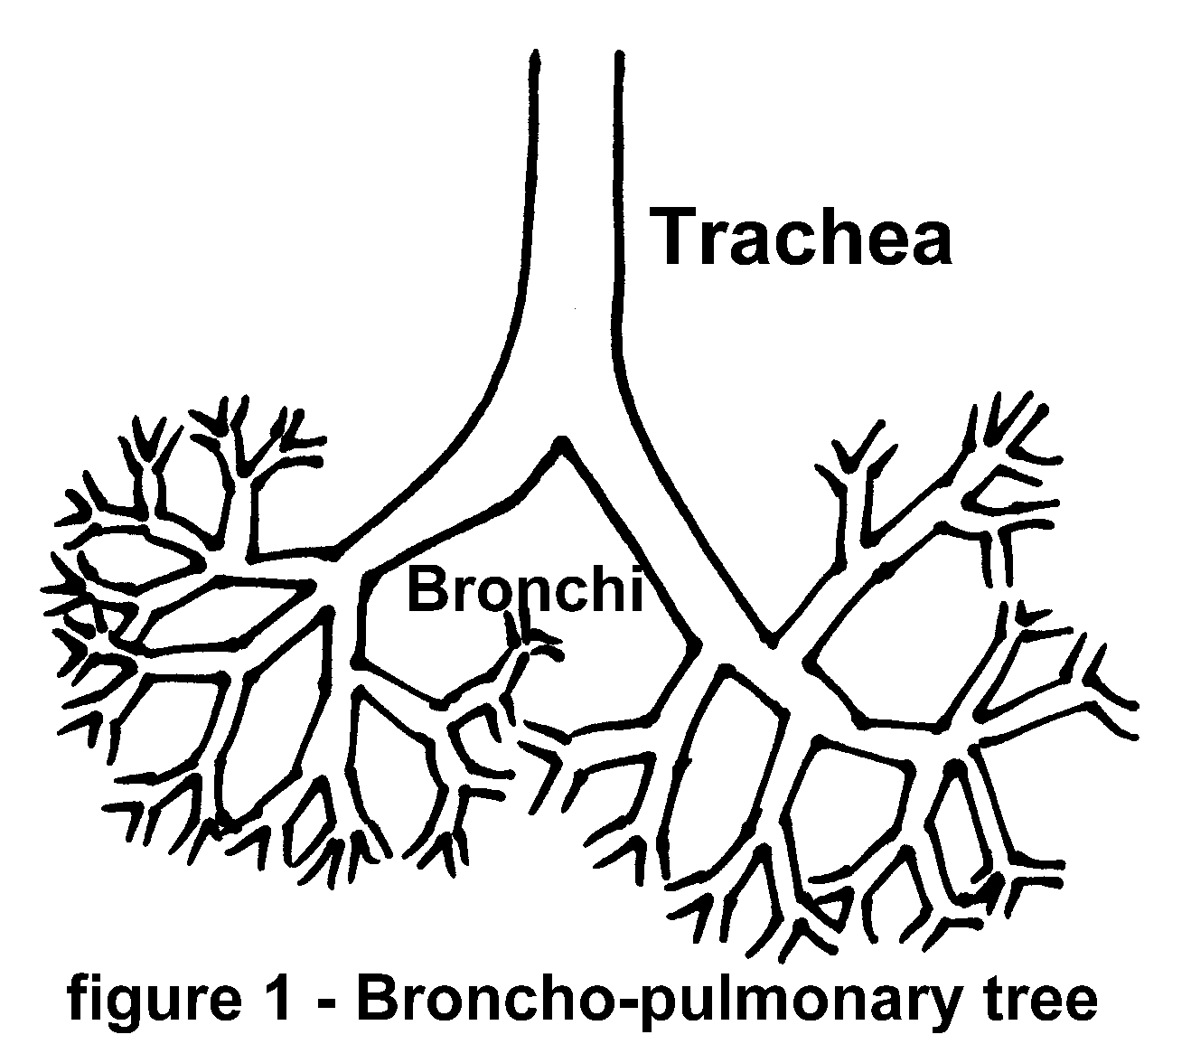

The single tube called the trachea points toward the center of the chest and then branches into two smaller tubes. These smaller tubes are called bronchi. The left and right mainstem bronchi in turn branch into smaller tubes. They in turn branch into still smaller tubes. We use the word "branch" for a good reason. If we were to view the whole system of airways upside down, the trachea would look like the trunk of a tree. As we looked higher into the tree we would see each generation of branches form the next smaller generation. In fact, the total airways system is often referred to as the "broncho-pulmonary tree".

If we call all the airways of about the same size a generation. That is the trachea is one generation. The left and right main stem bronchi form another generation and so on. Each generation of tubes branches into about twice as many tubes to form the next smaller generation of tubes. Thus, each generation of airways has about twice as many tubes as the previous generation. There are about twenty-four generations of airways.

Therefore we have

2x2x2x2x2x2x2x2x2x2x2x2x2x2x2x2x2x2x2x2x2x2x2x2 = 224

Two to the twenty-fourth power or roughly about ten million (10,000,000) tiny tubes connected to the business end of the lungs.

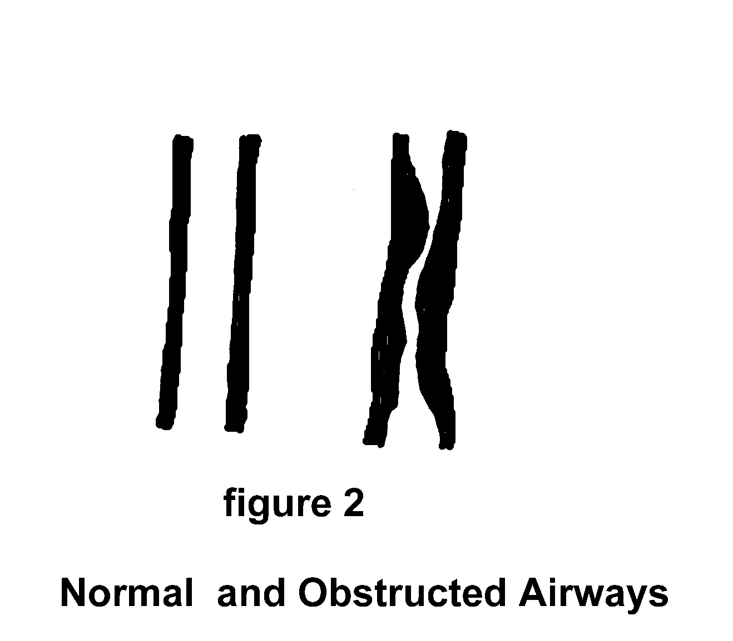

The structure of the airways is important to our breathing. The larger airways have rings of cartilage to provide support and hold the airways open. Cartilage is a stiff substance. your nose is made of cartilage. The cartilage rings are held in place by a net of fibers and muscles. The muscles wrap around the airways almost like the stripes on a barber's pole or candy cane. Whenever, these muscles contract, the airways are reduced in diameter. Whenever the airways are made narrower than normal air does not pass through as easily as whenever the airways are in their normal state.

If these muscles go into a spasm, we call this an asthma attack. Many different types of inhaled irritants can trigger an asthma attack. The inhalation of smoke always irritates the small airways and causes some degree of obstruction to normal airflow.

Let us examine the lining of these airways more closely. The lining is exposed to the air we breathe as it passes through the airways to the business end of the lungs.

If we were to magnify the lining of the airways, we would see several distinct tissues and structures.

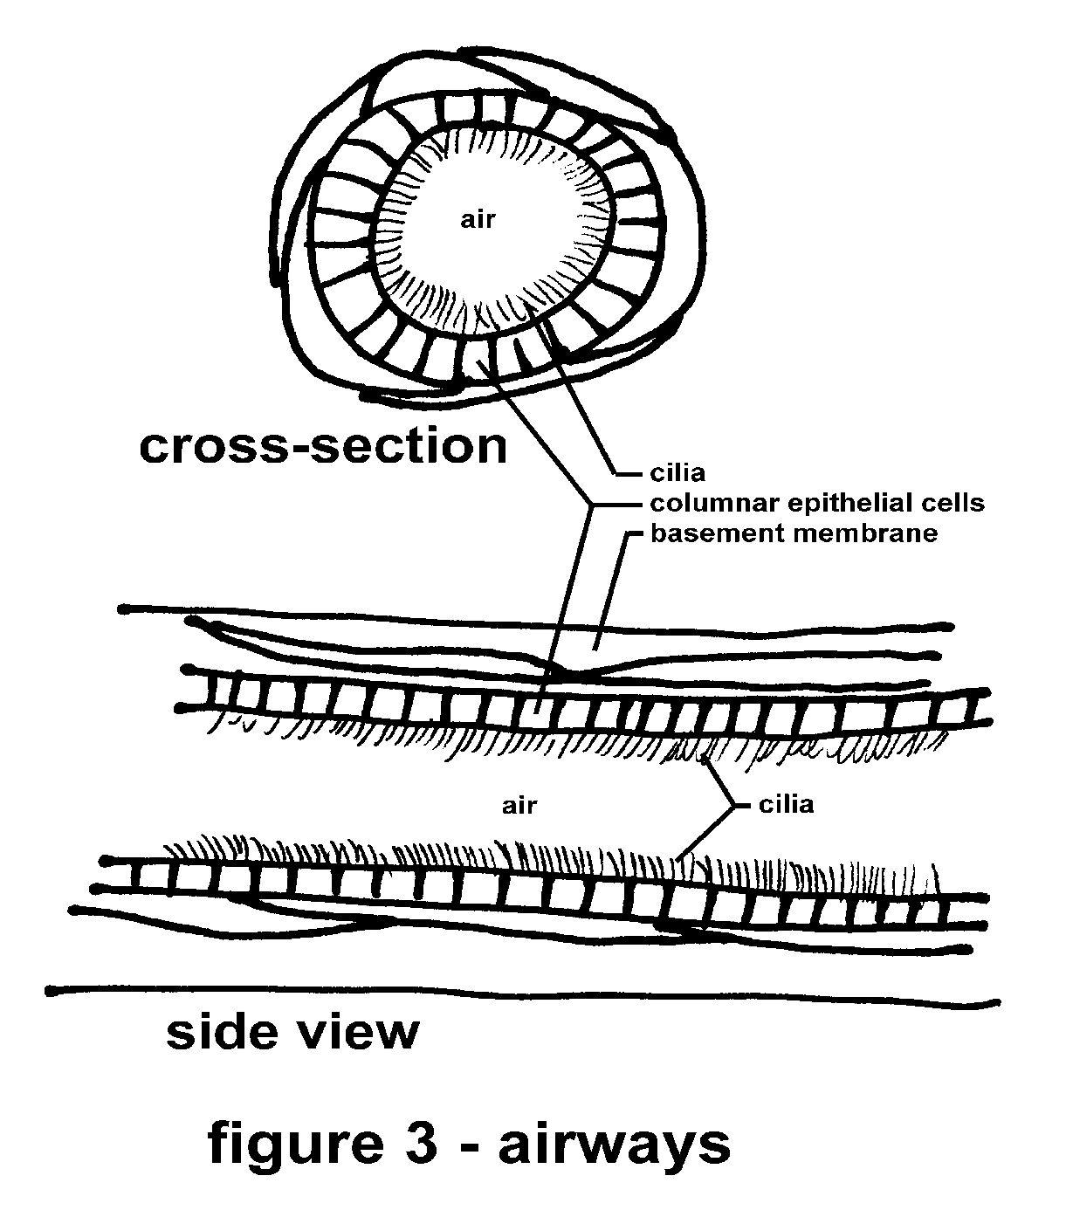

Above the basement membrane we find a very delicate lining, a layer of cells. the scientific name for these cells is columnar (columns) epithelial (on the surface) cells. They are packed very tightly together. At the top of every cell are tiny hair-like structures called cilia.

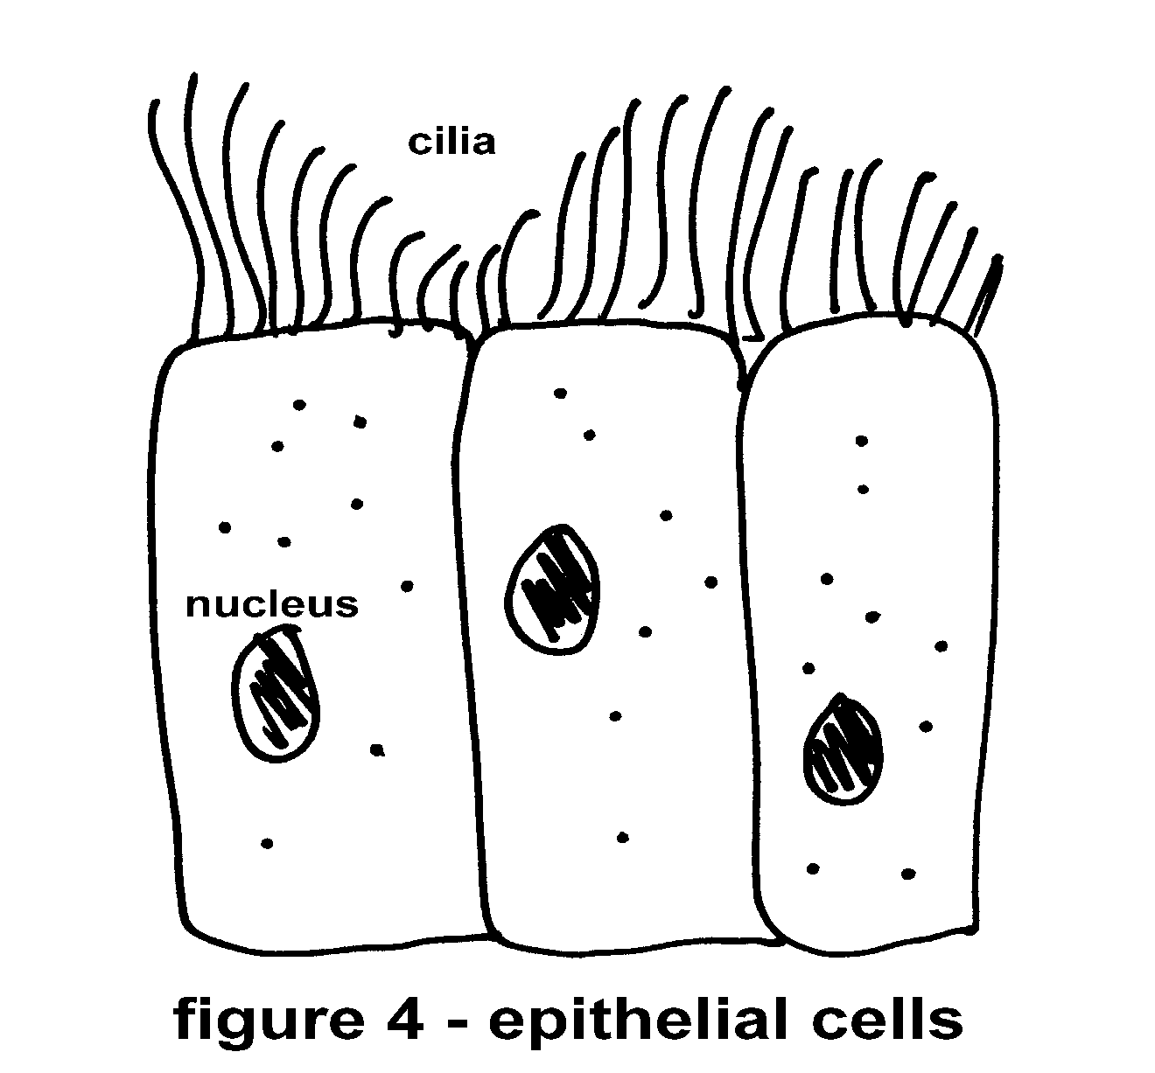

The cilia beat in a wave motion like the oars of an old wooden warship. This motion of the cilia slowly moves a mucous blanket up and out of the airways. To help you imagine how this works, think of a field full of people standing shoulder to shoulder with their arms stretched up over their heads. Their arms represent cilia. Imagine a very large blanket, so large that it covers everyone in the field. If these people were to use their hands and arms to move the blanket over their heads to one side of the field; they would be working in a manner similar to the cilia in our airways. Cilia are so small that thousands bundled together would not equal the width of a human hair. Cilia are delicate structures, yet their function is very important to maintain clear airways.

Mucous is familiar to most people. Although, it is not usually a topic of polite conversation. It is an important substance in our airways. Mucous is composed of water, sugars, proteins and several other substances. It is thick, moist, viscous, and sticky. This last property is used by the body to remove inhaled particles. Whenever a tiny speck of dust or a particle of smoke passes through the nose or mouth into the airways, it sticks to the mucous blanket along the walls of the airways. This trapped particle is then moved along with the mucous blanket up and out of the airways. Once the mucous is moved to the top of the airways sensitive nerves at the junction of these tubes cause us to cough and thus expel the dust or particle and mucous from our lungs. Normally, all day long we are swallowing a mixture of saliva from our mouths and mucous from our airways. Mucous is produced by special cells, called goblet cells. These cells are shaped like tiny goblets and are scattered among the epithelial cells.

Let's examine the far end of the airway system. The business end of the lungs is located at the farthest end of the airways from the mouth. The trachea and other airway tubes continue to branch and each generation is smaller than the one before. after about twenty generations or branchings, the tiny tubes begin to have some out-pockets. These pouches are the beginnings of our air sacs or alveoli. Within these tiny balloons gas exchange with our blood takes place. These airways are called respiratory bronchioles.

The alveoli or air sacs are tiny balloons. There are millions of them. They are clustered around the respiratory bronchioles . You may imagine them as grape-like bunches of balloons. Remember, the air we inhale is on the inside of these sacs and our body is the outside. We are interested in the nature of the thin "skins" around each one of these tiny balloons. Thus, the skins of these air sacs face the "outside" of our body. Just as our regular skin touches the air, the alveolar linings touch the air we inhale. The total area of these linings is surface area for your body. Let's go back to the idea of a bunch of grapes, for a moment. If we were to carefully peel a grape and then flatten the peel (to spread it, not to stretch it) on a table, we would see how big an area the skin represented.

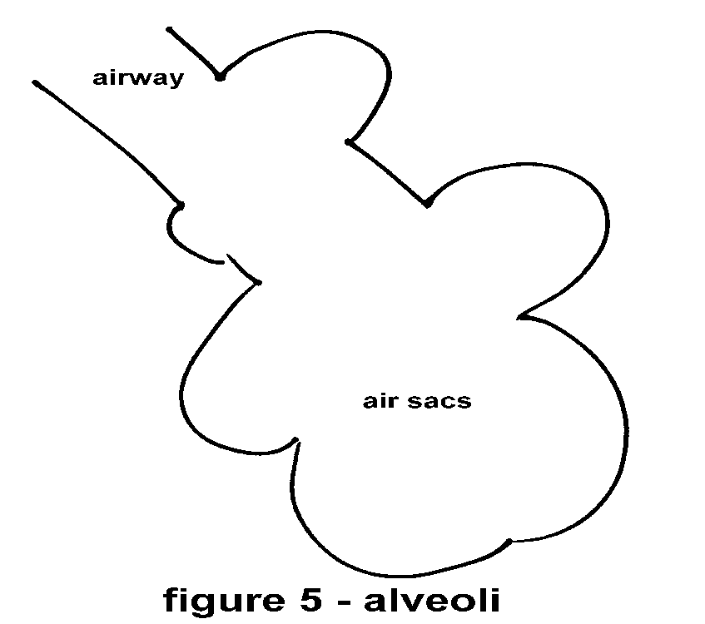

If we could do the same thing for all the tiny air sacs within our lungs and place them next to each other we would cover an area about the size of a tennis court! This is amazing.

Folded up in the shape of millions of tiny little balloons is a surface the size of a tennis court within our chest.

The analogy of a tennis court is also helpful for explaining the slow progression of most lung damage. Most of you are somewhat familiar with the game of tennis. Players bounce a small ball from side to side over a net across the center of the court. Tennis may be played on any one of several court surfaces. We will consider the clay court. Clay courts require special care. Normally, the clay is moistened and rolled flat in preparation for a game.

Imagine, if you will, a smooth clay court in the early morning, wet with dew. The clay is soft from the water. If we continue to imagine, the sun will rise and its heat will dry the clay to a hard smooth surface. This hard surface will be just right for playing tennis. At this time, just before the clay hardens, let's envision a small child out walking his dog, crossing a corner of the court, leaving his footprints in the soft clay.

Do these footprints (tiny ridges in the corner of the court) make it impossible to play tennis on this court? Of course not! Although, some world class tennis players may object, the few footprints would not have any effect upon the game as played by most people. (Most people are lucky if they can hit the ball. That they may be able to aim and direct the ball to a tiny footprint to cause an erratic bounce is unlikely.)

Oddly enough, the surface of our lungs functions in a similar manner. Small areas of damage go completely unnoticed. Except by a few well trained world class athletes, most of us simply don't use our lungs well enough to notice any small "footprints" on the surface.

TENNIS COURT

footprints

Let’s carrythis example a few steps further. Imagine the same wet clay tennis court. But this time let’s have a marching band practice one of their drills over the surface of the wet clay.

After they've gone and the clay hardens, will anyone be able to play tennis on that court? Probably not. Because, even a bad player would not be able to move the ball without it hitting a footprint.

Lung disease is that range between the complete inability of the lungs to support life and the first insensibly small areas of damage. This is a very big range. That is the heart of the tragedy.

With this information we can follow the path of a tiny dust particle that has been inhaled. Normally, any small particle that passes the nose will float upon the inhaled air until it gets stuck to the mucous blanket lining the airways. The mucous blanket is slowly moved up and out to the upper airways by the action of the cilia.

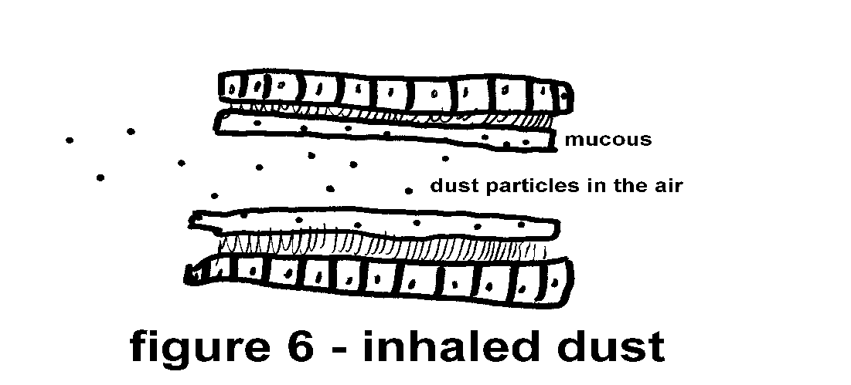

As mucous accumulates in the large airways, nerves sensitive to fluid movement cause us to cough. The cough pushes the mucous up to our throat and we are able to swallow the mucous. All day long saliva from our mouth is mixed with mucous from our lungs and is swallowed. This is how the lungs, normally, clear inhaled dust.

It is a simple cleansing mechanism. Dust gets stuck and is carried away. As long as the cilia keep working, the airways under ordinary conditions remain clean of dust particles.

But, what happens if we inundate our airways with too much dust? What happens in the airways of a coal miner, a sand blaster, a welder, a baker, or anyone working in a very dusty environment?

Inhaled dust particles get stuck to the mucous at such a high rate and in such a large quantity that some of the dust particles "rain out" or "fall through" the mucous blanket.

These particles are now among the cilia. They cannot be removed from the airways. They are beyond the reach of the cleansing mechanism of the airways.

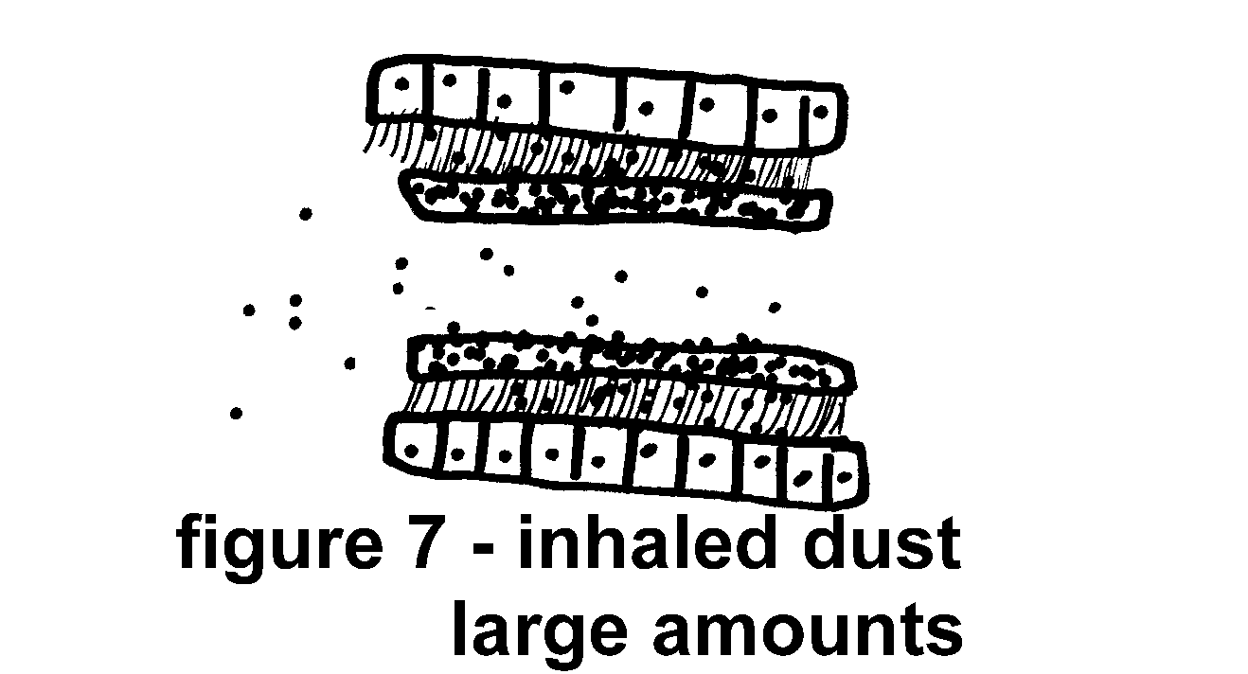

These particles are sitting right on top of the epithelial cells lining the airways. The cells will incorporate these particles. If the particles are edible (they, usually are not) the cell will digest them. If the particles are not edible (this is usually the case) the cells will still ingest them but will have to leave them encysted within the cell structure. The cells can't digest these particles. As the particles accumulate, slowly, the cells take on the physical characteristics of the particle material. The cells become more particle like than cell-like. Not only do the cells take in more particles, soon there is more dust than cells.

Imagine using a small dime-store sponge (the kind you would use to wash dishes) to help mix concrete. After a few times of being pushed around in the mixture of concrete, sand, and water the tiny little spaces in the sponge would be filled with concrete. Once dry, the sponge would be more like a brick than a sponge.

Use another sponge to mix bread dough. Soon the sponge is more like a piece of dough than a sponge.

The same process occurs within the lungs and the cells of the body. If we expose the cells to high or constant concentrations of particulate matter, the cells will take up the particles and take on the physical characteristics of the particle substance. If the substance is stiff, the lungs become stiff. If the substance is viscous, the lungs become viscous.

Almost every type of particle has a disease associated with the inhalation and deposition of the material in the lungs. Silicosis is caused by inhaling silica. Bagassosis is caused from inhaling too much bagasse (sugar cane). Pneumoconiosis from too much coal dust (black lung), Asbestosis from inhaled asbestos, etc. These physical changes in the soft pliable nature of the normal lungs are called restrictive disorders. Anything that restricts the volume of air breathed is a restrictive defect.

It is important to note that so far we have discussed only physical changes occurring in the lungs due to the inhalation of inert particles. The situation is a bit different if the particles contain toxic substances. The particles work their way into the cells, just as we have discussed above. Usually, a large amount of inhaled particles is needed to pass the mucous layer in the airways. Certainly, any particulate suspension that can be seen in the air (smoke, dust cloud, etc.) will provide more than enough particles to overload the lung's defense mechanisms.

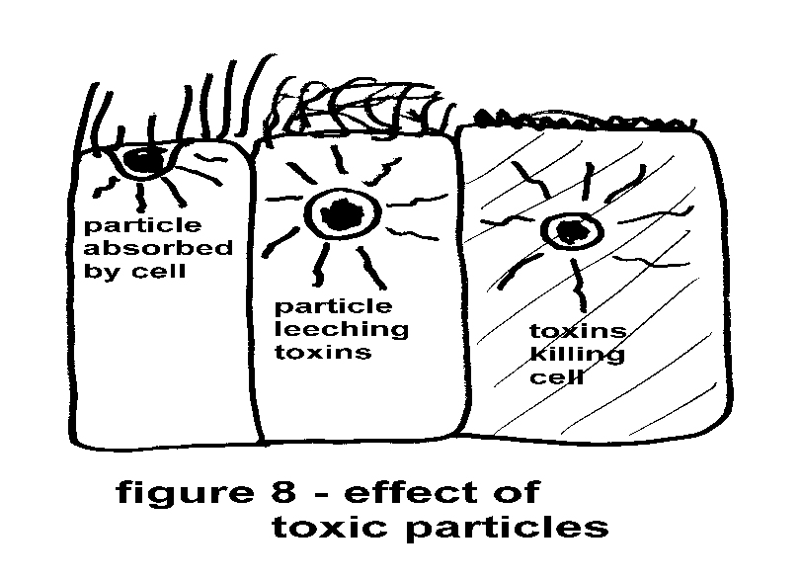

After the epithelial (surface) cells ingest some of these particles, toxic substances from the particles begin to leach into the cell. If the particles are very small or if the poisons are not very strong, the cell will "get sick" for awhile. This means that its cilia will not function. If and whenever the cell recovers the ciliary action will resume. If the cell is reproducing under the effects of the toxin it may not divide properly. In fact, this is one explanation of cancer development. Cells under the influence of chemicals (carcinogenic chemicals - cancer-causing chemicals - toxic substances) divide abnormally and deform their DNA, thus forming cancer cells.

We can see how for the cells just "getting sick" is enough to start a vicious cycle:

A. Particles accumulate on the mucous layer

B. Cilia move the mucous up and out

C. Particles "rain out" on to the cell surface

D. Cells "get sick" - cilia stop moving

E. Back to step A. but skip step B. more and more particles accumulate.

This cycle leads to gross accumulation of particulate matter and mucous, as well as, ultimately, the destruction of lung cells and tissue.

Oxygen passes from the air we inhale into our blood by simple diffusion. Diffusion is easy to understand. Open a perfume bottle in a closed room. Leave the opened bottle in the room. After awhile, go back into the room. You will smell the perfume, even across the room. The perfume molecules have slowly diffused (spread) from the bottle to the air in the room. The process of molecules going from an area of high concentration (bottle) to an area of lower concentration (room air) is called diffusion. Oxygen diffuses from the air we breathe into our blood. Carbon dioxide from our cells diffuses from the blood into the air through our lungs.

The airways are tiny tubes that direct the flow of air to the alveoli (air sacs). The alveoli are the business end of the lungs. It is here that gas exchange takes place. The total surface area of all alveoli is equivalent to the area of a tennis court. Oxygen from the inhaled air travels to our blood and carbon dioxide (a waste product of respiration) passes from the blood to the exhaled air. This process is called gas exchange. A hard working member of this process is the red blood cell. These tiny almost doughnut shaped cells carry oxygen from the lungs to every tissue in the body. The red pigment hemoglobin within the red blood cell makes all this oxygen transport possible. Hemoglobin is a large molecule. It is composed of a heme (iron) group surrounded by a globular (globin) protein.

The heme group has an affinity for oxygen. This means that it attracts oxygen. The globular protein around the heme prevents oxygen from getting too close to the heme. Slight chemical changes within the blood cause the protein to expand or contract a channel to the heme. Whenever the red blood cell is near the alveolar surface the channel is opened and the heme in the hemoglobin attracts some of the plentiful oxygen. The hemoglobin holds onto this oxygen as it is carried by the circulating blood to our body’s' tissue. As the red blood cell approaches some tissue, for example a muscle, the chemistry of the blood becomes more acidic, due to the production and accumulation of wastes from the muscle's activity. The acidic environment causes the globular protein to close the channel to the heme. It actually "pinches off" the oxygen molecule, so that the oxygen can by used by the muscle to aid its metabolism. This picking up, carrying, and dropping off of oxygen goes on constantly as the blood circulates from the lungs to the body to the lungs and so on.

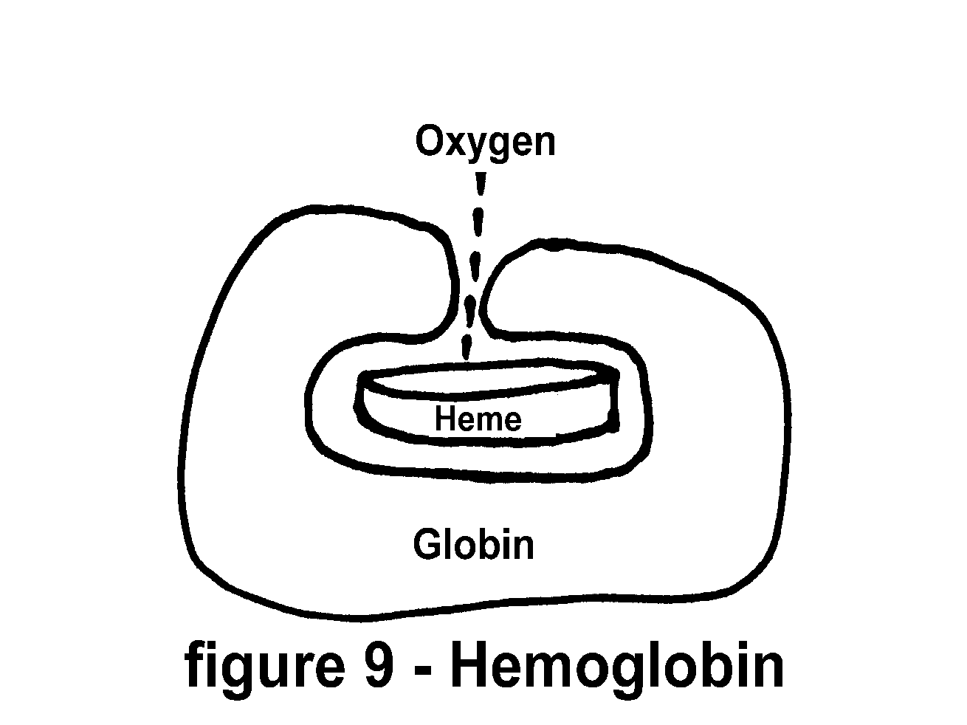

Before we close this chapter let's review the information presented.

The branching tubes that are passages for the air we breathe lead to billions of tiny delicate sacs that are the sites of gas exchange. Inhaled substances and particles slowly destroy these delicate structures, as well as the linings of the airways. This destruction leads to disease. Blood passing through the lungs picks up inhaled oxygen and gives up carbon dioxide to the exhaled air. Hemoglobin carries the life- sustaining oxygen to all the tissues of the body.

COURSE OUTLINE

Five more sessions

Lecture, activity and progress review each session

Psychological evaluation/Why do you smoke?

Pulmonary function testing/How are your lungs?

Motivation and modification of habits

Tobacco and smoke

Distribution of materials(hand-outs) for course and self study (book, photos, slides, handouts, etc.)

**Smoking is a learned behavior.**

**No one is born with the instinctive ability to smoke.**

**Thus, if you can learn to smoke**

**you can be retaught and learn not to smoke**

SESSION II

REINTRODUCE THE AUTHOR/SPEAKER.

Mark Pilipski is a resident of Westbrookville, NY. While active at his clinical duties, he was supervisor of the Pulmonary Research and Clinical Pulmonary Function Laboratory of Mount Sinai Medical Center , New York and a Neonatal Research Associate at The Children’s Hospital of New Jersey at Newark Beth Israel Medical Center in Newark, New Jersey. For over ten years he worked at St. Michael's Medical Center in Newark as manager of the Pulmonary Laboratory and Respiratory Care Department. He is a past member of the New York Academy of Sciences, the New Jersey Thoracic Society, past delegate for the National Society for Cardiopulmonary Technology, a Registered Hypnotherapist and many other professional and scientific associations. He presented his work with flow-volume loops (a then new diagnostic tool for evaluating lung dysfunction) at the First Pan-American Congress on Diseases of the Chest and has authored many scientific texts. He received the Special Award of Recognition from the Journal of Cardiopulmonary Technology for his clinical research. He also holds several patents for devices and chemical processes here and abroad. One device he is particularly proud to have invented is a low pressure ventilator alarm. His undergraduate education was in the sciences and education. His graduate work was in respiratory physiology. As a teacher, biologist, author, and inventor he is in demand by audiences for his inspiring lectures.

BRIEF OUTLINE OF THE GOALS OF THESE SESSIONS

Come to all of the sessions, even if you've quit smoking before the last session. This provides additional information to you about your smoking and will help you to remain an ex-smoker. Reinforcement - You won't go back to smoking.

Topics that will be presented and discussed include:

Why do you smoke ?

How your lungs work.

Breathing tests

Heart and lungs - A team

Psychology of smoking and habits

Diet and smoking cessation

Hypnosis and behavior modification

Cancer

Lung diseases

Breathing exercises, etc.

For those of you who are attending one of my Smoking Cessation Clinics, the cost of these sessions may be tax deductible for you. Consult your accountant.

WHAT IS TOBACCO SMOKE ?

What is tobacco smoke? Smokers may be able to describe the flavor and aroma of smoke. Nonsmokers will be able to describe the aroma or smell. Someone with a little insight may explain that smoke is a suspension of solid and liquid particles of condensed chemicals. Most people, however, will not be able to name these chemicals except for the few catagories found printed by law on the cigarette packs. These are

Carbon monoxide

Nicotine

Tar

But the actual list doesn't stop here, as we shall see later.

How much smoke do you inhale with every cigarette? The average cigarette weighs about 1 gram. You smoke about 70% of each cigarette or about 0.7 gram. Of this portion about 0.15 grams become ash and the remaining 0.55 grams become smoke. There are twenty cigarettes in a pack. Thus, you inhale about 0.55 x 20 = 11 grams of smoke for each pack of cigarettes. If you smoke a pack per day, that is about 365.25 packs per year, or 11 grams x 365.25 packs = 4,017.75 grams of smoke per year. Rounding this number to measures that may be more familiar, we have 4,017.75 grams = about 4.0 kilograms or about 9 pounds of smoke each year. That's about 90.0 pounds of inhaled smoke over a ten year period. If you smoke two packs per day, you inhale almost 200 pounds of smoke in ten years.

Think about this for a moment in terms that we can visualize. Imagine a ten pound bag of sifted flour (the type used for baking). Now, if you are a smoker, imagine inhaling those ten pounds of flour. Think about doing this every year. This is an incredible amount of debris to place in your body.

How much smoke do you inhale?

(1 pk/day/year = 1 pack-year = 9 pounds)

What is in a cigarette? Let us examine the nature of tobacco and consider what is a cigarette? Tobacco is a plant. Most cigarettes are constructed of a rod of loosely packed tobacco leaves held in place by a thin tube of paper. The flavor or taste of the tobacco is augmented by chemical additives. Cigarette companies want their patrons to find the same taste every time they smoke. Certainly, the natural flavor of tobacco varies within the growing season as well as from crop to crop. Only by including chemical additives can the flavor be stabilized over long periods of production. The exact amounts of additives and the actual chemicals used are "trade secrets"; thus, the cigarette companies are not required to tell us what they are. Some British companies have volunteered information about their additives (appendix V). It is a good bet that the American counterparts use similar processes for making cigarettes.

Nicotine, one of the major chemicals found in tobacco, is an addictive substance. It has been likened to other addictive substances as cocaine and heroin. A recent report by the Surgeon General of the United States says, "It is now clear that...cigarettes and other forms of tobacco are addicting and that the actions of nicotine provide the pharmacologic basis of tobacco addiction."

**Smoking machine standards**

**Did they change the chemistry of tobacco?**

**Did they extract the tar before manufacture?**

The government standards for evaluating cigarettes are just that, standards. A fixed device (smoking machine) was developed to smoke cigarettes and evaluate the smoke. The law requires that these smoking machines be used to evaluate cigarette samples before they are sold en masse. Unfortunately, the law is not very specific about how these smoking machines are to be used.

It was discovered by the cigarette manufacturers that if they slowed the function of the smoking machines (by changing the density of the packed tobacco or simply by turning the speed control on the machine lower) they would still remain within the letter of the law, but achieve substantially lower values for "tar". This from the same cigarettes that yielded higher tar values as the machines worked faster. Thus, by altering machine function within the law identical cigarettes might yield different results.

If we apply a little detective work and reasoning , we might draw the same conclusion without even being aware of the use or misuse of "smoking machines".

Old fashion cigarettes were "High Tar" cigarettes. Newer type cigarettes are "Low Tar". I ask the question: Have the tobacco growers developed new breeds of tobacco to account for this difference? The answer is, No. The genetics of tobacco has not changed much. New plants are perhaps hardier and withstand frost and drought better than their predecessors. However, the basic chemistry of tobacco has not changed in hundreds of years.

Are the cigarette manufacturers extracting "Tars" from the tobacco before the cigarettes are produced, thus, leaving a form of low tar tobacco? This is improbable. If tobacco companies could extract tars, economically, they would advertise the fact, just as some coffee manufacturers make 97% caffeine free or de-caf coffee.

We are led back to the conclusion that somehow cigarettes are being made with a different measure of tars not a different amount of tars.

WHY DO YOU SMOKE?

Although, the actual reason(s) you began smoking may be long in the past, smokers settle into clearly defined patterns and reasons for continuing to smoke.

The self evaluation (psychological questionnaire- (APPENDIX I) may be used to help you understand why you smoke. This knowledge may be used to help guide your return to being a non-smoker.

**Even the term "NON-SMOKER" is a cruel trick played upon us by smokers and the tobacco industry. People are not divided into "SMOKERS" and "NON-SMOKERS". These terms imply that somehow smoking is a basis for comparison. In reality, people are "AIR-BREATHERS" and those who choose to be "FOUL-AIR-BREATHERS" or "WASTE-BREATHERS". In other words, people are normal or they are smokers**.

*If you are attending one of the Smoking Cessation Clinics, there is an informational hand-out to read if you've completed the psychological test earlier than others in this session.*

Now, turn to APPENDIX I. Using a pencil, answer all sixty questions about your smoking habit, as explained. Return to here after you've completed the questionnaire.

PSYCHOLOGICAL QUESTIONNAIRE (see APPENDIX I)

Return here from APPENDIX I.

Insert grand totals here:

**A B C D E F**

Use these as references for understanding the psychological profile of your smoking habit.

You will notice that some scores are higher than others. These scores correspond to the descriptions below.

For example: If your highest total is in category "A", you probably smoke for stimulation, as described by category "A", below. The higher your score in any category, the more you tend toward being described as that type of smoker. If you have several high scores, you may have several motivations or reasons for smoking.

Think about how each category applies to you.

REASONS PEOPLE SMOKE:

A) STIMULATION (group 1)

You smoke whenever you feel good. You smoke to make a good time better. Alternatives for this kind of smoking include other stimulating activities, such as, walking, jogging, swimming, chewing gum, and just about any physical activity or exercise. Another important factor is proper sleep patterns. The old advice about early to bed and early to rise should be followed.

B) HANDLING (group 1)

You may require a tactile substitute for a cigarette. Something to keep your hands busy. Many find a useful substitute by knitting or sewing, doing magic tricks, whittling, puzzle working, etc.

C) RELAXATION (group 1)

If you smoke to relax you will find it easy to quit. You may find a hobby or sport equally relaxing for you.

D) HELP FOR TENSION RELIEF (group 1)

One of your responses (we all have many) to stress is to smoke. The smoker is probably aware that his smoking does not effectively resolve the stress. You use cigarette smoking as a crutch to help you through the day. You must learn to deal with those things that create tension in your life. Try doing something constructive an activity that has a measurable outcome (writing, for example).

E) CRAVING (group 2)

People who smoke in response to a craving for tobacco are the most likely to be able to quit immediately, cold turkey. Although the abrupt cessation of smoking can make you feel miserable, you will not go back to smoking easily once you are through your withdrawal.

F) HABIT (group 2)

Those who smoke as a habit probably are not enjoying their cigarettes. They light up as a matter of routine and often don't even remember smoking a cigarette. You must learn when you smoke to effectively break this habit.

A majority of people who smoke are group 2 smokers. This means that they smoke to satisfy a craving for tobacco or out of habit.

Group 1 smokers generally require a substitute for their smoking

COLD TURKEY

Armed with this information about your smoking habit and also having some good idea about the need to quit, everyone should quit as soon as it is possible. This is easy to say. It is quite another thing to do.

"Cold Turkey" is waking up in the morning and never having another cigarette, the sudden realization of what you are doing to yourself, throwing away your pack of cigarettes and saying "no more" and meaning it.

Quitting cold turkey is the fastest way to become a non- smoker again. It also is difficult. However, many smokers, if they try, can and will quit by this method. Try it.

Choose a day to quit. Pick a day that allows you maximum freedom for change. Don't choose a workday or a day that is full of routine chores. Make your day the kind of day that you can go wherever you want to go or indulge in whatever activity you may require not to smoke. Make the day you choose to quit a personal holiday.

One activity that you might want to consider for this day is visiting your dentist. Have your teeth cleaned to get rid of the tobacco stains and leave a nice fresh taste in your mouth.

Plan to and include in your day visits to places wherein smoking is prohibited. (libraries, museums, theaters, stores, churches, the "Y", etc.)

Avoid doing things that you've associated with cigarette smoking. Avoid alcohol and coffee. All depressants and stimulants should be avoided.

Review APPENDIX II for many helpful hints about quitting "Cold Turkey".

WITHDRAWAL

If you smoke, your body and mind are used to operating with a certain amount of nicotine. Removing the nicotine and other compounds by giving up cigarettes causes the body biochemical discomfort. The cells are not able to adjust to lower levels instantly. It takes time to adjust all your systems to the new healthier level. Just as hunger is a withdrawal from food. A similar hunger for a cigarette is experienced whenever you deprive your body of the smoke to which it has become accustomed.

After you've quit (whether you've quit cold turkey or just eliminated a few cigarettes each day) you will undergo physiological as well as psychological changes in you body and mind. These changes are called withdrawal symptoms. Don't fool yourself. There is no way to avoid withdrawal. Nicotine is an addictive substance. Physical dependency develops while you use nicotine. The removal or diminution of nicotine from the body causes withdrawal symptoms.

A PLAN OF ACTION:

First understand why you want to quit smoking. Don't just accept other people's reasons or explanations. It must be very clear in your mind why you want to quit. If you have no personal reasons to quit, you won't. It's that easy.

Here is a list of common reasons to quit smoking. (Make two (2) handwritten copies of this list for your own use.)

Reasons to quit...Why I should not smoke

* I want to quit

* I'll be healthier

* I'll feel better

* It will be a good example for my children

* I will control my own life

* I won't smell like a cigarette

* My family will be happier

* My family will be healthier

* I'll save money

* Eliminate bad breath

* No more burn holes

* No more messy ashtrays

* My house won't stink

* I'll be able to smell again

* Food will taste better

* The risk of starting a fire in my house will be less

* The children will not be burned by my lighter or cigarette

* No more craving

* I won't offend my friends

* To reduce the hazards while driving

*(Add your own reasons to this list)*

1. _________________________________________________________

2. _________________________________________________________

3. _________________________________________________________

4. _________________________________________________________

5. _________________________________________________________

***** POST THIS LIST WHERE YOU WILL READ IT EVERY DAY *****

(This list is also duplicated in APPENDIX IV)

POST TWO LISTS

Use a handwritten copy of this list or make your own with all the reasons you want to quit. Make all your reasons personal. Writing the list in your own hand helps reinforce these reasons in your mind.

Don't just say "The children will be healthier." try, "Bobby and Jane will be healthier." Read and reread this list often. Use it as a constant reminder of the reasons why you decided to quit smoking. Post a copy of your list of reasons near your bed. Read each and every reason each night before you fall asleep.

Post another copy of this list in a place that is prominent in your daily routine. If you are at home most days, post it on the refrigerator or your mirror. If you are at the office, most days, post it on your desk. Read and think about these reasons at least once each day. This repetition is very important. By reviewing these reasons to quit, you will also be changing your attitude about smoking. This of course is to help you stop smoking.

If you are attending clinic sessions, please submit a copy of your list of reasons to your instructor to help his/her understanding of your reasons for quitting.

KEEPING A DAILY RECORD

The next step is to keep an accurate account of your smoking habit. This will help you become aware of your habit. Most people will say, "I know I smoke." But if you asked them about the times of the day or the circumstances surrounding each cigarette smoked, they probably would not remember. They are simply not acutely aware of their smoking habit.

Let us consider an athlete in training a weightlifter perhaps. If we asked him how much weight he lifted last week or last year, he would be able to look it up in his logbook or diary. He is a man acutely aware of his daily progress. Anyone seriously pursuing a worthwhile goal should keep an accurate record of his/her progress. This little bit of knowledge is often the difference between success and failure. You should be determined to succeed in quitting smoking.

It is important that you become aware of the details of your own behavior. Do not allow yourself to fall back into routine behavior (such as smoking) without being aware of it. For each and every cigarette that you may smoke from now on you must keep an accurate record of when, where, what, and why you smoked that cigarette.

Therefore, you should photocopy the next page or APPENDIX III or make up a log of your own for each pack of cigarettes that you might use from this point onward.

CIGARETTE LOG: DATE______________________

**Always be honest to yourself!**

(Fill in the blanks for each cigarette)

**TIME LOCATION ACTIVITY REASON NEED**

**1.**

**2.**

**3.**

**4.**

**5.**

**6.**

**7.**

**8.**

**9.**

**10.**

**11.**

**12.**

**13.**

**14.**

**15.**

**16.**

**17.**

**18.**

**19.**

**20.**

write any comments on the back...

(Two of these forms will fit on a standard 8 1/2” x 11” sheet of photocopy paper.) Using a rubber band, wrap a log sheet around your pack of cigarettes. Thus, you will be reminded to fill in the log entry for each cigarette you decide to smoke. That is the key point. You must "decide" to smoke from this point onward. You must be aware of your own life. Do not be afraid. It is often an awesome task to accept responsibility for your own life and actions.

Before you light up a cigarette, jot down the time of day. Then note your location. You may want to use abbreviations: If you are at home, just write the name of the room in which you are. What are you doing? Write it down on your log sheet. Why do you want to smoke this cigarette? Note the reason you desire to smoke this one cigarette. Are you hungry, nervous, tense, tired, happy, etc? In the last column of your log sheet on a scale of 1 to 5 (1 meaning "I absolutely must have this cigarette" and 5 meaning "I don't really need this cigarette") evaluate your need for this particular cigarette.

Please notice that I have not asked you to alter the amount of cigarettes that you smoke. I have asked you to become aware of the cigarettes that you are smoking. Awareness is the first step in solving any problem.

Most people find that simply recording all their cigarettes, helps them cut down their consumption. Remember, you must be avowed to write down each cigarette in your log before you light it up to smoke. Many people are just too lazy to write for each cigarette. They will skip smoking that cigarette just to avoid writing. For whatever reason, keeping a log such as this helps you reduce your habit and that is what we are interested in doing.

YOU MUST SAVE ALL THESE LOG SHEETS. Do not throw out these record sheets. You will need them, later in this program. They will be a valuable record of your progress. The information they contain will be used to guide you and help personalize your quitting program.

EXERCISE

The final two instructions for this first stage of quitting deal with your general health. Your goal is to quit smoking. To do this requires some hard work. However, if you start slowly and sincerely, you will be able to accomplish your goal.

Regardless of your current state of health, our aim is to make you as fit as you can be to help you fight your smoking habit. For your part, you must begin a routine of light exercise. This should be an activity that you enjoy doing. It should also occupy at least fifteen minutes (15 min.) each day. I recommend walking as a light exercise. (See SECTION V on Walking as a Daily Exercise.)

DRINK WATER AND JUICE

Along with this light exercise each day, you must help your body purge itself of all the harmful by-products of smoking and your natural wastes. Drink lots of water and fruit juices. The flow of water through you body will help clean (in a biochemical sense) your cells to allow them to function properly again. You should drink at least four or five 8oz. glasses of water or fruit juice each day.

*NOTE TO THE SOLITARY READERS*

*Some of us seek the support of a group whenever we dare to try something difficult. The support of a group can be a very important factor in helping you accomplish your goal of smoking cessation. If you are attending the classes and sessions of the SMOKING CESSATION CLINIC you are already a member of the group of people in your class. If you are reading this text on your own, you should consider joining or organizing a discussion group of similar readers.*

*Forming a study group or a group of people learning to quit smoking is not difficult. Usually, just spreading the idea to your friends and neighbors will produce a few people with a similar goal. A small ad in the "Personals" column or a letter to the Editor of your local newspaper may provide enough responses from people wanting to quit to form a small group.*

*No one in your group has to be an expert. No one has to be a leader. You need only to be willing to share your ideas and problems with the members of the group. They in turn will share their ideas and problems. From these exchanges solutions emerge. Sometimes a fresh or new point of view makes a difficult problem seem easy to solve.*

**THIS IS IMPORTANT**

**Even if you are not quite convinced that this is the best way for you to quit smoking, please continue. If you are attending one of the sessions designed to augment the reading of this book, please attend the next session. Even if you don't want to, come back for the next session. Those readers who are reading and working through the exercises in this book on their own should continue to read. Remember, this book outlines a course and plan to help you quit smoking that requires about six weeks of your cooperation. You can do it! Review those things that you have learned so far about smoking (your smoking in particular) and pursue the goal of becoming a non-smoker**.

REVIEW OF YOUR PLAN OF ACTION.

These are activities that you must do to begin learning to quit smoking.

1. Make up and post two lists of reasons to quit.

One by your bed

The other in a common place

Read these lists aloud and think about the reasons each and every time you see them.

2. Keep a record of your cigarette smoking.

For every single cigarette "Write before you light".

3. Light exercise - fifteen minutes per day

4. Drink lots of water.

These four simple tasks are all you need do to begin this program.

Please notice that none of these tasks require you to stop smoking. They are designed to make you aware of your habit and get you into shape for the task of quitting.

**PRACTICE, PRACTICE, PRACTICE:**

**Only through practice will you achieve a degree of skill that will allow you to stand out as a success among others. Often, we sit back and marvel at the skill of someone else, the strength of an athlete, the grace of a ballerina, the mind of a scientist, or the performance of an actor. Never forget that they can do whatever they do because they have spent many years practicing their craft. They may have started with a bit more natural ability or talent than the average man, but far and away the bulk of their skill is owed to practice, practice, practice.**

SESSION III

LECTURE -

Poem by Rudyard Kipling - The Betrothed

The problems faced by the smoker who wants to quit are great. To show you how deeply people are effected by this habit, consider this poem by Rudyard Kipling about a man torn between tobacco and his bride-to-be.

"THE BETROTHED"

(You must choose between me and your cigar.) --Breach of Promise Case, Circa, 1885.

Open the old cigar-box, get me a Cuba stout.

For things are running crossways, and Maggie and I are out.

We quarrelled about Havanas - We fought o'er a good Cheroot,

And I know she is exacting, and she says I am a brute.

Open the old cigar-box--let me consider a space

In the soft blue veil of the vapour musing on Maggie's face.

Maggie is pretty to look at--Maggie's a loving lass,

But the prettiest cheeks must wrinkle, the truest of loves must pass.

There's peace in a Laranage, there's calm in a Henry Clay

But the best cigar in an hour is finished and thrown away--

Thrown away for another as perfect and ripe and brown--

But I could not throw away Maggie for fear o' the talk o' the town!

Maggie, my wife at fifty--grey and dour and old--

With never another Maggie to purchase for love or gold!

And the light of days that have been the dark of the days that are,

And love's torch stinking and stale, like the butt of a dead cigar--

The butt of a dead cigar you are bound to keep in your pocket--

With never a new one to light tho' it's charred and black to the socket!

Open the old cigar-box--let me consider a while.

Here is a mild Manilla-- there is a wifely smile.

Which is the better portion--bondage bought by a ring,

Or a harem of dusky beauties fifty tied in a string?

Counsellors cunning and silent--comforters true and tried,

And never a one of the fifty to sneer at a rival bride?

Thought in the early morning, solace in time of woes,

Peace in the hush of twilight, balm ere my eyelids close,

This will the fifty give me, asking nought in return,

With only a suttee's passion-- to do their duty and burn.

This the fifty will give me. When they are spent and dead,

Five times other fifties shall be my servants instead.

The furrows of far-off Java, the Isles of the Spanish Main,

When they hear my harem is empty will send me my brides again.

I will take no heed to their raiment, nor food for their mouths withal,

So long as the gulls are nesting, so long as the showers fall.

I will scent them with the best vanilla, with tea will I temper their hides,

And the Moor and the Mormon shall envy who read of the tale of my brides.

For Maggie has written a letter to give me my choice between

The wee little whimpering love and the Great God Nick O' Teen.

And I have been a servant of love for barely a twelvemonth clear,

But I have been a priest of Cabanas a matter of seven year

And the gloom of my bachelor days is flecked with cheery light

of stumps that I burned to friendship and pleasure and work and fight.

And I turn my eyes to the future that Maggie and I must prove,

But the only light on the marshes is the Will-O'-the-Wisp of love.

Will it see me safe through my journey or leave me bogged in the mire?

Since a puff of tobacco can cloud it, shall I follow the fitful fire?

Open the old cigar-box--let me consider anew--

Old friends, and who is Maggie that I should abandon you?

A million surplus Maggies are willing to bear the yoke

And a woman is only a woman, but a good cigar is a smoke.

Light me another Cuba--I hold to my first sworn vows.

If Maggie will have no rival, I'll have no Maggie for spouse!

-- Rudyard Kipling

It should be clear from reading this comic approach to the problem of smoking that you are not alone in the battle. It has been waged by many people for many years.

CANCER, THEORIES AND PRACTICE

Cancer is a name applied to a group of diseased cells that seem uncontrollable and spread throughout the tissue of the body.

Normal cells grow at an almost steady rate. They repair minor damages to themselves and reproduce normally. Cancer cells have wild irregular growth patterns. They produce useless or even harmful tissue. Cancers often deprive normal cells and tissues of nutrients. They displace normal cells and if allowed to run their course cancers will displace and destroy normal cells. Cancers oftimes will spread to other areas of the body.

Cancers are called neoplasms (new substances). All cancers are not alike. Different types of cancers attack different parts of the body.

Look at a normal cell.

Cells have many parts and microscopic structures. Cells are the tiny building blocks that make up your body.

The part(s) that concern us in this discussion are located within the nucleous of the cell. Nucleic acids (DNA and RNA) contain the chemical information that allows the cell to function, normally. You may imagine DNA as very long strings of chemical beads. This DNA, this stuff of life, actually controls what the cell does and how it does it.

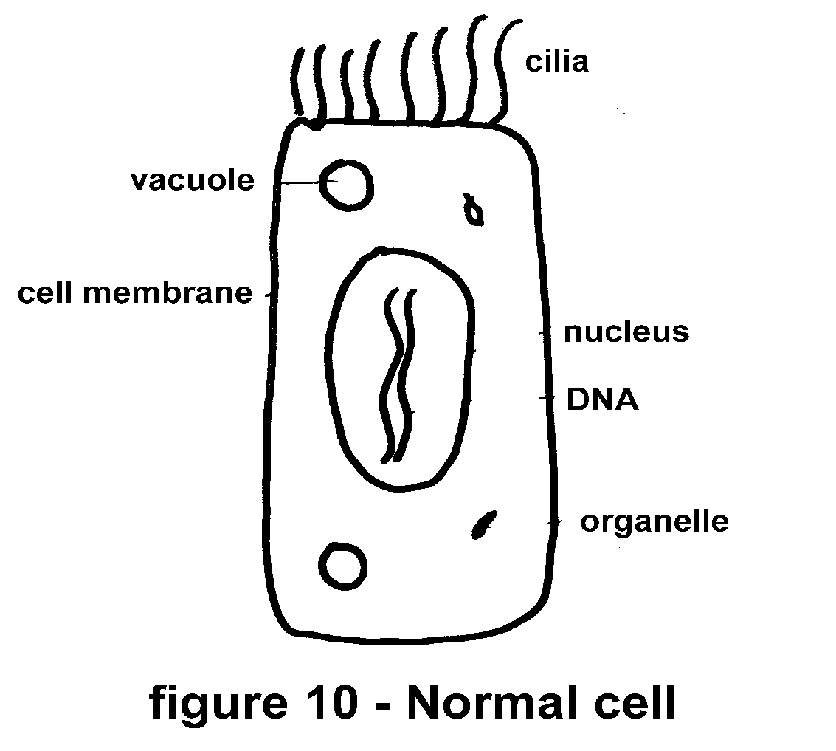

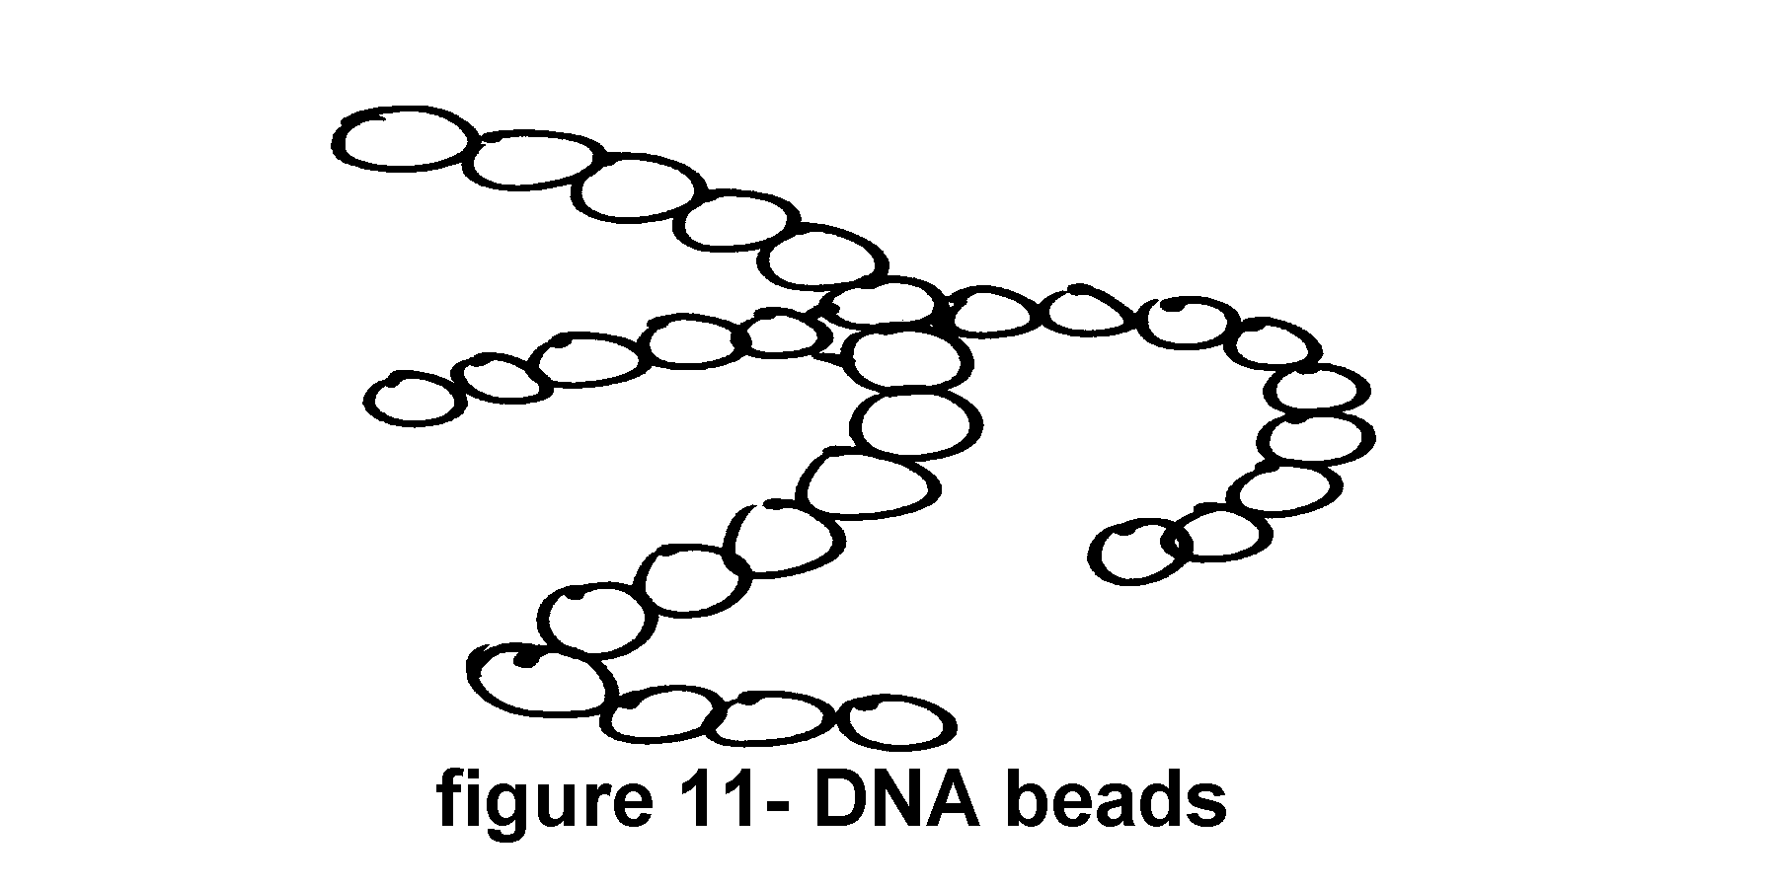

Anything that stresses these long strings of chemical beads may also cause them to break. If a DNA molecule breaks in enough critical places, the cell loses its ability to function, properly. Instead the broken DNA may direct the cell to act, wildly. This aberrant function is seen in cancer cells. Whenever the DNA is disrupted beyond repair, the cell or its offspring either die or become cancerous.

IONIZING RADIATION

One type of stress that may break DNA is in the form of radiation. X-rays, Gamma rays, radioactivity, or just plain light can act as ionizing radiation. In other words, radiation that can cause chemical changes is called ionizing radiation. Photons or subatomic particles moving at very high velocities collide with some of the chemical beads on a DNA string and destroy or alter the chemicals of the DNA.

There are basically three types of ionizing radiation ; Alpha particles, Beta particles, and Gamma rays. Alpha particles are heavy helium nuclei and move slowly. Even though they are subatomic (very small) you may think of them as bowling balls. Beta particles are electrons that are moving very fast. You may imagine them to be bullets. Gamma rays are photons. They have no mass but move at the speed of light. You should picture them as pinpoint laser beams. Use your imagination now, to see how these different forms of radiation effect the cells in the body. If you were standing in a large room while someone was rolling slow moving bowling balls at you, would you have any problem. Of course you would have a problem. But it would not be life threatening. Bowling balls move slowly. You could simply "get out of the way" of them. Even if one did hit you, it would at most break a leg. Alpha particles function much the same as our bowling balls. They move slowly. They are big (for a subatomic particle, that is). They are stopped by a single sheet of paper. Even your skin is strong

α alpha •

β beta •

γ gamma ~

figure 12 - Radiation types; alpha, beta and gamma

enough to stop Alpha particles. Generally, Alpha particles approaching from the outside present no danger to humans. Just remember the bowling balls. We do not think of bowling balls as being particularly dangerous.

Beta particles, however, are very dangerous to human tissue. If you were standing in a room with someone shooting bullets would you feel very safe? What if the bullets were being shot in a random pattern. I don't know about you, but I would think it is dangerous being in a room with bullets whizzing in all directions.

Gamma rays are photons of energy. They include things such as X-rays. Gamma rays have no mass. But they travel at the speed of light. They are so energetic, that they go right through you. Even now while your sitting and reading this book, Gamma rays (very low dosages) are going through your body. Think of these as pinpoint laser beams. Gamma rays are so small and move so fast that they do not have time to react with much of the body tissue. Thus, Gamma radiation, except in high doses, is not as dangerous to living tissue as Beta particles.

Let's review our knowledge of these three types of radiation and the effects of each upon our cells. Alpha particles (bowling balls) coming from the outside of our bodies are slow and are stopped by the skin. Beta particles (bullets) are high energy particles that may be quite dangerous. Beta particles coming from the outside into our bodies cause the breakdown of the chemicals in the cells that they puncture. The Gamma radiation (pinpoint lasers) is so tiny (they have no mass) that they may go right through you without ever touching any part of your cells.

Now let's imagine the source of radiation to be within our body. Instead of having the radiation come at you from the outside, imagine the radiation coming from some point inside your body. Immediately, you see that the Alpha particles have a different effect upon us if they originate from within the body. Imagine a bowling ball trying to get out of your gut. I think everyone would agree that being ripped apart by such an event would damage a lot of cells and probably be deadly. The danger presented by Beta particles and Gamma rays remains about the same (perhaps just a little more dangerous) if they originate from within the body. Thus, ordinarily harmless Alpha particles become deadly to the DNA in our cells if the source of radiation is inside the body.

Oddly enough, there is an Alpha emitter that may get into our bodies. It is a by-product of all out nuclear testing. The fallout and debris of our nuclear age contains a chemical isotope called Polonium-210. Polonium-210 is an Alpha emitter. It gives off Alpha particles. For many years no one thought that Polonium-210 presented any problems to man or animals on the planet. After all Alpha particles were stopped by the skin. But what wasn't known at the time was that Polonium-210 is concentrated by tobacco plants. It may seem odd. But the tobacco plant for some reason takes up large amounts of this Alpha emitter.

The person relying upon air for his daily breath has no problem with this. The person smoking cigarettes, however, inhales quantities of Polonium-210. Some of this Alpha emitter remains in the lungs and airways. Now the situation has become hazardous. The Polonium-210 sits on the surface of the airways and emits Alpha particles. There is no skin in the airways to protect the delicate cells. The Alpha particles start blasting the cells. The DNA within these cells becomes altered and the scene is set for the development of cancer. This may explain why so many smokers get lung cancer. This may only be part of the story. But it is certainly a very important aspect of the development of cancer in the lungs.

TOXIC CHEMICALS

Cells under the influence of toxic chemicals (cancer causing chemicals - carcinogens) divide abnormally and deform their DNA, thus, forming cancer cells. Many chemicals seem to be able to interfere with a cell's normal reproduction or division. Carcinogens react with the enzymes and nucleic acids required for normal cell division, resulting in cancer cells. Certain chemicals cause cancer at even very low dosages.

There are several compounds and chemicals that seem to cause cancers. Unfortunately, many of these are found in cigarette smoke. To make matters worse, smoking seems to aid some compounds in their ability to cause cancer. Asbestos is just such a compound.

ASBESTOS AND SMOKING

By itself, asbestos has been linked to cancer production. However, if we add a history of smoking to a history of asbestos exposure, we get a greater chance of developing a cancer. Here's how this fact translates into numbers. If you are a non-smoker and you have not been exposed to asbestos, the relative risk of you dying from lung cancer is about 1%. That's very low. If you are an asbestos worker and a non-smoker, your relative risk of dying of lung cancer is about 5%.

You can see that asbestos is not good for you. If you are a smoker and have never been exposed to asbestos, your relative risk of dying of lung cancer is almost 11%. That's more than ten times the non-smoker's risk. It's also twice the asbestos worker's risk. Now comes the shattering fact. If you are a smoker and an asbestos worker (exposed to asbestos), your relative risk of dying of lung cancer is approximately 53%. That's more than smoking by itself and asbestos exposure by itself. This high risk of dying of lung cancer is almost equal to the risk from asbestos "times" the risk from smoking. Asbestos and smoking work together to assault your cells and lungs to cause cancer.

It is not only asbestos that has this effect of making smoking more deadly than it is by itself. Many chemicals and inhaled substances increase the risk of cancer development.

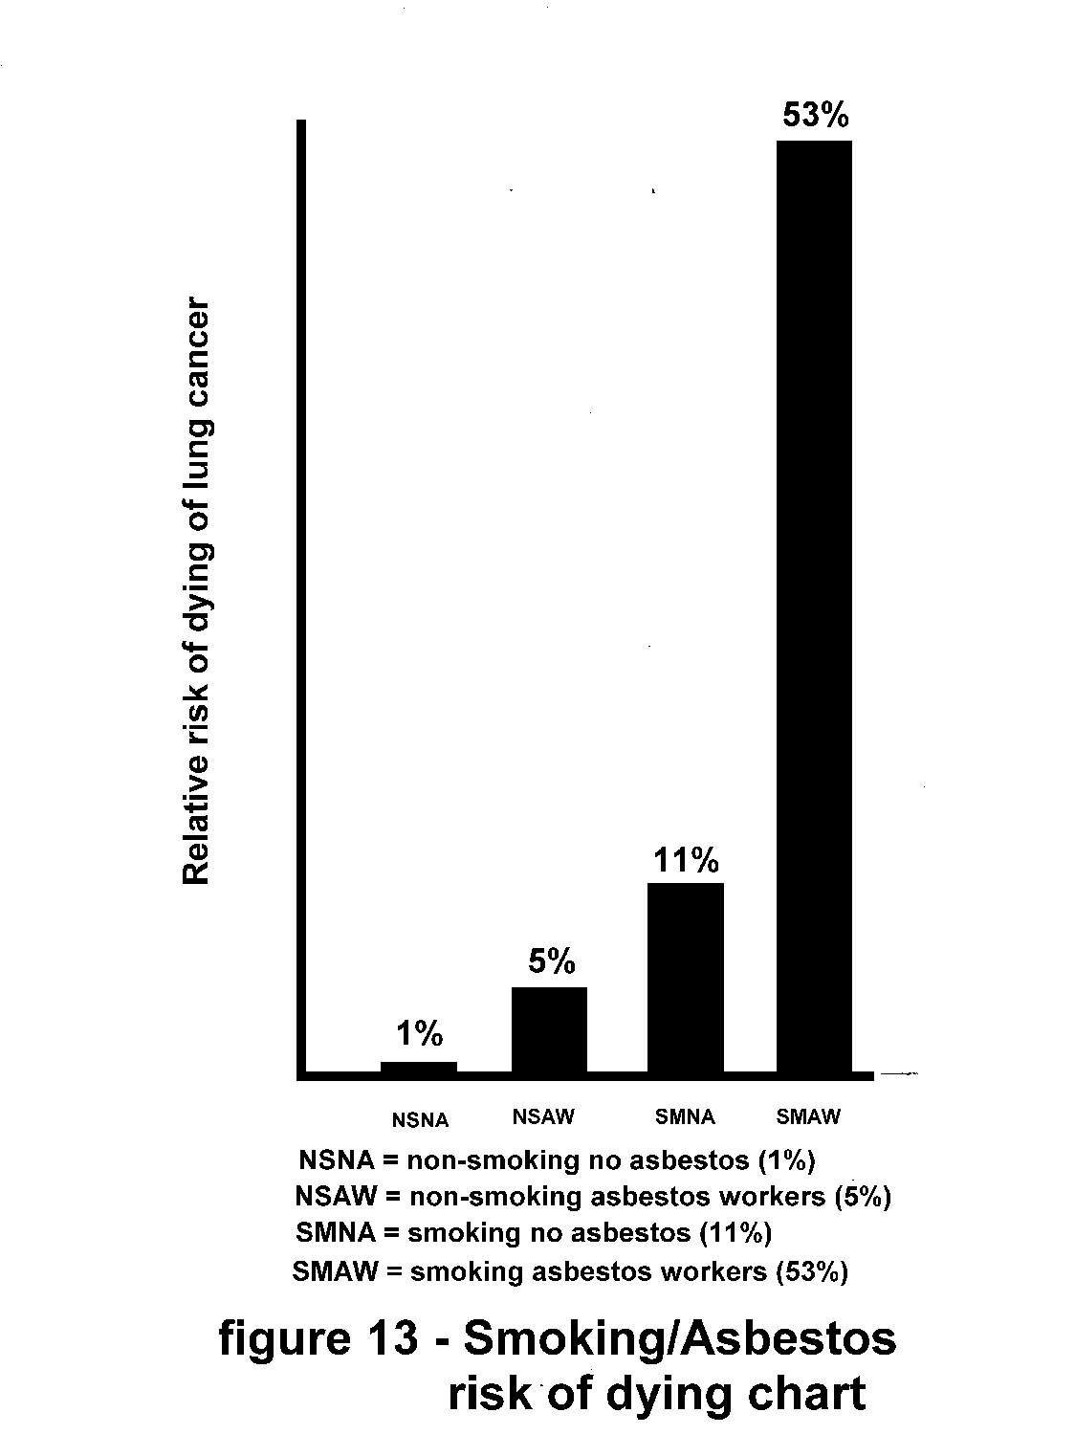

CHEMOTHERAPY

There have been major changes in the understanding and use of anticancer drugs. These chemical agents (anticancer drugs) are poisons designed or discovered to be more toxic to cancer cells than to normal cells. Most anticancer drugs affect cells that are rapidly growing or reproducing. Because these agents are powerful poisons they also affect the lining of the intestine, reproductive organs, hair follicles, and the lymph system.

For example, Adriamycin affects the heart, Vincristine poisons the nerves, kidney function is impaired by Cisplatin and Bleomycin injures the lungs.

Why would anyone want to take a poison into their body? The answer is complex. Basically, we try to poison or kill the cancer cells in the body, before any lasting damage is done to the normal cells in the body.

Some of the current principles of chemotherapy include the use of several chemicals at the same time instead of using just one agent. Complete remission or eradication of the cancer is the goal of chemotherapy. Anything short of this goal offers little for the survival of the cancer patient. Chemotherapy usually begins with the strongest and suspected most effective agent in the maximum possible doses.

RADIATION THERAPY

Aside from chemotherapy as a treatment for cancer, there is radiotherapy. This form of therapy may seem odd to you because it requires the cancer cells to be bombarded with radiation. X-rays have been used to find disease within the body. High levels of X-radiation, usually thousands of times higher than used for a chest X-ray, kills or injures cells. Other types of radiation are also used for radiotherapy. Normal cells, as well as, cancerous cells are affected. By the careful aiming of the radiation beam, doctors can kill or reduce the size of a cancerous growth. Gamma radiation from a cobalt isotope is directed at the cancer growth. The intense radiation kills many cells. Cancer cells seem to be effected by this radiation faster than the normal cells. Thus, the goal of this type of therapy is similar to that of chemotherapy. It is designed to kill cancer cells and leave the normal cells injured but not dead. Knowing what you now know about ionizing radiation, you can appreciate the risks involved.

SURGERY

Another method of dealing with some cancers is surgery. Some cancers are localized in a small area of the body. If they can be cut out and removed safely, the patient will be relieved of the cancer. However, usually by the time a cancerous growth is large enough to be discovered, it has also developed or spread elsewhere in the body.

Within the lungs the conditions responsible for the development of cancer (smoke, chemicals, low oxygen levels, poor blood supply, the genetic make-up of the lung cells, etc.) are approximately the same throughout the entire lung system. Thus, if a cancer has developed in one small area of the lungs (remember our image of footprints on a tennis court.) it is probably developing elsewhere in the lungs at a similar pace.

A more recent surgical technique for the treatment of lung cancer is called laser surgery. A narrow fiberoptic tube is advanced from the patient's nose or mouth into the airways. The physician can actually look at the inside lining of the airways with this procedure. If any small areas of the airway lining appear to be abnormal, a tiny yet powerful infrared laser beam can be directed to vaporize the diseased tissues. This entire laser procedure is sometimes referred to as phototherapy.

RELATED TO INHALED PARTICLES AND SMOKING

Perhaps one of the most important facts about lung cancer is that it is usually related to inhaled particles and chemical fumes. These are just the things found in cigarette smoke. The inhalation of things other than air places a tremendous biological strain upon the tissues of the lungs.

The only behavior that will guarantee relief from these cancer causing conditions is to start breathing just air as soon as possible. Every cigarette that you DO NOT smoke lessens the load upon your lungs and reduces the risk of cancer development.

REVIEW OF THINGS TO DO

1. Post and read two lists of reasons to quit

2. Keep a record of your smoking habit

(Record every cigarette)

(Light smokers find it easier to quit than heavy smokers)

3. Exercise regularly every day

(15 minutes of walking is also 15 minutes of thinking)

4. Drink lots of water or juice

If you've been following the instructions in this manual as you've been reading, you will be doing those things listed above.

AUTOSUGGESTION

The first two tasks may seem a bit repetitive to you. This is indeed true. But the purpose of such repetition is important. By reading your posted lists of reasons to quit, you will slowly re-enforce these ideas until they become reality achieved and not just logical goals. The recording of each and every cigarette eliminates your ability to group all these cigarettes into the idea of "a pack a day". If you continue to smoke you must confront each and every cigarette with your very heart and soul. Do you really want this one? Do you really need this one? Can you do without just this one cigarette? Individualizing each cigarette allows you to deal with your habit in small simple steps. However, please don't be lulled to complacency. Each step in the right direction is a hard won battle with yourself as the enemy.

The use of repetition and introspection to accomplish desired goals has a history as long as mankind's. The value of such repetition is akin to the value of prayer. Prayer, the quiet yet verbal review of your desires or needs, permits a certain communion within your mind with the power(s) required to accomplish any goal. Some people call these powers god. Others say they are the forces of nature. Regardless of how you view the world, prayer and repetition strengthens your ability to perform those tasks required to achieve your goals. Prayer allows the mind the chance to review the questions and problems set before it.

No undertaking great or small has been successful without some verbal review of the goals. We might call this review, prayer.

This aspect of prayer and autosuggestion are similar. Auto-suggestion (a form of hypnosis) is a process whereby you give yourself a suggestion enough times until you act upon it. If you tell yourself each day that you are going to take better care of yourself, each day you will take better care of yourself.

Let's spend a few moments to understand why repetition, prayer, and autosuggestion work and of course, how we can use them to help ourselves become nonsmokers, again. One explanation of the function of hypnosis is based upon the idea that the mind is really two distinct but cooperative minds working together. The conscious mind is the one with which we are most familiar. Our conscious mind is an interpreter of daily events. It evaluates our activity. It makes judgments about things that are good for us and bad for us. The conscious mind is an analyzer. It considers everything we experience, past and present. It analyzes everything we experience and then files it in our memory for future reference. It tells us that birds fly and fish swim, because it is logical and based upon our experience it seems true that birds fly and also that fish swim.

Our subconscious mind in contrast to the conscious mind, is a grand recorder. The subconscious mind records everything. If it is true, the subconscious records it. If it is false, the subconscious records it. If I were to tell you that birds swim and fish fly, your subconscious mind would record this. Indeed it just has. The subconscious mind does not evaluate our experiences. It simply records them. The conscious mind often has need to call upon the subconscious mind for some information to make a judgment. The subconscious gladly supplies the recorded information, without checking to see if it is true or false.

Hypnosis may work by allowing the conscious mind to become sleepy and less alert. Thus, the subconscious mind is permitted to record everything without any interpretation or blocking from the sleepy conscious mind. A post-hypnotic suggestion may be implanted into the subconscious mind by the hypnotist.

An example of a post-hypnotic suggestion might be: "Whenever you light up a cigarette, you will feel nauseous and put the cigarette out."

Some people respond very well to hypnosis. Others do not. It is important to remember that programs such as hypnosis are superimposed upon your habit. Whatever factors contribute to your habit will still exist. The personal needs that are satisfied by your habit will still seek expression. Often the new method of expression is just as detrimental to you as your smoking was.

HYPNOSIS AND SUBLIMINAL MESSAGES

Ordinarily, our daily routine admits two states of mind; consciousness and unconsciousness (unconsciousness includes such states of mind as dreaming.) While awake we are usually conscious (As you are now. Because you must be conscious to read this.) While we sleep we are usually unconscious. All of us are familiar with these two everyday states of mind. Each state is quite different from the other. We can’t accomplish a new technical task without conscious concentration. After we’ve learned a task, however, we may do it ‘automatically’ without much conscious help. (Think about walking up or down a flight of stairs. Normally, you do it without thinking about it. But if you are a small child or recovering from a foot or leg injury, you must slow down and think about each and every step.) Likewise, we rarely dream unless we are asleep (except for day-dreams, which are not true dreams.)

There are, probably, about a half dozen other states of consciousness (day-dreaming and just waking, for example) that occur infrequently and for very short periods of time during our normal days. We may or may not be aware of these as they briefly replace our consciousness or sleep.

While we are conscious there is a tremendous amount of sensory information and neural processing going on in your brain. As a matter of fact, there is so much processing going on that it seems as if most of it is not needed to support consciousness. In other words we seem to think about a lot more things than we are aware we think about. All this extra processing is described as unconsciousness. All this extra processing seems to be used to support our conscious thoughts but not actually becomes part of it. For example, if you were thinking about how to spread a piece of carpet, you may measure the length and width of the floor and then measure the length and width of the carpet to decide whether or not the piece of carpet that you have will indeed cover the floor you want to cover. While you are trying to decide whether this is true or not, your problem solving thought processes may jump at the multiplication problem by pulling up some times table figures that you memorized as a child in grade school. These figures (Let’s say, ‘8 x 12 = 96’) are more or less ‘given’ to your conscious thought processes. They are not remembered the same way you would sit and recall some wonderful day at the beach from your childhood. They emerge from your unconscious. Once you’ve learned them, they are yours’ to use with facility.

The increasing use of personal computers has introduced and opportunity to use the incredibly fast processing speed of these devices to implant information into our mental processes without disturbing our consciousness. In other words, a computer or television can be used to present information to your brain that is not noticed by your consciousness but is recorded by your unconscious processes. This is called ‘subliminal messaging.’ A message (usually a bit of text or an image) is presented to your eyes for a very brief moment of time (so brief that your ordinary conscious processes cannot ‘see’ it.) You brain, nonetheless, does ‘see’ this image and it is processed. It sort of passes into your thought processes without passing through all of the normally active filters of consciousness.

One product that utilizes this technology to help people quit smoking is called the SUBLIMINAL COACHTM. It is a computer program that works in the background on your computer. While you are doing your everyday work in front of the computer monitor, the SUBLIMINAL COACHTM flashes brief messages on to your computer screen to help you quit smoking. For the most part these messages are similar to the messages on your ‘List of Reasons to Quit Smoking.’ Information about the SUBLIMINAL COACHTM for Smoking Cessation is found in APPENDIX IX.

Our goal is to expose the reasons why you smoke and then develop behavior that will be beneficial to you and satisfy your individual needs, now being met by your smoking. By pursuing this goal, you will alter the course of your life's direction. You will put yourself on a healthier path. You may also find in the process that as you give up your smoking habit, you will replace it with helpful and healthier behavior.

No doubt, you are familiar with the wisdom in the calling to: "Think good thoughts, do good deeds." It is equally applicable to say: "Do good deeds, think good thoughts." if you take proper care of yourself, by giving up smoking, etc. you will find that your thoughts and feelings will be clearer and crisper than before.

Remember, each day the effort you devote to improving yourself will pay off for the rest of your life. Each day you will be able to extend your limits a little more than the day before.

Repetition and practice are the only ways to acquire any skill in a new talent.

Practice, practice, practice: and you will succeed in whatever you choose to do.

ACTIVITY - Vital Capacity Testing

For those readers attending regular clinic sessions following this outline, it is time to test your lungs by performing a Forced Expiratory Vital Capacity maneuver. Readers following this manual on their own may use a similar yet less sophisticated evaluation described below as the "Match Test".

Your Vital Capacity is a measure of the maximum amount of air that you can exhale (or inhale) in a single breath. The device we use to measure your Vital Capacity is called a spirometer.

At the beginning of the test you should breathe normally through the mouthpiece of the spirometer. You will be asked to take in the deepest breath you possibly could take. Then with your lungs filled to the limit, you will be directed to blow out hard and fast, until your lungs are completely empty. Of course, even whenever you think your lungs are empty, there is always an amount of residual air within them.

The spirometer will draw a graph representing the flow and volume of your forced exhalation. This graph may be a curve of volume versus time. As you exhale into the spirometer a pen will leave a tracing along a sheet of paper. The shape of that trace will reflect the airflow from your lungs. This curve will be very steep at the beginning because you will be blowing out very hard and fast. It will level off near the end because the flow out of your lungs will slow down. It will look something like this:

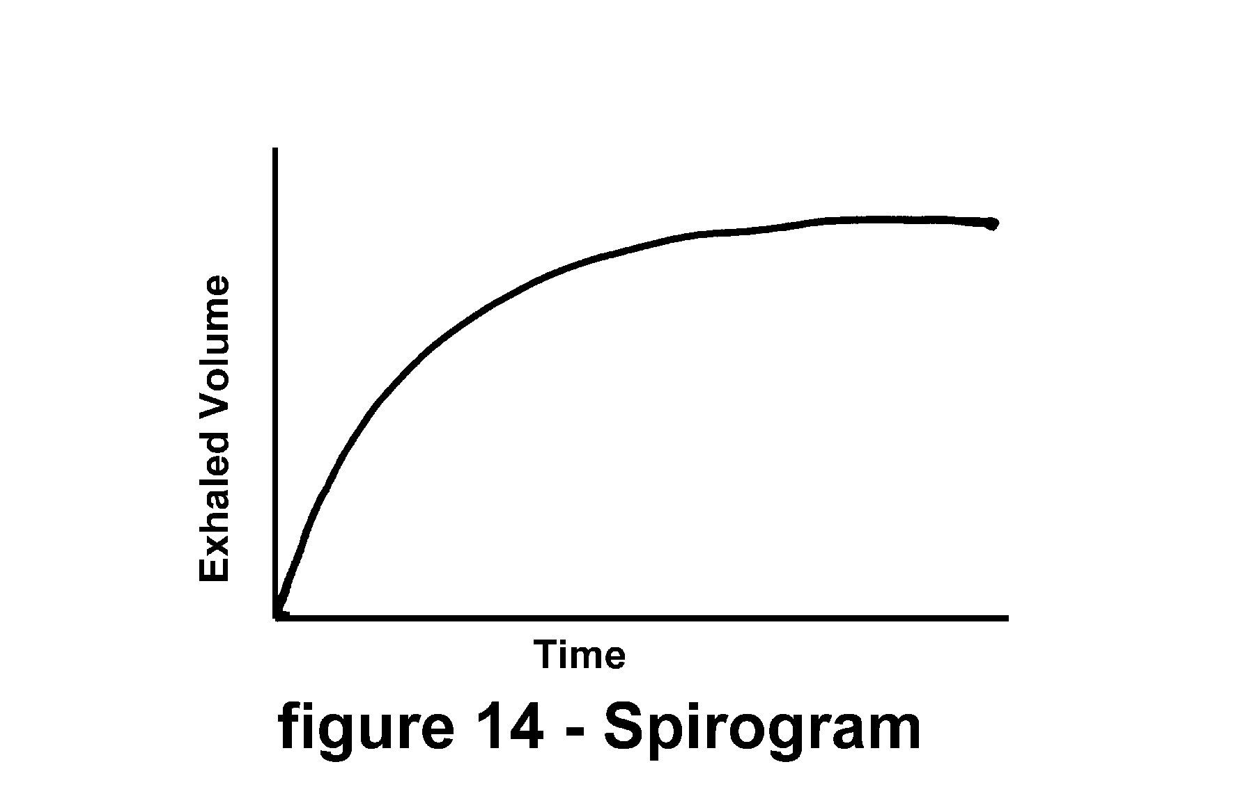

This is called a spirogram.

Another way of plotting the same information is called a flow-volume loop. It is a curve representing flow versus volume and will appear to be something like this:

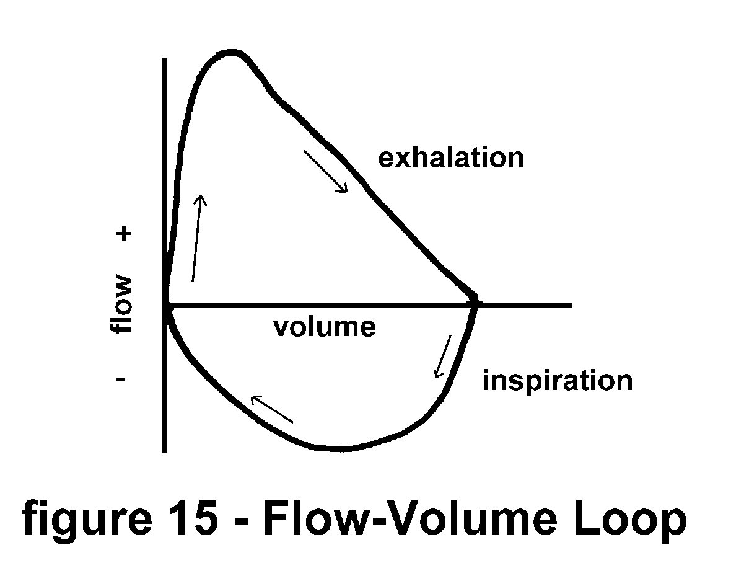

We will review some of the uses of these curves later when we discuss different types of lung diseases.

The maximum amount of air that you can move in or out of your lungs with a single breath (your Vital Capacity) is proportional to your height and age. If you are tall, your normal Vital Capacity should be larger than it would be if you were short. As we age, as adults, our Vital Capacity tends to decrease, slowly. We can predict what your vital capacity should be, based upon your age, height, and sex (males have slightly larger Vital Capacities than females of the same height and age).

The flowrate of your expired air reflects the openness of your airways. If your measured flowrates or volumes are far below your predicted values, you may suffer from some malady. Thus, it is important that you blow out as hard and fast as you can, while creating the spirogram or flow-volume loop.

In SESSION VI we will compare your spirograms with various other curves and relate them to different conditions in the lungs.

MATCH TEST

If a spirometer is not available, you may perform a self test that will provide some information about the condition of your airways.

The "Match Test" has been used by physicians for many years to provide an immediate evaluation of a patient's expiratory flowrates. Light a match and hold it at your arm's length in front of yourself. Vital Capacity is related to height and arm length is related to height. Blow hard and try to blow the match out. If you succeed at extinguishing the match with a single blast your flowrates and volume are probably within normal limits. If, however, you are unable to blow out the match, you may have some decrement in flow. The "Match Test" is not sensitive enough for us to quantify any impairment in lung function but it may be used to qualify normal flowrates.

Let us add only two more activities. Things to start today:

BREATHING EXERCISES

One new activity is very passive. The other is very aggressive. We will start with passive breathing exercises.

Deep breathing helps open airways and alveoli (tiny air sacs) within the lungs. Taking a deep breath also helps move fluids around in your chest and gut. Blood and lymph flow more freely after a few deep breaths. Three times each day (upon waking, before lunch, and just before lying down to go to sleep) you must slowly take ten very deep breaths. Do not take these ten breaths so rapidly that you make yourself light- headed. Take each breath, slowly and deeply. Relax while you do these exercises. Later you will be presented with more detailed breathing exercises that you may want to do. For now ten slow deep breaths three times each day will suffice to get you started.

ELIMINATE THE PEAK TWO HOURS OF SMOKING EACH DAY

You are about to begin the actual cessation of smoking. All the activities and exercises mentioned so far in this manual have been designed to prepare you for the next step - limiting your intake of cigarettes.

By just keeping an accurate record of your smoking habit, you may have decreased the amount of cigarettes you smoke daily. This decrease although viewed as an important step in the right direction should be recognized as a passive effect of your record keeping. Now, we are about to take our first aggressive step.

Using all the daily logs of your cigarette smoking, create a graph of your daily habit. Follow the example below. Using a filled in log sheet, place a small mark (a dot) on the weekly summary sheet for each cigarette that you have smoked. The small marks should coincide with the time line representing the time the cigarette was smoked.

CIGARETTE LOG: DATE______________________

**Always be honest to yourself!**

(Fill in the blanks for each cigarette)

**TIME LOCATION ACTIVITY REASON NEED**

**1. 5 AM bedroom waking to wake up 5**

**2. 5:45 AM kitchen after breakfast taste 3**

**3. 6 AM corner waiting for bus relaxation 2**

**4. 6:30 outside the office buying paper relaxation 2**

**5. etc. etc. etc. etc. etc.**

**6.**

**7.**

**8.**

**9.**

**10.**

**11.**

**12.**

**13.**

**14.**

**15.**

**16.**

**17.**

**18.**

**19.**

**20.**

write any comments on the back...

Weekly summary of cigarette consumption

**TIME MON TUE WED THR FRI SAT SUN**

**1-3 AM**

**3-5 AM**

**5:00 AM**

**6:00 AM**

**7:00 AM**

**8:00 AM**

**9:00 AM**

**10:00 AM**

**11:00 AM**

**12:00 NOON**

**1:00 PM**

**2:00 PM**

**3:00 PM**

**4:00 PM**

**5:00 PM**

**6:00 PM**

**7:00 PM**

**8:00 PM**

**9:00 PM**

**10:00 PM**

**11:00 PM**

**12:00 MID**

(This form is available for photocopying in APPENDIX VI)

Complete a weekly summary sheet for each week that you been documenting your habit. After you've completed filling in your weekly summary sheets, a quick glance at them should show you the period during each day that you smoke the most cigarettes. In the example below you can see that our smoker smoked most heavily during his lunch break at work on Monday.

Weekly summary of cigarette consumption

**TIME MON TUE WED THR FRI SAT SUN**

**1-3 AM**

**3-5 AM**

**5:00 AM ** * * * \***

**6:00 AM ** * \***

**7:00 AM \***

**8:00 AM * * * * \***

**9:00 AM * ** * \***

**10:00 AM * * * * * \***

**11:00 AM * ** * ** \*\***

**12:00 NOON *** *** *** *** ** * \***

**1:00 PM * \***

**2:00 PM * * * \***

**3:00 PM * * * \*\***

**4:00 PM \***

**5:00 PM * * \***

**6:00 PM * \***

**7:00 PM * * \***

**8:00 PM \***

**9:00 PM \***

**10:00 PM**

**11:00 PM**

**12:00 MID**

If we look at a complete week's worth of data we see this even more clearly. Above the weekly summary sheet for our smoker shows his smoking activity for a complete week. The concentration of dots (cigarettes smoked) seems to cluster around his lunch breaks at work. Notice also that on the weekend our smoker did not smoke as much as he did on weekdays.

Look at your completed weekly summary sheets. Is there a time period of about two hours wherein you smoke more cigarettes than usual? For our sample smoker this period would be between the hours of 10:30AM-12:30PM.

Your task is to determine your two hours of peak smoking and then abstain from smoking during these two hours every day. From now on you may not smoke during those two hours. Make this a firm resolve. You may want to put aside these two hours to read or reread this manual. Since you are already not smoking while you're reading. Thus, you could do both at the same time. It is only two hours each day. If you check your summary sheets, you will find that there are probably several two hour periods each day during which you already do not smoke. So you simply have to not smoke for only two hours each day. These two hours will be when you normally would smoke, heavily. Choose your peak two hours, fairly. Choose those two hours that usually include the most cigarettes.

Using our sample smoker: he might be tempted to choose 10:00AM-12:NOON as his two hours of abstinence, knowing he could "grab a smoke" before going back to work at 12:30PM. But, he would be cheating himself. Choose the two hours that encompass the maximum amount of cigarette smoking.

If you are having a problem deciding when your maximum cigarette consumption occurs, follow these directions. A simple way of choosing your two hours of peak smoking is to cut out a paper guide with a gap equal to two hours of the summary sheets.

**CUT A PIECE OF PAPER OR USE A CARD**

**AS A GUIDE TO FIND YOUR PEAK TWO HOURS**

**use APPENDIX VII as a template**

By placing this guide over a summary sheet and counting the dots visible inside the gap, you can determine your peak two hours. The position of the guide that contains the most dots is your peak.

**9:00 AM * ** * \***

**11:00 AM * ** * ** \*\***

**12:00 NOON *** *** *** *** ** * \***

**2:00 PM * * * \***

**3:00 PM * * * \*\***

Once you have determined the hours of your peak cigarette consumption, you may set aside your cigarettes each day for these two hours. You should read APPENDIX II - HELPFUL HINTS to get some ideas that will help you accomplish this important task. Changing your brand of cigarettes often is very helpful for this task.

REVIEW

Let's review what you should be doing each and every day:

1. Post and read two lists of reasons to quit

2. Keep a record of your smoking habit (record every cigarette)

3. Exercise regularly every day (15 minutes of walking)

4. Drink lots of water or juice

5. Deep breathing (three times a day)

6. Two hour abstinence (change brands)

If you haven't begun any of these, begin doing it today! Remember, this plan will work only if you follow it, faithfully.

SESSION IV

LECTURE - HEART AND LUNGS, A TEAM

Smoking places a strain upon our lungs and heart. The heart and lungs function as a team to remove gaseous waste and provide fresh oxygen to our body tissues. This session will explain some things about your heart, your lungs, and how they cooperate to keep you alive.

Your heart is an amazing organ. It is a pump. It begins working and pumping your blood around to every cell in your body before you are born. Every day of your life your heart beats a little faster than once each second and pumps blood to the rest of your body. The two gallons of blood in your body are circulated again and again by the heart. Each hour the heart pumps about eighty gallons of blood. The heart is probably the most durable muscle in the body.

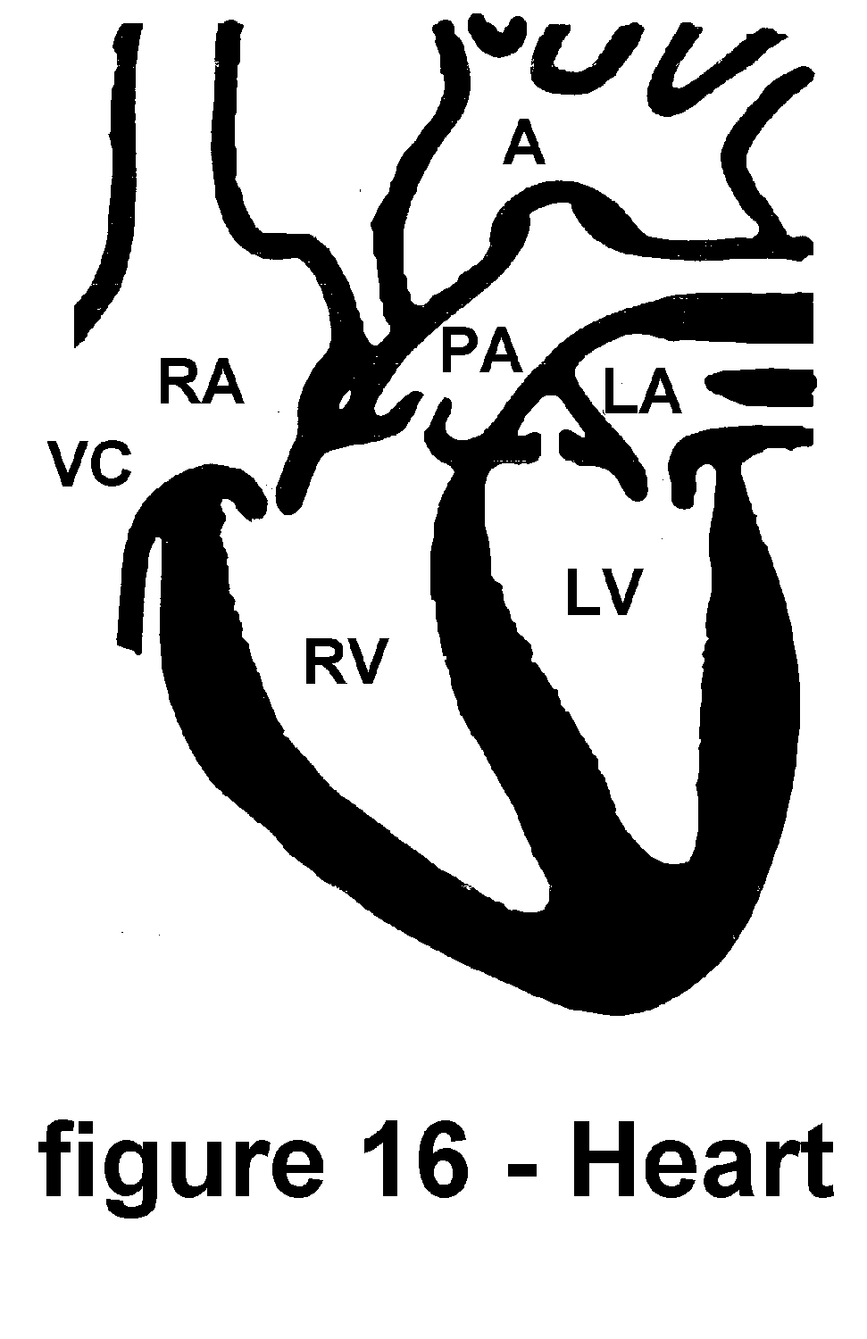

To give you some idea of how much work your heart does, let's perform a little experiment. Hold one hand out from your body and open and close your fist, rapidly, (about once every second). Your hand is now working a little bit less than your heart. Keep this up for about two or three minutes. You may of course rest whenever your hand becomes fatigued. Your heart, however, can not afford the luxury of resting. It must pump and circulate blood at all times.

Blood flows from the body into the small veins and finally into the vena cava (VC in figure 16.) Once blood from these large veins fills the right atrium (RA) of the heart, the heart begins to contract near the top. This contraction squeezes the blood from the atriums into the ventricles. Thus, blood from the right atrium is pushed into the right ventricle (RV.) Contraction of the ventricles next pumps the blood up to the pulmonary artery (PA) on its way to the lungs. (We will discuss how the blood gets fresh oxygen from the lungs, later in this chapter.) After passing through the lungs and becoming rich with oxygen, the blood returns to the heart through the pulmonary veins. It flows into the left atrium (LA.) A contraction pushes it into the left ventricle (LV.) As the contraction continues, the blood is pushed from the left ventricle (LV) up into the aorta (A) and on its way to the tissues and cells of the body.

As the atriums and ventricles contract and relax to pump the blood, four one-way valves (see above illustration) keep it flowing in the proper direction.

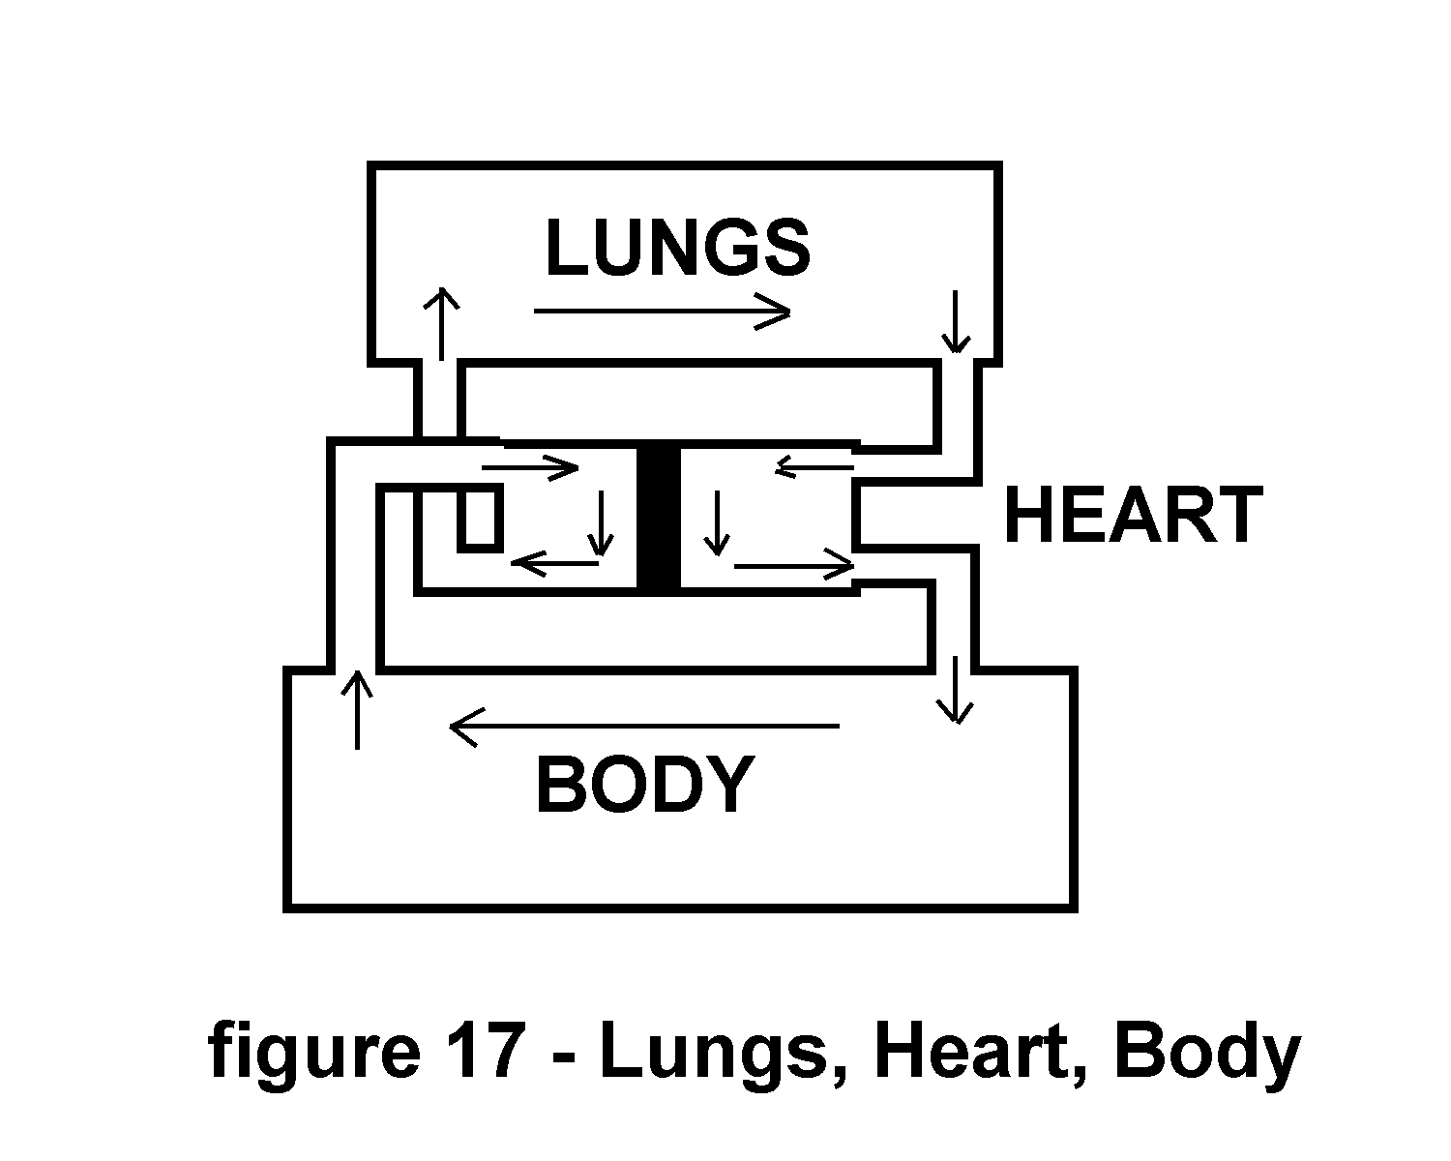

Large blood vessels, such as the pulmonary artery and the aorta carry blood to smaller and smaller vessels. The many smaller arteries also branch and divide into even smaller blood vessels. Finally, the blood is flowing through the tiniest of blood vessels called capillaries. A capillary is just big enough to allow only one or two red blood cells at a time to pass through it. At this point at the capillary level, blood washes each individual cell in the body.

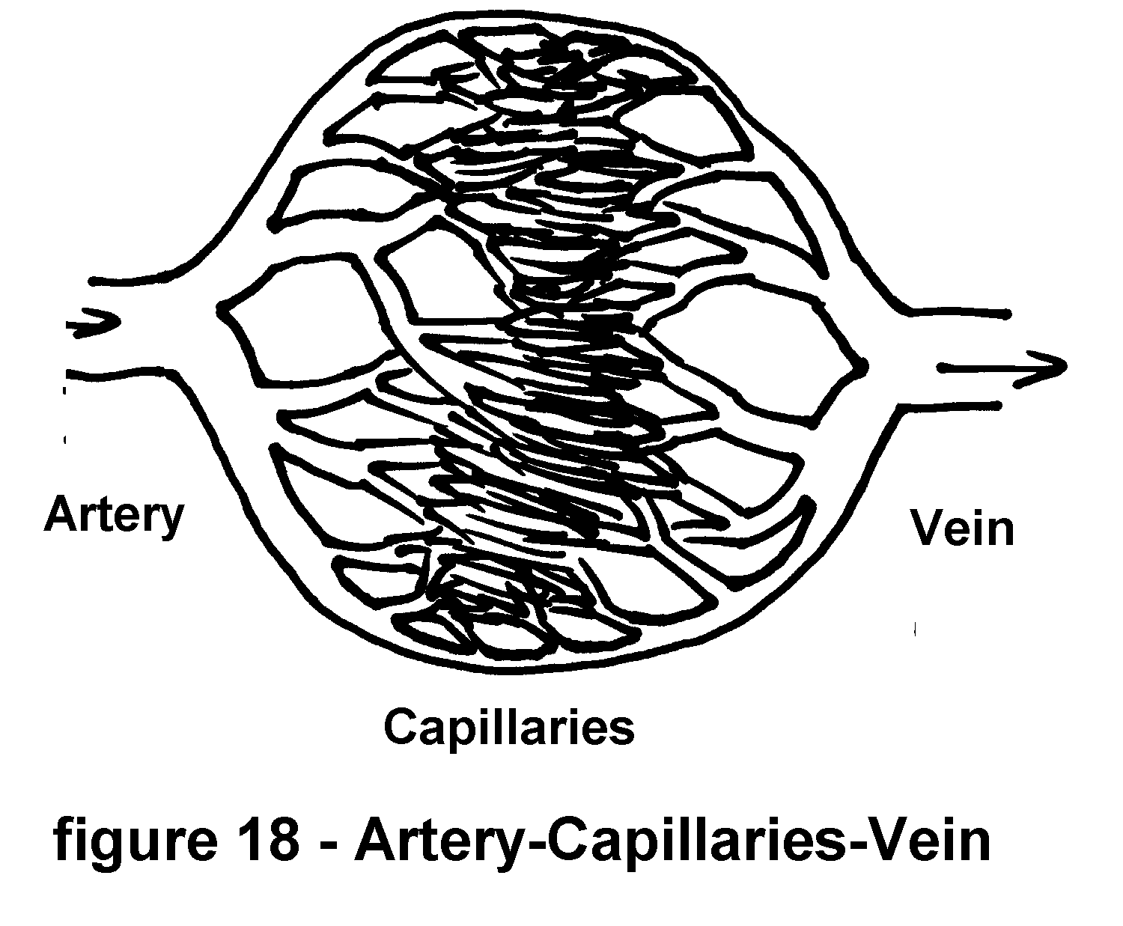

After bringing fresh oxygen to the cells of the body and washing away cellular wastes (One example of waste produced by the cells is carbon dioxide.), blood from the capillaries flows into ever larger veins. This occurs much like many millions of tiny streams flow downhill to merge and form a great river. These veins then carry our blood back to the heart to begin the cycle of blood flow, again. One complete cycle (filling, contraction, pumping and relaxation) or beat lasts less than a second.

The major pumping muscle of the heart is the myocardium. It surrounds the ventricles. This muscle, unlike the muscles in your arms or legs, contracts by itself without any thought from you. It has a small area called the atrial sinus that sends out a small pulse of electricity faster than every second. This is your heart's pacemaker. This pacemaker begins a wave of electrical activity in your heart muscle causing the muscle to contract and pump your blood.

Using very sensitive amplifiers, doctors may measure this electrical wave of heart muscle activity. They produce a graph or drawing of each heartbeat. It is called an Electrocardiograph (ECG - Sometimes EKG).

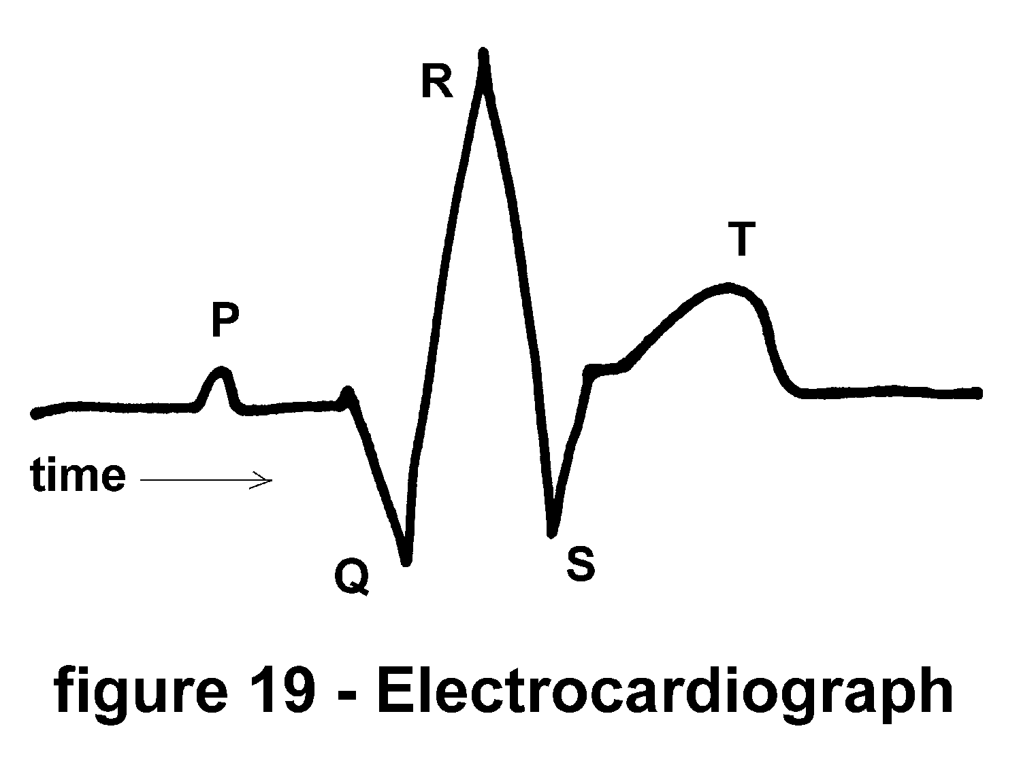

Each hill and valley on this ECG represents some aspect of heart muscle activity. By comparing an ECG with other clinical signs and symptoms, doctors understand how the individual patient's heart is functioning.

Your heart and lungs are a team. Lungs refresh your blood with oxygen and remove waste carbon dioxide. The heart carries this blood to the cells of the body. It also carries the blood back to the lungs. Together they provide these essential functions to keep us alive. They are a team in another manner, too. Anything that hinders lung function also effects the heart. Likewise, anything that hinders heart function effects the lungs. Both heart and lungs are needed for adequate oxygenation. As the fresh air you inhale swirls around inside the tiny air sacs (alveoli) carbon dioxide from the blood diffuses through the lung tissue into the air. At the same time oxygen from the air diffuses into the blood and gets picked up by the hemoglobin in the red blood cells. This exchange of oxygen for carbon dioxide happens continuously. Every breath, every heartbeat brings fresh air and blood together for this gas exchange. Pumping blood through body tissues is called perfusion. In most animals, man included, there must be a match of ventilation and perfusion. If we breathe well but something blocks our blood flow to the lungs, we have a mismatch of ventilation and perfusion. If our heart is working well and a proper amount of blood is being pumped through our lungs yet something blocks the airflow for proper breathing, there is a mismatch of ventilation and perfusion. Both ventilation and perfusion must be matched for there to be harmony in our body's function.

The gases in the air (oxygen and nitrogen) are also present in our blood. Blood contains (in addition to oxygen and nitrogen from the air) carbon dioxide produced by our cells' metabolism. Every breath of air allows some carbon dioxide to "spill" out of the blood into the air sacs in the lungs. As we exhale we blow out some of this carbon dioxide. In fact this is the reason we breathe; to get rid of carbon dioxide. Our body and nervous system are so constructed so that sensors detect raised levels of carbon dioxide and signal the beginning of a breath. As the air enters our lungs carbon dioxide is flushed from the blood and the sensors that monitor carbon dioxide relax and wait until it is time for the next breath. Many people are surprised to find that we breathe to control carbon dioxide rather than to acquire oxygen. Regardless of the mechanism, you require carbon dioxide to leave the body and oxygen to enter the blood. To accomplish this feat your heart and lungs in good working order are required. Smoking damages your lungs as well as your heart.

DIET AND SMOKING HABITS (SEE APPENDIX VIII)

I do not advocate fad diets, crash diets, or miracle diets. I don't believe that anyone can change their diet abruptly and benefit from doing so. However, many people who smoke cigarettes claim that if they were to stop smoking they would gain weight. So dieting is a very important topic for these people. They are very smart about themselves. They recognize that by giving up smoking they may still have a need to satisfy. Eating is often a substitute for smoking. We can use this to our advantage. A proper diet is essential to good health. So why not develop a proper diet to aid us in our task? If you are embarking upon a smoking cessation program or if your diet is not the best for you, you should modify your eating habits to permit yourself a long and healthful life. It's easy to say "Don't eat too much!" It's something quite different to change our diets. (Even if it's for the better.)

What is a healthy diet? For everyone it is slightly different. But we may safely say that a healthy diet is one that provides you with the nutrients and satisfaction that you require for living. Please notice that I've included satisfaction as an ingredient. Lack of satisfaction in our diet causes us to overeat and, thus, gain weight.

Any good nutrition book can advise you about the nutrients, fluids, food groups, vitamins, and minerals you need for a balanced diet. But few of these sources consider your satisfaction while explaining your needs. Ask someone who is on a diet to say, "I'm on a diet." Most of them will moan, groan or look pained as they recite the words. This is because they are not satisfied by their particular diet. Dieting is not just about food. It is about eating. Eating is a daily habit as well as a requirement for life.

In the normal person, as your metabolism uses up the available nutrients, you get hungry. In the obese person the biochemistry is such (because of the excess fat) that the nutrient level never drops low enough to make this person feel hunger. Thus, the obese person's excessive food intake is not due to hunger, but due to a lack of satiety (satisfaction).

The trail of evidence between food and satisfaction is very clear. Most people prepare their meals to make the food tastier and eating more enjoyable. Our eating habits and even our problems with eating begin early in life. Sometimes mothering is equated with food. Thus, we take food for love. Abundant love and positive emotional stimulation are usually prized. But excess food has long term negative effects upon us. Parents will lovingly force their children to eat excessively, sometimes out of a sense of guilt or anxiety. Often a child is fed every time he cries. Spouses may lavish special feasts and "dinners out" on their mates, as a sign of affection.

Food (probably because we require it, regularly) has become closely associated with our coping with insecurity, love, relationships and often means much more to us than nutrient. Simple put, being overweight means that you eat more fuel than you burn. Food intake is not balanced by energy utilization.

This fact has led many to propose vigorous physical exercise as a means of burning up the excess calories in food. Sadly, the amount of exercise and physical effort required to burn up just one pound of excess fat is so much more than you may realize. To burn up just one pound of body fat (4,222 calories) you would have to walk (at 4 MPH) for 14 hours. That's a 56 mile hike! If you just exercise to lose weight and don't moderate your eating, you will probably be very disappointed. I'm not claiming that exercise is no good! Exercise will give you many healthful benefits. Losing excess weight by exercise is not one of them.

The following chart summarizes the amount of time and exercise needed to "burn" calories from common diet portions:

MINUTES OF EXERCISE FOR A 132 POUND PERSON <1>

FOOD CALORIES JOG 6MPH SWIM WALK DANCE

BIKE 13MPH (CRAWL) 4MPH (BALLROOM)

Coffee+sugar 34 3 1/2 4 1/2 7 11

Potato Chips 113 11 15 22 1/2 38

Wine (glass) 137 13 1/2 18 27 46

IceCream cone 230 23 30 1/2 46 77

Pizza (slice) 236 23 1/2 31 1/2 47 78

French Fries 340 34 45 68 113

Apple Pie(Pc) 410 41 54 82 136

Cheeseburger 520 52 69 104 173

<1> Adapted from Bones and Church, FOOD VALUES OF PORTIONS COMMONLY USED, Published by J.B.Lippincott Co.

Eating for Better Health, a booklet available from the U.S.Department of Agriculture - Food and Nutrition Service is Program Aid #1290 (1981). It lists many recipes and hints to help people eat wisely. It also includes a section of low calorie menus for those wishing to limit their overeating. This booklet also offers seven bits of advice about How to Lose Weight:

1. Get daily exercise

2. Have regular meals

3. Eat smaller portions

4. Use a smaller plate

5. Eat fewer sweets and fats

6. Eat slowly

7. Stop high-calorie snacking

This is not a diet book. Our goal is not so much to lose weight but to prevent weight gain as you quit smoking. Of course, you may want to lose a few pounds in the process. These hints generally applied will help you achieve that goal. Let's review them one at a time.

GET DAILY EXERCISE: If you've been following the program outlined by this book you are already exercising on a daily basis. If you are not - please reread the earlier sections. If you are concerned about gaining weight as you quit smoking, skip ahead to read the section on Walking as a Daily Exercise in Section V. Then come back to here and continue reading about maintaining a healthy body weight.

HAVE REGULAR MEALS: This very important aspect of a proper diet is often overlooked. Our daily routine is usually anything but routine. We rush here. We're late for this. We're expected to have that job done, already, etc. Eating like smoking is a daily habit. The best way to deal with a habit is to work with it, not against it. Remember, a habit is something you do on a regular basis. If you want to "regulate" your eating habit, you must develop a "regular" eating habit. By sitting and eating at the same time each day, you will begin to control your eating habit. Regular meals tend to eliminate extraneous cravings for food. Your body will get used to eating at mealtimes and will not urge you for more food at other times. Thus, you will be able to eliminate nibbling, extra snacks, sugared soft drinks, and the like without really working too hard. This is possible, because it will be your habit to eat only at regular mealtimes.

EAT SMALLER PORTIONS and USE A SMALLER PLATE: are aimed at helping you become aware of what and how much you are eating. How much is too much? By using smaller plates your normal food intake will appear to be bigger.

EAT FEWER SWEETS AND FATS: Sugars and fats provide "empty calories" to the body. This means that all of their energy is converted to heat. They do not provide the protein that we need to build muscle tissue. They are fuel that must simply be "burned up". If your body has more fuel than it needs, the excess is stored as fat. By cutting down on your consumption of fats and sugars you allow your body to burn more useful fuels and not build up a surplus of fat. The calories (kcal) in fat and sugar mount up very fast. A regular diet for you is probably near 2700 kcal for males or 2000 kcal for females <2>. That's only half a pound of fat. Expressed in everyday terms, this is equivalent to: cream in your coffee, butter on a roll, a handful of potato chips, three pieces of chocolate, one meal with fried food, one glass of milk, and a slice of layer cake with butter-creme icing. Of course, these are only approximate measures to give you some idea of how fast you can exceed your normal daily requirement of calories by stuffing some fat and sugar into your mouth. Items such as these are usually eaten in addition to your normal meals. Thus, the excess calories quickly accumulate. By limiting excessive fats and sweets from your diet, you may allow your body to utilize the food you eat without the burden of extra calories. Recent research shows that the proportion of fat to muscle in your body also depends upon the proportion of fats in your diet. So, stay away from fatty foods or else, you may wind up eating less calories but putting on more body fat.

EAT SLOWLY: This permits your mind and body the time required to realize that you have eaten. If you gulp down a fast food meal (usually, a fast food meal is fast but not a true meal) in less than a minute or so, somehow your mind doesn't register it as a feeding. Afterwards your mind might start sending you signals that you should eat. It didn't understand that that fast food was a meal. Within your brain you have a mechanism that actually counts the number of times you chew your food. If you chew each mouthful of food many times, this internal counter registers a high total. If you just chew a few times and then swallow, your internal counter registers an inadequate number of jaw movements. This may seem very odd. But one way your body finds out if you've eaten enough food is to check the tally of chews on this internal counter. If the tally is low your brain says, "eat some more." If the tally is high the brain says, "you've had enough." So, chew your food well. This is of course a simplified explanation of only one of the of the many mechanisms that provide us with the means for regulating our diets and daily eating habits.

STOP HIGH CALORIE SNACKING: Most people don't even consider the few peanuts they pick up as they pass the nut bowl part of their regular meals. Tasting a bit of new food or something sweet is interesting. But, it also adds to our total caloric intake of food. You should concentrate your effort on eating at regular times and eliminating all the little, seemingly insignificant, bits of food that you may be eating at other times. If you must eat (and we all must eat), do so at a regular mealtime. Do not supplement your diet by snacking.

<2> from RECOMMENDED DIETARY ALLOWANCES, 9th ed. Food and Nutrition Board, National Research Council - National Academy of Sciences, 1980

Perhaps the most important aspect of this whole process that of quitting smoking, dieting, etc., is your desire to succeed. If you are willing to work at it faithfully, whatever the mind conceives, you can achieve! Nothing is free, however. You must work and work hard for every success. Follow the plan outlined in this book -- follow it faithfully and you will be a nonsmoker. Likewise, moderate your eating habits and you will not gain weight as you quit smoking.

ACTIVITY -

Our next activity may be divided into two parts. The first part consists of an exchange of experiences encountered while trying to maintain a two hour abstinence every day. Those readers participating in a regularly scheduled session will find the diversity and similarity of problems enlightening. For those readers reading this manual on their own; below you will find some common problems and comments taken from actual sessions.

The second part of this activity is your next move toward becoming a nonsmoker. In addition to the two hours of no smoking each day, you will now eliminate those cigarettes that you need the least. This will be explained in detail at the end of this session.

Oftimes, especially whenever we are stressed, we believe that we are the only person in the world who understands what we are going through. This is simply not true. All the tension, all the anxiety, all the little problems that you face each day while trying to quit smoking are common to almost everyone else doing the same task. You are not alone. You should have no reason to want to give up trying because of some "special" circumstance. Here I'm addressing those people who are starting to have second thoughts about being able to quit smoking.

REVIEW THE RESULTS OF THE TWO HOUR ABSTINENCE

Let us talk about the process of recording each cigarette and finding our period of peak smoking activity. If you are going to be successful, and this means you will quit smoking cigarettes, you must understand exactly what you are doing. If you want to stop doing something, you must know exactly what it is that you want to stop doing. By writing down the time and place you smoke each cigarette on a small piece of paper (Daily Cigarette Log) you will be defining your habit. Not only will you be documenting your progress as you quit, but you will be defining your smoking habit so precisely, that you will be able to see exactly what you must do to help you quit smoking. One of the aspects of habitual behavior is that we tend to do it automatically. We don't think about it, too much. We do it uncritically. Now, if you write down every time you smoke, you have the opportunity to be critical of your own actions. I don't mean critical in only the negative sense of the word. You may also be critical in the positive sense of the word. You should know when to pat yourself on the back for a job well done. Just as you should know whenever you've tripped on something;

Review SESSION II particularly the section that describes how to record your cigarettes on the Daily Cigarette Log.

If there is any doubt in your mind about which period during the day is your peak period of cigarette consumption, please reread the end of SESSION III to determine when it is that you smoke the most. This information is vital to your effort to quit smoking.

EXCHANGE AND DISCUSS PARTICIPANT'S PROGRESS

Below are several stories actually presented at clinic sessions. These represent a sampling of the spectrum of response to the tasks of smoking cessation. I'm sure you will be able to identify with some of these. Aside from the stories presented here, you should be made aware that everyone experiences changes in their lives differently from the next person. You may find yourself dizzy, hungry, irritable, aggressive, etc. something you would not ordinarily feel. Yet, under the pangs of withdrawal from cigarette smoking these may emerge. All these feeling are normal reactions to abstaining, even if you've only abstained for two hours each day. Take heart, each and every one of these people has quit smoking.

I FELT I WAS DOING SOMETHING I WASN'T SUPPOSED TO DO.

STORY: I found myself watching the clock to get through the two hour period. Then I felt guilty after I lit my first cigarette. It felt like I was doing something I wasn't supposed to do.

ASIDE: Talk about the guilt!: There are three ways of dealing with guilt; 1. stop doing the activity that makes you feel guilty. 2. Ignore the guilt and it slowly subsides, but doesn't go away. Ultimately, you will pay the price. 3. Understand why you feel guilty then decide if this is a valid belief. We feel guilt whenever we do something that violates our belief system. (That is we feel guilt whenever we believe we have done something wrong. The act we did need not really be wrong. We only have to believe it is wrong for us to feel guilt.) In our example, here: If you believe smoking is wrong, then you will feel guilty about smoking. Now your emotions have had their say and you must fix them. You seem to imply that by abstaining you generate the guilt. But you must realize that it is the smoking that's producing this reaction in you. We will discuss habitual behavior in SESSION V. You will find that this guilt feeling is just one way your body and mind are trying not to change their habits.

SUGGESTION: Do an enjoyable activity that may last longer than the two hour period of abstinence. Activities such as going to the movies, museum, or dining out may make this period of abstinence pass unnoticed. You may also try working on a hobby or reading a good book. If you have a pool, river, lake, or ocean available to you, you should consider swimming or boating for two hours each day. Leave your cigarettes behind. Not everyone can afford the luxury of a couple of hours of play each day but you can certainly work some of these activities into your weekly schedule. Without making this process too complicated, you should sit down and write a list of all the activities you enjoy doing. Plan to do one or two of them each day until you've quit smoking. These activities will not only occupy your time they will be rewards for your efforts toward smoking cessation. Bear in mind that you should select activities that exclude smoking or even the exposure to cigarette smoke. (If you like playing billiards, don't go to a smoke filled pool hall. Go instead to a non-smoking area such as the local "Y" or health club.)

REBUTTAL: But that could be costly. Going out to dinner or lunch each afternoon will be expensive. I could drive myself to the poor house just trying to quit smoking.

ANSWER: Yes, you could, if you wanted to. But this expense is only for those who can afford it. There are many activities available to us at low or no cost to relieve the tension of sitting and watching a clock while we abstain from smoking. Also, consider that this expense is an investment for the future. It is applied only while you are in the process of quitting. Once you've quit, you need not apply this technique on a regular basis. Further, consider the cost of health care for smoking related diseases. As smokers age their expenses for health care increase at a shocking rate. Nonsmokers on the other hand enjoy far less medical and related expenses.

I COULDN'T DO IT!

STORY: I couldn't do it! -- I'd go for about an hour and then I've got to have a cigarette. (as an aside from this story--this person did not smoke during the sessions--each session was about one hour and fifty minutes.)

SUGGESTION: Engage in a group activity with nonsmokers for these hours of abstinence. Ask friends or even casual acquaintances to help you with this project. After you've explained the problem to them, you will find many people sympathetic to your task and willing to help.

REACTION: I changed my desk (switched with a coworker) at work to be within a group of nonsmokers during the time I was supposed to not smoke. That did the trick. While I was sitting there, I didn't dare smoke. How could I? I was, in a way, their guest. (later, this person moved her entire workday into a nonsmoking section of the office.)

I COULD DO IT, WHENEVER I WAS ALONE, BUT

STORY: I could do it, whenever I was alone, but my peak time was in the evening. The noise of the TV, the kids playing, and my wife in the evening seemed to make it impossible for me to concentrate on my task.

SUGGESTION: I solved the problem myself. I asked my wife and the kids whether they wanted a husband and dad who smoked or one that didn't smoke they made it very clear they wanted me to quit smoking. I went to the library in the evenings, during my peak hours. Sometimes the kids would go with me. That took me away from all the distractions and I was able to read the daily newspaper and not smoke at the same time.

I MUST EAT.

STORY: I can hold off smoking for long hours but I must eat during that time. It seems that as long as I am eating, I'm not thinking about having a cigarette. But if this keeps going, I'll put on a lot of weight.

SUGGESTION: This person knows he must handle something. The psychological self-test (APPENDIX I) has provided this bit of information. Why not do something with your hands during those periods when you are not smoking. Perhaps working on a jig-saw puzzle, or manual hobby may provide you with enough activity to keep you occupied.

I QUIT SMOKING, FOREVER. JUST LIKE THAT.

STORY: I was a one and a half pack per day smoker. After keeping my smoking record and deciding to quit for just two hours each day, I quit smoking completely, after just two days. The first day was so easy, that I thought I should try to extend the time I didn't smoke. The second day came. I quit smoking, forever. Just like that.

SHE DRIVES ME CRAZY.

STORY: While on the phone, talking with my mother, I smoke. My peak two hour period also includes the time I'm on the phone with Mom.

SUGGESTION: Ask your mother not to call you during those hours while you're quitting smoking.

REBUTTAL: I can't do that. She's my mother! Besides, sometimes I call her. It's part of our daily routine.

SUGGESTION: Turn off your phone so you'll not be distracted while your quitting.

REBUTTAL: I can't do that!

SUGGESTION: You mean, "I don't want to do that." Do you want to quit smoking?

ANSWER: I do.

SUGGESTION: Somehow you associate talking with your mother on the telephone and smoking cigarettes. You seem to be telling us that whenever you talk with your mother you also smoke. Further, you tell us that you want to quit smoking, but you also want to keep talking with your mother on the phone. This is almost the same as saying that you want to quit and you don't want to quit at the same time.

Let me ask you another question. Can you talk with your mother without smoking?

ANSWER: No.

QUESTION: (At this point someone else in the group asked a question that cut right to the heart of the matter.) What is it about talking to your mother that makes you smoke?

ANSWER: She (her mother) doesn't listen to me. I tell her things and she ignores them. It just frustrates me. That's why I smoke. She drives me crazy. Oh, I must sound terrible. But I must call her, she is my mother.

SUGGESTION: At this point we are dealing directly with the real problem. The source of the problem begins with your feelings and relationship with your mother. If a casual acquaintance spoke to you on the phone and didn't pay much attention to what you were saying in the conversation, what would you do? Sometimes we confuse reality with our belief of the way things ought to be. Here is a women who knows the dangers of smoking yet believes she must keep up a faltered relationship with Mom. At some point in your life you must decide what is good and healthy for you. The fact that you are reading this book shows that you have decided that smoking is not good, indeed it's killing you, for you. This may sound cruel but it is reality, friends will come and go, mothers and fathers will come and go, but if your lungs go - you go!

I DON'T WANT TO ...

STORY: I don't want to keep a log of every cigarette I smoke. It seems like a waste of time. I can tell how many I've smoked at the end of the day by just counting the ones left in the pack.

QUESTION/ANSWER: Why are you here? Why are you reading this book? To learn how to quit smoking. Any learning process requires some repetition and some simple tasks to develop the skills needed to perform more complex tasks. Recording each and every cigarette permits you the time needed to break the cigarette habit and ask yourself each time "Do I want to smoke this cigarette?" Even though you may not use these exact words, the thought is there every time you stop to write on your logsheet. By asking this question everytime you are confronted with the desire to light a cigarette, you have reduced a big task (Quitting at once) to a series of small tasks (Quitting just this once).

WHY DO I HAVE TO ...

Why do I have to read my list of reasons to quit every night? It seems like a useless chore.

ANSWER: Your question tells me that you are looking for excuses to use after you fail. No task is useless, if it helps you accomplish your goal. Often we need to review our progress and goals in life. Repeating the reasons you've outlined for quitting smoking is an important part of keeping your goals in sight. It also is a way of reminding you of the personal value of quitting. The benefits to you and you alone are within your list of reasons to quit smoking.

Parts of our complex personality absorb information more slowly than our intellect. You may have to review something hundreds of times to allow its true meaning to "sink in".

Reviewing your list of reasons to quit is a worthwhile task and should not be dismissed.

Share common successes and problems of cessation with those around you. You will be pleasantly surprised at how supportive your friends can be.

Notice that most people know exactly where their problems lay.

"I changed my desk." "I could do it, whenever I was alone" "I can hold off...but I must eat" "She drives me crazy" "I don't want to..."

One of the primary goals of this book is to help you think realistically about your smoking. Once you are able to understand a problem you've already made a big step toward solving it.

You may say to yourself, "Sure, you've described a handful of very simple discussions. But my case is completely different from those you've printed."

This may be true. But if your case is completely different, take heart. By now you should be able to get to the center of the problem and define it in very clear terms.

Although all of these stories did not come from one particular session, they should leave you with an impression of the kinds of reactions and problems people face while quitting smoking.

You may need to tell your story to someone. Sometimes, just talking to a friend about problems makes it easier to deal with the problems. Ask a friend to help you with this. You can't replace a sympathetic listener by reading a chapter in this book; but, perhaps by realizing that others have passed through the same or similar trials, you will not feel ready to give up trying.

After reading this section, if you find that you still need to exchange some words or thoughts on the subject --- please write to me:

Mark Pilipski

SMOKING CLINIC (MARKOV PRESS)

Box #561

Clifton, NJ 07012

ELIMINATE THE MINIMALLY NEEDED CIGARETTES

First, we documented our habit. Second, we quit for two hours each day. We choose these hours to be our time of peak consumption. So we would get the maximum effect from the minimum effort. (If you quit smoking for two hours while you happen to be sleeping, ---You don't smoke while you're sleeping---you wouldn't decrease your daily consumption of cigarettes at all.) But, by quitting for two hours during a time when you would normally be smoking heavily, you may cut your consumption by a large percent.

Now, we will continue as above and eliminate the minimally needed cigarettes (#4 and #5 on your log sheets).

While progressing toward the end of SESSION II, you began making a daily log of your cigarette smoking habit. If you have been doing this correctly, you will by now have accumulated many daily log sheets. You have been rating each and every cigarette on a numbered scale from #1 (I absolutely must have this cigarette) to #5 (I don't really need this cigarette). Use your daily log sheets and your weekly summary sheets to determine if there is any pattern related to your smoking habit. Specifically examine these sheets to see if those cigarettes that you've rated as #4 or #5 (little needed) fall into a pattern of occurrence. Do they occur at about the same time each day? Do they occur whenever you are performing a specific activity? For example, do they occur after dinner or while you are reading? Are these least needed cigarettes smoked in the same room or place? If you look at and examine your log sheets and weekly summary sheets, you will uncover a pattern of smoking these least needed cigarettes.

Your next task is to eliminate those cigarettes from your daily routine. Those cigarettes that you have called #4 and #5 are to be eliminated. By your own evaluation you do not need these cigarettes. Therefore, from now on after you fill in the line on your log sheet (remember, WRITE BEFORE YOU LIGHT) if you've rated your need for a particular cigarette as #4 or #5 do not light up that cigarette. Also, to help with this task your awareness of when during the day and under what conditions you usually smoke these little needed cigarettes will guide you. For some people, eliminating the #4 and #5 cigarettes will be simple. Some people only have a few #4 and #5 cigarettes on their logs. Some of you may mind that the majority of the cigarettes that you smoke are little needed (#4 or #5). No matter what your individual situation; smoke no more #4 or #5 cigarettes. These are cigarettes that you have evaluated as unneeded. Thus, you will be able to eliminate them without too much trouble.

REVIEW

Let's review what you should be doing each and every day:

1. Post and read two lists of reasons to quit

2. Keep a record of your smoking habit (record every cigarette)

3. Exercise regularly every day (15 minutes of walking)

4. Drink lots of water or juice

5. Deep breathing (three times a day)

6. Two hour abstinence (change brands)

7. Eliminate all the cigarettes you least need (#4 and #5).

If you haven't begun any of these, reread the earlier sessions to pick up wherever you've stopped participating. Remember, this plan will work only if you follow it, faithfully.

SESSION V

LECTURE -

LUNG DISEASES (disorders)

Are any functional abnormalities of the lungs. Also any functional abnormality of the chest (bellows disorder or neuromuscular disorders).

Any disorder that interferes with normal breathing is sometimes called a lung disease, even though the lungs may be normal.

In this session we will examine briefly some major and common diseases of the lungs and their relationship to cigarette smoking. In SESSION I we outlined some of the mechanisms that allow the lungs to work. We also showed some of the ways that the lungs' normal function may break down or become less than ideal. SESSION I also gave us an introduction to the structure (anatomy) of the lungs. We will see in this session that normal structure and function break down in the face of different diseases. Many, if not most, of these lung diseases are caused or made worse by smoking.

To simplify our discussion we will explain three categories of functional lung disease;

Obstructive (blockage or obstruction of the normal airways)

Restrictive (limiting or restricting the normal volume of air moved with each breath)

and Emphysematory (emphysema, the actual breakdown of lung tissue causing disruption of airflow and bloodflow)

Then we will present some information about infections and lung cancers.

OBSTRUCTIVE LUNG DISEASE

An obstructive lung disease is any disorder that blocks airflow through the airways. Remember that the trachea (windpipe) branches and branches into ever smaller tubes. All these tiny airways should be open to allow air to flow freely into and out of the lungs with each breath. If enough of these tiny tubes are blocked or closed, normal airflow is obstructed.

These airways may be blocked by an accumulation of mucous. The tiny hair-like cilia, that normally keep the mucous flowing up and out of the airways, are poisoned by cigarette smoke. Thus, mucous accumulates and the airways become obstructed. Obstruction may also occur by deforming the airways. This sometimes happens by squeezing the tiny airways until they don't conduct airflow well. Of course, no one reaches into the lungs and pinches the airways closed. But there are small muscles surrounding the airways that may contract to close the tubes. Whenever a large number of these small muscles contract, it is called asthma. Also, if the tissues of the airways are weakened by the poisonous effects of smoke, they may collapse by themselves each time you exhale. This type of collapse occurs due to the pressure changes within your chest during normal breathing. Under these conditions the air you breathe goes into the lungs easily but is blocked by the obstruction on its way out.

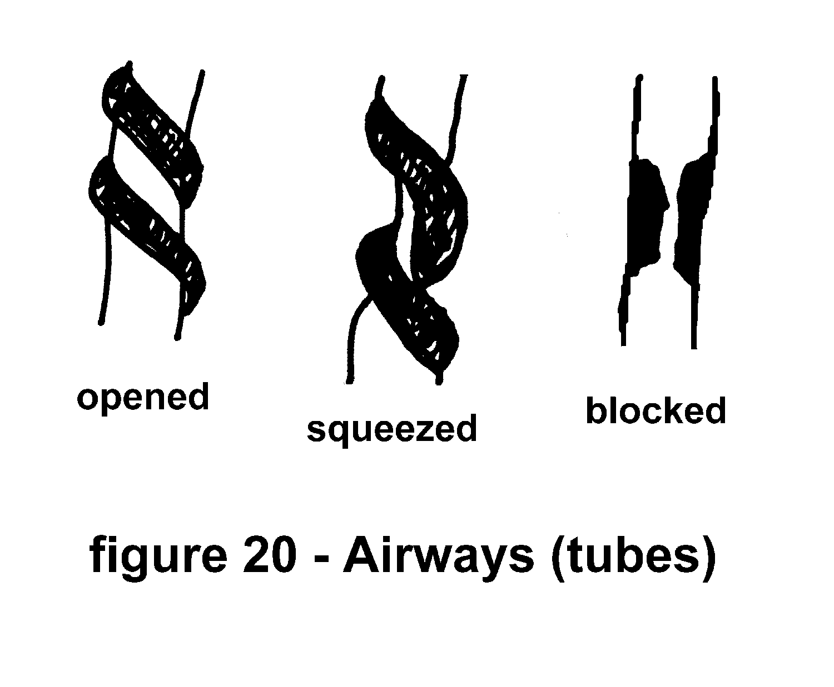

Obstruction or blockage of the airways sometimes leads to air trapping in the lungs. The air goes in easily but gets trapped inside the lungs. If you can imagine all the molecules of gas in the air as people in a crowded theater and a single door that opens inward as the obstructed airway, you may get a pretty good idea of how air-trapping happens. Every time the door swings open more people try to rush into the already crowded theater. As the people crowded on the inside push against the door they only prevent themselves from exiting.

A form of airway obstruction, perhaps a very common form is called asthma. Asthma is a condition that occurs whenever the muscles that surround the airways contract. This contraction causes the airways to narrow blocking free airflow. Unfortunately, the mechanisms of muscle contractions and tissue swellings that cause asthma are very complex. Fortunately, for some asthmatics there are medications called bronchodilators that relax these contracted muscles and open up the airways.

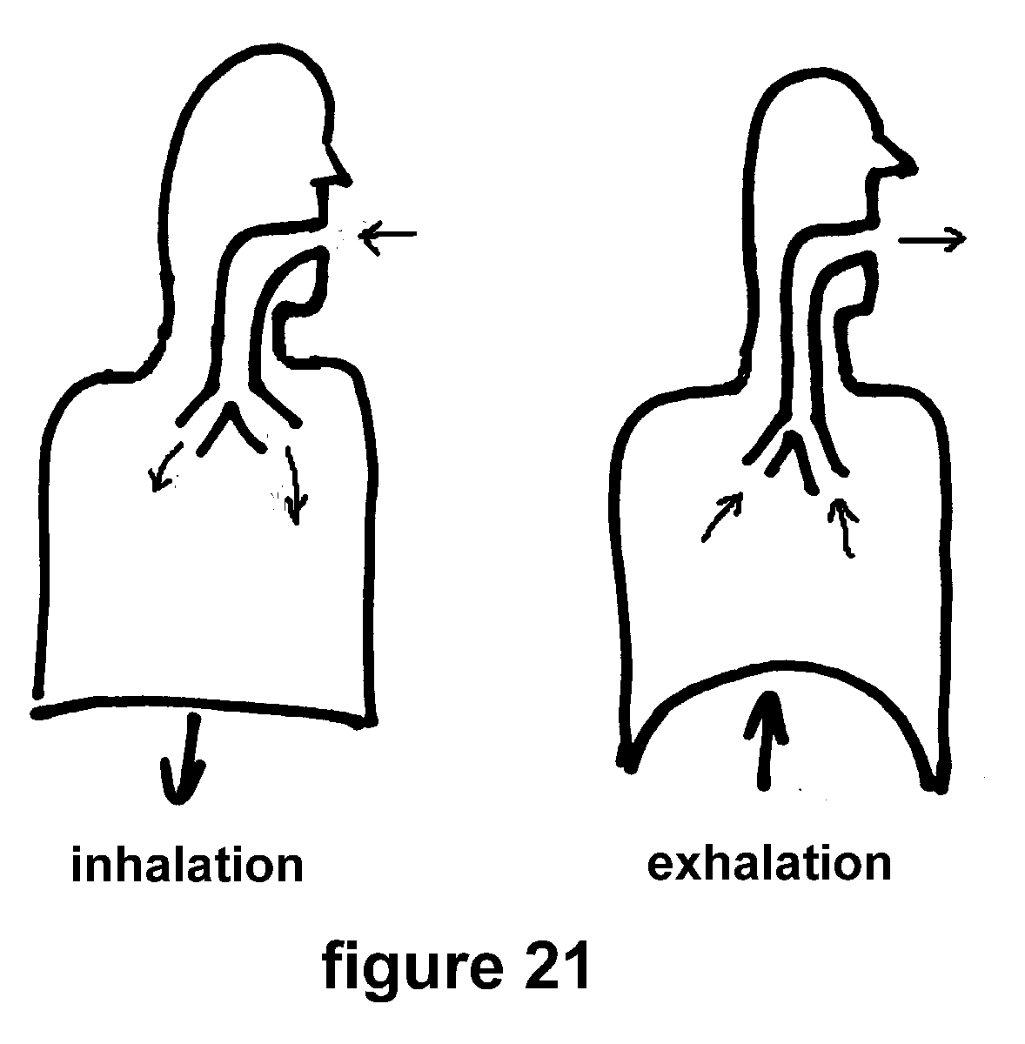

There are special cells surrounding the airways called mast cells. Each mast cell contains hundreds of tiny packets of enzymes. These enzymes are normally used for digesting dead cells and other debris that may accumulate in normal tissue. Some forms of asthma are caused by the release of these enzymes into the tissues of the lungs surrounding the airways. These enzymes cause swelling and muscle contraction and the airways become obstructed. We know that several substances found in cigarette smoke cause mast cells to dump their enzyme packets. Mast cells may also degranulate (dump their enzyme packets) in response to something to which you may be allergic. For example, if you are sensitive (allergic) to dog hair and you inhale some of the proteins in the dust from four friend's dog, you may have an "asthma attack". First, you are allergic to something like dog hair. Then, you inhale a tiny bit of that stuff. Later your mast cells react by dumping their enzymes.

This in turn causes the muscles around your airways to contract. That with the local tissue swelling blocks airflow and makes you "wheeze" while you try to catch your breath.

If you are adventurous and would like to experience something similar to asthma (without the dangerous clinical effects, of course) here is an experiment for you. Find a fat soda straw. This straw should be about a quarter of an inch in diameter. Hold the straw in your mouth, as you would hold a cigarette. Now, hold your nose and breathe only through the straw.

Let me explain to you what will probably happen. First, you will find that it takes longer to get a breath in or out. This is due to the obstruction (narrowing) caused by the straw. You may try adjusting your normal breathing pattern to accommodate this obstruction. You may breathe slower and deeper or maybe with faster and shallower breaths. But after a few minutes you will take the straw from your mouth and heave a sigh of relief. As you do this, remember the asthmatic cannot remove the obstructed airways from his lungs so easily and must suffer with his ailment.

To help with the diagnosis of lung diseases, such as asthma, doctors use information from pulmonary function tests. A test similar to the one we performed at the end of Session III is used to diagnose the problem. The patient takes in a deep breath and then blows it all the way out, hard and fast. This is all recorded on special equipment. The airflow in the asthmatic airways is reduced. Therefore, we see a reduction in the vertical (flow) aspect of our flow-volume loop graph.

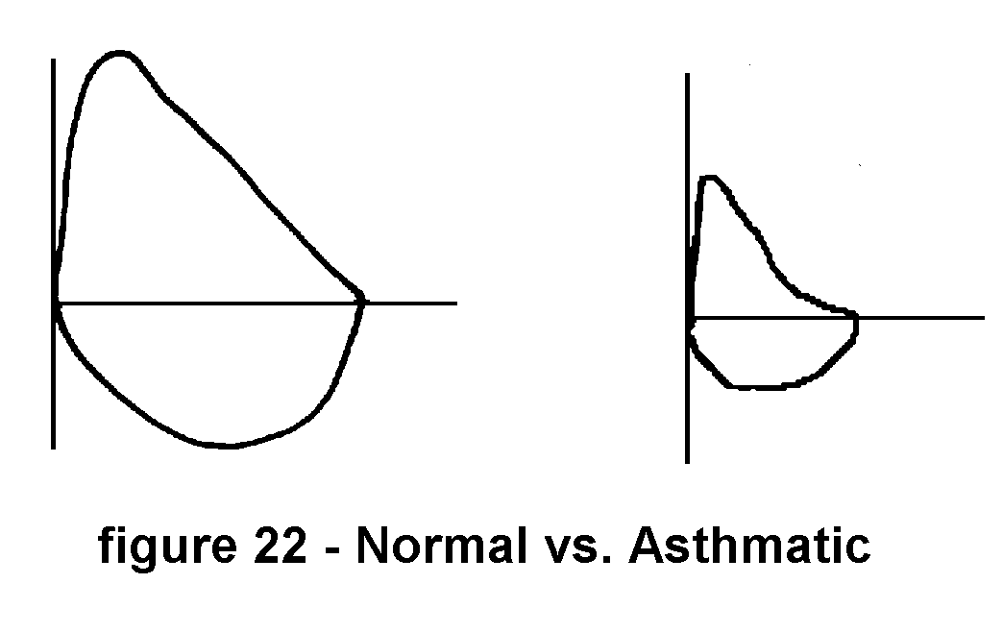Note the "bowing" down on the asthmatic (obstructive) loop. This bowing is characteristic of airway obstruction. It is also seen in the lung function test results of smokers.

RESTRICTIVE LUNG DISEASE

A restrictive lung disease is any disorder that limits (restricts) the volume of air in the lungs. This means that as you breathe, you are not able to take in or blow out as much air as would normally be expected. Usually, we see a reduction in the dynamic volumes. These are the volumes of air moving in and out of your lungs.

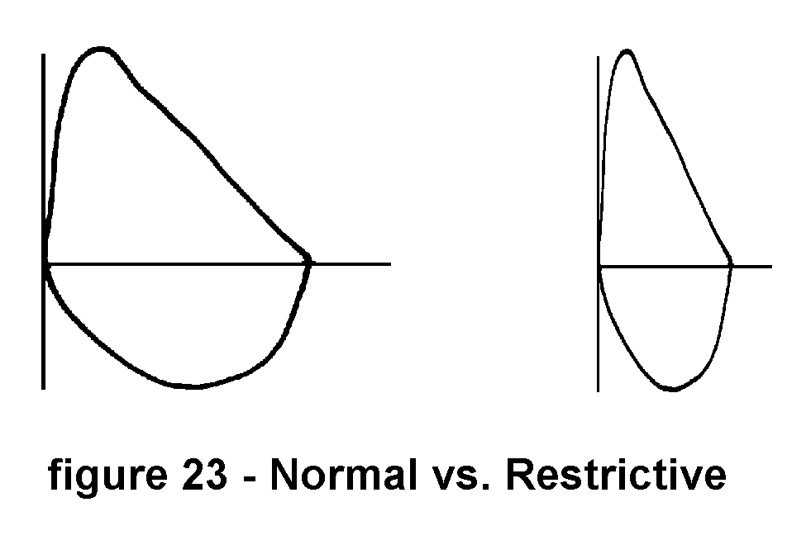

In SESSION I we discussed several processes that may lead to restrictive diseases. One of these involved the inhalation of dusts and fine particles of things such as coal, cotton, and asbestos. As these dusts are inhaled most of the particles are trapped by the hairs in your nose and thus prevented from entering your lungs. Some very tiny particles make their way passed these hairs and into the airways. There they are trapped on the sticky surface of the mucous lining. If these very tiny particles are not purged from the airways they will settle out on the surface of the cells lining the airways. Tiny particles usually are carried up and out of the lungs by the action of the tiny hair-like cilia inside the airways. However, sometimes due to poisoning by cigarette smoke or the immense bulk of the inhaled dusts or many other disorders; these particles find their way to the cell surface. Once upon the surface of the epithelial cells the particles work their way into the very tissue of the lungs. The lung tissue begins to acquire the physical characteristics of the inhaled substance. Slowly, the lungs of the coal miner because he inhales great quantities of coal dust during his work, become more like coal than soft supple lung tissue. The common name for this restrictive disease is coal miner's lung. Sometimes it is called the black lung. Almost every industry that exposes its workers to plumes of dusts has an associated restrictive lung disease. Glassblowers get glassblower's lung, silicosis. Farmers may contract farmer's lung. Asbestos workers develop asbestosis. Sugar cane cutters fall prey to bagassatosis (bagasse is the native term for sugar cane.)

Sometimes a disease process will leave scars within the lungs. this scar tissue is not as soft as the original lung tissue. Thus, the formation of scarring within the lungs also leads to the development of a restrictive disease. the presence of fibrous scarring in the lungs is called fibrosis.

As with many lung diseases the use of spirometry aids the physician with making a diagnosis. Above we see a comparison of a normal flow-volume loop with the same maneuver performed by a patient with a restrictive disease. Note that the volumes are reduced for the restrictive patient. Turn the pages back to the similar comparison of the normal spirometry and the asthmatic. Compare the asthmatic (obstructive) curve with that of the restrictive curve.

If you are curious about what it might feel like to have a restrictive lung disorder, here is an experiment for you. Use an ordinary waist belt. Place it around your chest. Exhale and pull the belt tight around your chest. You have now created a restrictive breathing disorder. This restrictive disorder is easily reversible by removing the belt from your chest. But while it is on your chest and pulled tight, you will experience the sensation of not being able to take in a deep breath. Your chest wall will be prevented by the belt from expanding freely as it would normally do while you are breathing. Please do this with someone else in the room, just in case you get the belt stuck.

EMPHYSEMA

Emphysema is a lung disorder that involves the actual breakdown of lung tissue. An emphysematory disease is the result of the lung tissue breaking down and literally being digested by the surrounding tissue. Look at the next picture of a microscopic slide of normal lung tissue and lung tissue from the lungs of someone with emphysema.

There is a tremendous amount of scientific research being conducted to find the exact cause of emphysema. So far we know that many different factors can cause emphysema. Smoking is highest on the list of causes. The smoke that is inhaled into the lungs reacts with the lung tissue probably through the formation of some acid and kills the delicate cells of the lung. The elastic substance, called elastin, within your lungs is required to keep them soft and stretchy so they may expand and contract as you breathe. Elastin is a form of connective tissue in the body. Substances in cigarette smoke and substances released by dying cells killed by smoke destroy the elastin in the lungs. The body uses special enzymes and a form of the trace mineral copper to try to rebuild the damaged elastin. However, if the delicate lung surfaces continue to be exposed to smoke the elastin continues to degrade. This process leads to emphysema.

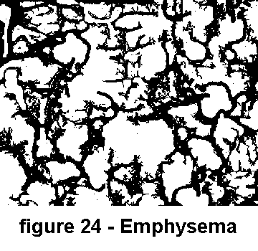

How does this effect our breathing? Let's use an ordinary kitchen sponge to demonstrate the effects of emphysema on the lungs. Take an ordinary kitchen sponge and dip it in a pan of water. Lift the sponge from the pan and feel the weight of the water picked up by the sponge. Wring out the water in the sponge into a glass or measuring cup. This is the amount of water that your normal sponge will hold. Now let's create an emphysematory disorder in our sponge. Using a small sharp knife (please handle the knife carefully) stab the sponge. This will cut some of the connective fibers in the sponge. Now continue stabbing the sponge with the knife. If you stab the sponge about three hundred (300) times you will be able to see a change in its structure.

Dip the punctured sponge in a pan of water. Lift the sponge from the water by one corner. Notice that the sponge does not hold the water like before. Now squeeze the water out of the sponge into an empty glass or measuring cup. Compare the amount of water held by the normal sponge and the sponge after its connective tissue was destroyed. The normal sponge held more water. Which sponge is larger? The cut sponge looks larger, but it actually holds less water.

A similar thing happens in the lungs of a smoker. Each molecule of acid that is inhaled or each molecule of digestive enzyme that is released by a damaged cell is the same as a tiny stab from a sharp knife. After millions of these tiny cuts the lung tissue begins to show the effects. Even though the lungs seem to get bigger, they actually become less useful for gas exchange.

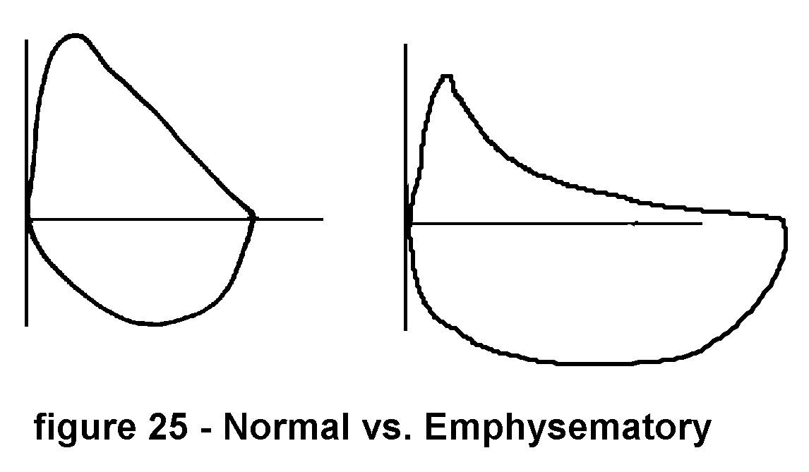

Look at the spirometry of a patient with emphysema compared with normal spirometry. We see that the volume of air is increased, while the airflow is obstructed.

These three descriptions -- restrictive, obstructive and emphysematory are actually categories of disease. They are not precisely the disease entities or causative agents. They are more closely akin to processes. These categories are used to describe the effects of some diseases so that they may be easily understood.

Infections within the lungs are common forms of lung diseases. Infections are caused by the invasion of some foreign organism into the lung tissue. The cells that make up the lung tissue form an ideal incubator for bacteria. Within the lungs it is dark, it is moist, it is warm, and all the nutrients that a germ might need are to be found in the surrounding cells.

Bacteria are tiny one cell plants. They are also closely akin to single cell animals. They can work their way down into the airways in just the same manner that dust particles enter the airways. Normally an inhaled bacterium would ride into the airways on a tiny droplet of water or speck of dust. If the mucous and cilia lining the airways are working properly the bacteria and dust will be carried up and out of the airways. But if the cilia are compromised by smoking or poor diet, then the germs are given a little more time than normal within the lungs. This extra time is used by the germs to multiply. Bacteria multiply so fast that within a few hours they can more than double their number. Within a day or two there are thousands and then millions of germs eating and making waste (toxins, poisons) within the lungs. They invade the cells of the lungs. This invasion alters the normal function of the lungs. As the bacteria or germs grow, the normal lung tissue tries to fight back. The body sends in white blood cells to combat the infection. This whole battle of bacteria and body causes the lung tissue to swell. We call this condition pneumonia.

Pneumonias may be caused by things other than bacteria. Viruses also may cause a pneumonia. A type of virus commonly called a Flu virus may be known to you. Flu is short for influenza. Certain fungii may also cause a pneumonia. Even small parasites and chemicals can cause a pneumonia. Anything that can be inhaled and cause some reaction with the lung tissue is capable of causing a pneumonia.

Whereas, a pneumonia is a swelling of lung tissue, bronchitis is a swelling or partial blockage of the bronchii. The bronchii are the tubes (airways) that direct the air we breathe to the lung tissue. Usually, a bronchitis is caused by the same sort of agents that may be responsible for causing a pneumonia. There is one form of bronchitis, chronic bronchitis, that is responsible for what is known as the "smoker's cough". A small infection or irritation causes the cells lining the airways to swell. This swelling and several other problems cause the cilia to quit working. Some of the cells will die. Mucous begins to accumulate. If this weren't enough problems the goblet cells begin to make extra mucous to help clean all the debris out off the airway. The swollen cells, the dead cells, the extra mucous, and the lack of adequate ciliary motion all contribute to the blockage of airflow in the bronchii. These pockets of infection within the bronchii are ideal places for bacteria to thrive.

At night while the smoker is sleeping (and presumably not smoking) some of the cells recover a little bit. Some of the cilia begin to work as they should. Mucous begins to move up and out of the airway. In the morning this accumulated mucous has made it all the way to the large airways, as it should. Special fluid sensors at the junctions of the large airways trigger a cough in response to this fluid mucous moving over them. Upon awaking the smoker begins coughing, sometimes uncontrollably , until the airways are cleared. Then the disaster occurs. The smoker lights up a morning cigarette to suppress the coughing and begins to poison the cilia and airways all over again. Breathing becomes a vicious cycle of smoke, swelling, mucous, germs, infections, over and over again.

Lung cancer is a name given to several types of diseased cells growing within the lungs. (For a more complete description of cancer development reread SESSION III.) Normal cells grow at a modest rate and repair minor damages to themselves. Cancer cells have wild irregular growth patterns. They produce useless or even harmful tissue. Cancers often deprive normal cells and tissues of nutrients. They displace normal cells and if allowed to run their course, cancers will displace and destroy normal cells. Cancers oftimes will spread to other areas of the body. Whenever a cancerous growth invades the airways it will block normal airflow and effect normal breathing.

Although no one has developed a complete explanation about the causes of cancers, we know that they are linked to various substances and poisons. The breakdown of normal DNA within the cells of our lungs is one of the first steps toward the development of a cancer. This disruption of DNA has been shown to be caused by ionizing radiation. X-rays, Gamma rays, and Alpha particles are forms of radiation that can cause cancer. Tobacco plants and the smoke from tobacco contain a source of Alpha particles. If enough smoke particles settle within the lungs the Alpha radiation effects the surrounding cells and can cause cancers to develop. Various toxic chemicals also have been linked to cancer. The smoke from a cigarette contains many chemicals known to produce cancers. These chemicals once inhaled begin by poisoning the normal function of the small cells within the lungs. If the level of poisons is high enough to damage some cells but not high enough to kill them, these cells may mutate into cancerous cells.

The effect of lung cancer is disastrous. Cancer, dependent upon the type of cancer, within the lung alters your ability to breathe properly. If the cancer growth blocks blood flow or airflow your lungs will not be able to exchange fresh air for waste gases. If the cancer changes the consistency of your lung tissue, the mechanical properties of the lungs will also change. Normally soft pliant tissue may become thick as glue. breathing becomes impossible under these conditions.

**Smoking is a learned behavior.**

**No one is born with the instinctive ability to smoke.**

**Thus, if you can learn to smoke**

**you can be retaught and learn not to smoke.**

HABITUAL BEHAVIOR

Why do people start smoking?

Many studies have been performed to uncover the key to habitual behavior. We know many things about the effects of habits, good and bad. Most of us tend to ignore or discount our good habits. For instance, it is a good habit to brush your teeth, regularly. It is a good habit to look both ways before crossing a street. The list of good habits can go on and on. Let us assume that all our good habits are worthwhile. Each time we brush our teeth or look both ways before crossing a street we are helping ourselves. We should not worry about our good habits. Our attention and concern will be focused on our bad habits. We will try to understand and change those habits that seem to be detrimental to us. Overeating, drinking too much (alcohol), smoking, biting our nails and dozens of other habits lead to unwanted results.

Let's examine some of the factors that contribute to the start of habitual behavior, smoking in particular. Why do people start smoking? Certainly not for the immediate reward of flavor or taste. Inhaled cigarette smoke has an almost repulsive effect on the nonsmoker. Do you remember the taste and effect of your first attempts at smoking? You, like almost everyone else who ever tasted tobacco smoke for the first time, probably coughed and gagged. If you were determined to master this habit and continued to smoke after that first warning, you were probably ill that evening. All of that is the normal response of the body to inhaled tobacco smoke.

If it's so noxious to us , why do so many people continue to smoke? This is where the concept of habituation comes into play. Your body becomes adjusted to the smell, taste, and pungent effects of the smoke. To the smoker of many years, smoke has a different effect upon his system than to the newcomer.

Certainly, many people start smoking simply out of initial experimentation. Children and adolescents observe adults smoking cigarettes and decide that they are going to try some of this "adult" behavior. Along with early experimentation we find a certain amount of social status attached to smoking behavior. This status need not be based upon any logic. It is enough that children see some adults smoking and some adults not smoking for them to make comparisons. The "tough guys" smoke, The "men" smoke, The "hip" smoke, and so on. All of these images are of course false and just the results of billions of dollars dedicated to the sale of tobacco and its products. Tough guys do not smoke. Ask any Olympic athlete, ask any professional fighter, ask any astronaut, in fact ask anybody in any profession or sport that requires strength, and mental fortitude. We see very quickly that whatever definition we find to describe smokers (sophisticated, for example), doesn't really match the reality of our world. Sophisticated people simply don't smoke. On the other hand people who think they are sophisticated might smoke. But that in itself does not make them sophisticated.

There are many factors that may influence a person to begin smoking cigarettes. Family habits and home life are near the top of this list. A child growing in a home wherein all the adults are smokers, will take it for granted that smoking is acceptable behavior. He may even envision himself in the future as being a smoker. For this child or young adult smoking cigarettes may be as natural in his mind as sitting down for an evening meal.

I must insert this important point. WE LEARN BY DOING. We may observe something for a long time. But in the end, we must do it if we wish to learn how to do it. We learn to smoke by trying it time and time again. You can learn not to smoke by practicing not smoking over and over again.

Outside of the immediate home there are many social factors that may contribute to the beginning of a smoking habit. The society within which we live often provides many examples of behavior to us. If most of your friends and associates are smoking, you may believe that smoking is acceptable. Please be aware that under these conditions smoking may be socially acceptable but biologically unacceptable. It will remain unhealthy no matter how many people do it. Unfortunately, most of us are not staunch individualists. If "everyone" is doing it, "we" are probably going to do it too. You, however, must decide what is good for you and you alone. Most people are not mature enough to make such a decision at the adolescent age at which this decision must be made. We are simply too young to know that most of the adults who we are watching may be doing something unhealthy. The fact that you are now reading this book is evidence that you are now mature enough to critically evaluate your situation with respect to smoking or not smoking. At this stage in your life you may also understand the pervasive nature and effect our culture has upon any individual.

The next factor to influence the beginning of a smoking habit is within the individual. This factor is your personality. Who you are, who you really are will be a tremendous influence upon your behavior. If you, even at an early age, are a free-thinker you may not be tempted to try even one cigarette. Likewise, if you can not imagine yourself with a lit cigarette in your mouth, you probably won't start smoking. On the other hand if you are self-destructive smoking may be just the activity you need to hurt yourself. Each of us has a slightly different personality from our neighbor.

Akin to our personality (the way we see ourselves) is our persona (the way we think others see us). Sometimes these two get confused with each other. The persona is sometimes called the mask we wear whenever we are with other people. It is our image. If you see yourself as a movie star type person and that movie star is always smoking, you may be smoking too. If you want to be seen as the picture of health, you probably won't be seen with a cigarette.

All these factors -- home, society, culture, personality, and persona influence the initial decision to begin smoking tobacco.

Aside from all these influencing factors, some of us may be born with a predisposition to smoking behavior. This doesn't mean you are born to smoke. It means that your body's chemistry may favor smoking, much like some people's chemistry favors alcoholism. Another example of a predisposition is overeating and its link to heart disease. If you overeat, you will become obese. If you are obese, your heart will be overworked. If your heart is overworked, you will tend to develop heart disease. This is a simple example of how a predisposition to eat too much can lead to heart disease. Everything you do in life walks hand in hand with who you are and how you live your life.

If any of the above reasons explain why we start smoking, they don't always explain why we keep smoking. This is the aspect of habitual behavior that is hard to pin down. In the next few paragraphs, I will describe some of the systems operating within us that maintain our habits and suggest ways of altering habits to our benefit. But before that we should look at some of the reasons we continue to smoke cigarettes.

Once smoking behavior has been learned, just as any learned behavior, it may be used to achieve many different goals. Each person may use his smoking habit to accomplish different tasks. Here are some examples:

Sally works in a cloud of dense pungent smoke. This smoke screen is so thick that many people avoid coming near her. This is a great advantage at her job. It keeps down the number of interruptions every day, so she may concentrate on her work.

John never smokes alone. But if someone comes up to him and begins a conversation, John pauses and lights up. He doesn't answer or speak until he's gone through what appears to be an almost ritual lighting and first drag of a cigarette. John uses his smoking habit to effectively "buy a little time" before he has to confront anyone.

Mary is a bossy person. She uses her smoking habit to act in an authoritative manner. "Give me a light.", "Go get an ashtray for me.", and many other outright commands can be heard from her. She has found a way, through her smoking habit, to boss people around in an almost socially acceptable manner.

There are many aspects of our personality that we seem to ignore or hide, so we do not see them. In the examples above, Sally doesn't want to tell people to leave her alone, John doesn't want to show others that he needs a few moments to gather his thoughts before he confronts anyone, and Mary certainly doesn't want to run the risk of people thinking that she is just a bossy person. These people haven't developed their personalities to the point where they can accept who they are and present who they are to others. They are hiding part of themselves behind a "smoke screen".

Any habit may be turned to good use. We all use whatever tools are available to us to get through our days. Some of us are more efficient than others. Some of us "make do" with what we've got. Some of us use smoking and all its related behavior to help us deal with our lives and our interaction with other people. The problem with that is that the personal price you must pay, in the form of poor health and lung disease, is never compensated by the small goals you may achieve.

By taking a big step and reading this book, you have decided that there are perhaps better ways to deal with some of the tasks you must face in your life. There are indeed many ways to do the same thing. Some ways are better than others. Our goal is to eliminate cigarette smoking and still be able to accomplish all those little tasks.

There is a misunderstanding of words involving smokers. Many people, smokers included, believe that smokers are weak or have weak personalities because they smoke. Smokers are actually quite strong in this sense. Strange as this appears, their strength is expressed through their smoking habit. Even if they themselves claim to be weak because they smoke, against all the opposition (loved ones, relatives, friends, doctors, scientists, etc. all telling them to quit) they continue to smoke. That alone requires strength. We are going to use that same inner strength to stop smoking. As a smoker your goal should be to express that strength by not smoking.

Part of your brain, indeed perhaps the most primitive part, controls or influences most of your routine behavior. It is a system of nerve bundles, called the limbic system. It is sometimes called, the lizard brain, because animals such as lizards have similar type structures in their brains. The limbic system of our brain probably developed with the lizards along the evolutionary path toward modern man. The limbic system provides behavior modification for our most basic and daily needs.

Our daily eating habits are regulated by the limbic system. It provides some of the signals that tell us when to eat. Some people have established the habit of eating three times each day. If they skip a meal, they will feel hungry. Even if they've consumed a full day's food supply at their previous two meals, they will still feel hungry. Their limbic system is pushing them to eat some more food. The limbic system also controls emotions. It will make these hungry people very irritable, if they do not eat on the schedule that they've established.

Because the limbic system controls, or at least influences, our emotions, you can bet that it influences our sexual behavior. Remember, food and reproduction are at the top of the list of our basic needs. We'll discuss this topic a little later when we tie all of this habitual behavior and the limbic system together in a manner we may use to our advantage.

Sleep and rest periods are also influenced by the limbic system. Just consider the regular pattern of your sleep behavior. How do you feel, other than being tired, whenever you've lost some sleep?

Your limbic system is at work, constantly, trying to get you to do the same things you've done before. You might wonder, if the limbic system is pushing me to do the same things over and over, how will I ever quit smoking? The answer is, to use the limbic system to establish new daily habits. Slowly at first, and then wholeheartedly, we will teach our limbic system to push us in the right direction. Once you've got such a powerful nerve system structure on your side, you will find the task of not smoking as easy as eating

Another aspect of the limbic system we should consider is its dependence upon your sense of smell. The sense of smell is the only sense that has nerve endings that go directly to the limbic system. Basically, the only sense of the outside world that the limbic system has is through the nose. Our emotions, controlled by the limbic system, are strongly influenced by our sense of smell. Perfume makers have known this for years. A perfume that smells good may cause just the right state of mind. The smell of good food makes us hungry. A walk through a leafy garden out in the fresh air puts us in a peaceful frame of mind. Crowd a lot of men into a smelly locker room and many of they will begin to behave aggressively. Our sense of smell is tied directly to our emotional status.

Smoke from tobacco dulls the sense of smell. If the sense of smell is dulled so is your emotional response to your surroundings dulled. As you reduce your exposure to smoke, you will again begin to experience wonderful emotional responses to things and events around you.

Here's how you may use your limbic system to help you quit smoking. The limbic system likes to keep every day the same as the day before. But it is not a "reasoning" structure of our brain. It seems to remember what yesterday was like and provides emotions and feelings to direct us to do the same things we did yesterday. If instead of smoking you reward yourself with something you like, the limbic system will after a few weeks want you to not smoke. If you give up that "one last" cigarette before going to sleep, you will find after awhile that you would rather go to sleep than smoke that cigarette. Just as you slowly conditioned your body, lungs, and nose to the effects of smoke, you can recondition your system to fresh air and other healthful activities.

Always reward yourself for doing something good. Always reward yourself in a positive way. Progress is sometimes very slow. But you must remember that it took you many years to carry on your smoking habit, it will take awhile to develop healthy habits.

Let's turn our attention to exercise and consider walking as a daily exercise.

WALKING

What does walking do for you? How to walk? When to walk? Where to walk? ...accept no substitutes...PRACTICE, PRACTICE, PRACTICE!

I refer to this section as "WALKING" because the idea of exercise means different things to different people. However, whenever I say "walking" most people understand the meaning of this term.

What does walking do for you? I've always admired that certain glow of youth in the manner of some very old people. It seems to me that some people grow old in body and spirit and others only appear to be old yet their bodies are active and their minds and spirits are sharp as can be. After years of watching old people, I think I've found one of the things that distinguishes the man or woman who is pushed by time and ill health to their death and those individuals who wake each day with spring in their steps to greet every possible enjoyment life has to offer for them.

These people who seem forever young, despite their many years, have a common activity. They walk. Not just walking around the house or walking to the corner store. They walk around the neighborhood, sometimes for miles as a matter of their daily routine.

Walking, it seems, is a natural exercise that requires a minimum amount of strength. Yet, walking bestows a maximum amount of benefit upon the person who walks in addition to his daily routine. The body and mind of the person who walks are aided in many ways.

(a) Major muscle groups are worked rhythmically and slowly develop strength and endurance.

(b) Balance and coordination are improved.

(c) The body's tolerance for work is increased.

(d) Exercise releases adrenaline, the body's natural stimulant.

(e) Your heart and lungs will be toned.

(f) As a consequence of the above, blood pressure will be lowered.

(g) You will lose excess weight.

(h) Circulating cholesterol and triglyceride compounds, implicated in coronary disease, will be reduced.

(i) You will develop psychological and physiological well being.

How to walk: Although most people know what walking is, they do not know how to walk in a manner that is most beneficial for them. Walking requires no special equipment. However, a comfortable pair of shoes is a definite asset. The walking that you would normally do in the course of your daily activity, no matter how many hours you spend on your feet, does not qualify as walking for exercise. Walking for exercise and the healthful benefits requires that you walk in addition to your normal activity at least fifteen (15) minutes each and every day. This extra 15 minutes of walking must be continuous. Walking back and forth over a short distance for 15 minutes is not sufficient. You must also walk every day. You must acquire the habit of walking each and every day. You will find, if you've walked each day for 15 minutes, after a week or so, you will require a further distance to fill your 15 minutes of time. This is so because you will be walking a little faster than you did before.

When to walk: Choose a time during the day that would ordinarily find you sitting and relaxing. This is the best time to walk. Although, everyone's situation is different, I can offer some suggestions and guidelines to aid you in beginning your walking program. Remember, you are going to be walking to help you quit smoking and to improve your general health for the rest of your life. Walk whenever you are tired. This may seem like an odd request. However, if you condition yourself to walk whenever you are tired you will feel very relaxed after your walk. You will also eliminate a major excuse for not walking, "I'm too tired". You'll never be too tired for anything again in your life.

You should walk every day at about the same time. The object is to not only walk but to establish a daily routine of mild exercise. Thus, if you walk each day and every day at about the same time, you will build up the habit of daily exercise. Incidentally, you should consider how well a habit, once established, is maintained. You will be exchanging your "bad" smoking habit for a "good" walking habit in part.

Where to walk: Choosing a path to walk is more important than most people realize. Examine your options before you begin. Are you planning to walk in the morning, at lunch-time, or in the evening? Where are you usually located at these times? Is there a park nearby? Is there a street with many shade trees? Is there a garden nearby? You should choose the course or path that you will follow so that you can easily make your walk longer. This will enable you to accommodate your steadily improving walking ability. The path you walk each day should pass by much plant life. trees, bushes, gardens, even plain grass acts to purify the air. Naturally, the air surrounding many plants will be cleaner than the air hovering over a busy street.

For this reason mankind has relaxed in gardens, whenever possible. The clean air of the garden has a quieting effect upon the body and mind. So walk along a path that brings you close to as many plants and trees as is possible.

Accept no substitutes: Once you have begun your daily walking routine, don't allow a day to go by without walking. Don't say to yourself, "well, I played tennis today. I'll use that as my exercise instead of walking."

You must walk in addition to regular daily activity and in any extra activity you may engage.

PRACTICE, PRACTICE, PRACTICE: Only through practice will you achieve a degree of skill that will allow you to stand out as a success among others. Often, we sit back and marvel at the skill of someone else, the strength of an athlete, the grace of a ballerina, the mind of a scientist, or the performance of an actor. Never forget that they can do whatever they do because they have spent many years practicing their craft. They may have started with a bit more natural ability or talent than the average man, but far and away the bulk of their skill is owed to practice, practice, practice.

If you falter, if you skip a day without walking, don't give up. Tell yourself to walk the next day and then do it. Each step is toward your benefit.

Remember the words of the ancient philosopher, Lao Tzu: "A journey of a thousand miles begins with a single step."

ACTIVITY

You have just quit smoking! For some readers this is premature. But if you've progressed through the course and text and have followed all the instructions and advice, if you have not already quit, you will certainly quit smoking. Keep up the good work.

This pat on the back is given to you because right about now you need it. Many of your classmates throughout these sessions have quit. You might start having doubts about your ability to quit. This is perhaps the hardest period for you to bear. I never said it would be easy. Too many people will give up on a hard task just as they are about to complete the hardest part of that task. If they only knew how easy it would be from here on, they would never give up trying. Right now you may be at such a "turning point". Evaluate your progress carefully. Reward yourself for a job well done so far. After you've patted yourself on the back for the good job you've been doing, take a deep breath and continue your practice and work toward your goal.

To evaluate the progress you've made toward quitting smoking cigarettes is a simple task. Collect the data from last weeks log sheets. Use either the daily log sheets (APPENDIX III) or the weekly summary sheet (APPENDIX VI) for this review. Compare the total number of cigarettes smoked in one week with the same total from the first week when you began to keep these records. Comparing the two numbers (cigarettes per week, then and now) will provide a real estimate of your progress.

Here's an example of how to interpret these data. If you were a two pack per day smoker (40 cigarettes/day) that's about two hundred eighty cigarettes in one week. If you've cut your habit to about one pack per day (20 cigarettes/day) that's now one hundred forty cigarettes in the last week. In this example, you've done the same task as quitting a one pack per day smoking habit. That's very good.

Don't ever say to yourself, but I'm still a smoker. Yes you are still smoking, but you've demonstrated that you can quit and that you have the tools and determination to quit. Always consider the positive aspect of your achievement. Everyone is different. Everyone learns and progresses at their own rate. If you've cut your cigarette consumption in half, you are more than halfway to being a nonsmoker. The same reasoning may be applied to even the most modest progress.

The evaluation of your progress should not only include the amount of cigarettes you've eliminated from your life but also an understanding of those tasks that have been hard to do. Use some of the insight into your own smoking habit that you have developed by reading this book and construct some useful steps (steps that apply specifically to you) to help you quit completely. Be creative. Construct other methods to eliminate or diminish the amount of cigarettes you now smoke.

If you are participating in one of the classroom sessions, you will be exchanging and discussing your ideas and progress report with other participants. Listen to their experiences and compare theirs to yours. How to we evaluate success? Share your success with others as well as any problems with cessation that you may be having.

Choose one day this week and quit "cold turkey". In the beginning of this program you attempted this. This time you are more prepared than before. Treat this attempt as a "one day only" trial. If you are able to quit for one day, continue to quit for the next "one day only". You may find that the succession of "one day only" days will indeed become a lifetime. Give it a try and work hard to make it successful.

Change your brand of cigarettes, again. Do not go back to the original brand that you were smoking. Choose a brand name or type of cigarette that you have absolutely no interest in to smoke. This may also help you with the above task of quitting cold turkey. If you don't like the cigarettes, why would you want to smoke them?

Another bit of advice is to smoke only "borrowed" cigarettes. Smoke only other people's cigarettes. i.e. only "grub" cigarettes. This has the effect of making you stop and explain your goal of quitting completely, yet your inability to do it just now. For most people, this will greatly limit the amount of cigarettes that they smoke.

Read APPENDIX II carefully. It is entitled "Helpful Hints". Try any of those hints that you feel will help you to quit smoking.

Continue to eliminate little needed cigarettes. In the past these have been those cigarettes that you have evaluated as #4 or #5 on your need scale. Now eliminate the #2 and #3 rated cigarettes. If you must continue to smoke, smoke only those cigarettes that are absolutely essential to your existence. I hope by now you can see that at some point you will realize that cigarettes, any and all cigarettes, are not essential to your existence.

Construct other methods to eliminate or diminish the amount of cigarettes you now smoke. Use the insight you've developed from reading this book.

REVIEW

Let's review what you should be doing each and every day:

1. Post and read two lists of reasons to quit.

You must read aloud your list of reasons to quit.

Don't fall into the habit of just glancing at these lists.

Read them aloud.

Think about what you are doing and why you are doing it.

Jot down any new reasons for quitting that might occur to you.

2. Keep a record of your smoking habit (record every cigarette.)

Do this faithfully. It should be second nature to you by this time. Oftimes just the commitment to jot down the information is enough to deter you from lighting up a cigarette.

For each and every cigarette "write before you light."

3. Exercise regularly every day (15 minutes of walking)

4. Drink lots of water or juice

5. Deep breathing (three times a day)

6. Two hour abstinence (change brands)

7. Eliminate all the cigarettes you least need. (#2, #3, #4 and #5)

If you haven't begun any of these, begin doing it today! Remember, this plan will work only if you follow it, faithfully. Now is the time to go back to the earlier sessions and reread any portion that you might have skipped. Do not give up your task to quit smoking. Just pick up wherever you've stopped participating and follow the instructions.

SESSION VI

LECTURE -

Breathing exercises

Learned behavior/Behavior modification

Other cessation methods

Most people breathe without thinking about their breathing. However, if some stress is encountered, we become aware of our breathing. For example, if you were to walk up a few too many steps, you would begin to notice your breathing. You might even become "short of breath" or your breathing may be a bit faster and deeper than is usual. This is the normal response to physical stress or exercise.

An infant breathes through his nose. By the time we are children we develop the ability to breath through the mouth as well as the nose. As we near adolescence, boys begin to rely almost completely upon their abdomen for breathing movement. Girls on the other hand rely upon lifting their chest a little more than moving their abdomen. No one is sure whether these differences in breathing patterns between males and females are genetic or social. It is important to also consider that these patterns are only small parts of a wide range of normal variations. Many men will breathe by moving their chests. Just as many women will breathe by moving their abdomens. There are no hard and fast rules for this, only a general trend. Whatever the reasons for selectively using only a few muscles for regular breathing, it should be obvious that humans do not use their complete breathing apparatus for everyday breathing. Basically, we settle into a pattern of use that becomes comfortable. This, however, may not be the most efficient way to breathe.

Let's do some exercises that might show us a little about our breathing.

HYPOVENTILATION (not enough breathing) : Sit comfortably in a chair at a table. Rest your hands (elbows and palms) on the table. Look at a clock that has a second hand or a digital watch that marks seconds and count the number of times you breathe in one minute. (Do not breathe fast or slow. Just relax and breathe normally.) The number of breaths that you normally breathe in one minute is called your respiratory rate.

To feel the effects of hypoventilation, slow down your breathing. Do not take deeper breaths. Just slow down your respiratory rate. Do not hold your breath. Just breathe as slow as you can without gasping for air.

As soon as you definitely feel uncomfortable go back to normal breathing. The discomfort that you've just experienced was due to hypoventilation. Without the proper amount of air flowing through your lungs every minute, carbon dioxide is not flushed from your blood quickly enough. The very slight buildup of carbon dioxide in your blood causes the discomfort that you've just experienced. A few minutes of normal breathing will return the carbon dioxide level in your blood to your normal value.

HYPERVENTILATION (too much breathing) : Sit comfortably in a chair at a table as you did in the above exercise. Rest your hands (elbows and palms) on the table.

To feel the effects of hyperventilation breathe as hard and as fast as you can. Within a very short period of time (usually less than a minute) you will feel the effects of hyperventilation. As soon as you feel a little "light headed" slow down your breathing and return to your normal respiratory rate. The feeling of "light headedness" you've just experienced was due to hyperventilation. With more than the proper amount of air flowing through your lungs every minute, carbon dioxide is flushed from your blood. This loss of carbon dioxide alters your blood chemistry to cause this "light headed" feeling. A few minutes of normal breathing will restore the carbon dioxide level in your blood to your normal value.

WHAT IS PROPER BREATHING?

The lungs are part of a very complex system. Many muscles may work in tandem or alone to pump air in and out of the lungs. Blood flow to sections of the lungs may not be uniform. Mucous secretions may alter airflow through the airways. Many factors determine how we breathe. It would be impossible to state that one way of breathing is the proper way of breathing. But we can state that some ways of breathing are more efficient than other ways of breathing. Thus, these more efficient methods may lead to better health.

Consider the purpose of breathing and the structure of the lungs. Millions of tiny air sacs are supposed to expand as they fill with air from an inhaled breath. This inhaled air mixes with the gases from your blood and then is exhaled as these little air sacs squeeze the air out through the airways and back to the atmosphere.

Obviously, only a very deep breath will fill all these alveoli (air sacs) with air. Usually, the average breath leaves some of the air sacs alone and uninvolved. Normally, we compensate for this by taking a deep breath, called a sigh, every few minutes. Most of the time you are not even aware that you have just taken a sigh or deep breath.

The major respiratory muscle is the diaphragm. Indeed this dome shaped muscle attached to your lower ribs may be called the respiratory muscle. All other muscles that may be used to assist breathing are called ancillary muscles.

As the diaphragm contracts, air flows into the lungs. As the diaphragm relaxes, air flows out of the lungs back to the atmosphere.

Although we have many muscles that can help with respiration, we tend to rely upon very few of them. Even for the normal individual, breathing does not usually involve all the muscles that are available for breathing. If we exercise the body a bit more than usual, we find that we recruit more muscles to help with breathing. If we were to analyze the breathing of a world-class sprinter during a race, we would find that almost all of his respiratory muscles are indeed used to help his breathing.

Put all this information together and we may be able to come up with a method that might be called "Proper Breathing." First, mind your posture. Always stand or sit with your head erect and your back straight but not stiff. This allows the lungs to expand in a normal manner and allows your abdomen to move freely. Second, practice yoga EXERCISE III described below to understand how air should flow into and out of the lungs filling as many air sacs as possible with each and every breath. Third, exercise (mild exercise) regularly to stress the muscles and recruit them to work together while breathing. This will develop a greater muscular reserve and ultimately make your work of breathing less by distributing the work over many muscles rather than relying upon only a few. Fourth, Take a few very deep breaths several times each day. You are probably sighing regularly now but not very deeply. By thinking about taking deep breaths you will be performing very effective sighs. Lastly, the most important aspect of proper breathing is to breath only clean air. Do not smoke while you are doing any exercises. Do not smoke while you are breathing.

YOGA FOR BREATHING

Hatha yoga is the practice of controlling the body and mind. Of utmost concern is the control of breathing. To accomplish control of the breath students of yoga first purify their bodies by exercising and eating moderately. Of the many exercises to purify the body and control the breath are three that I will describe below. These exercises are designed to strengthen the diaphragm and secondary muscles used for breathing.

EXERCISE I - Stand upright with your hands on your thighs in a semi-squatting position. Your knees should be slightly bent. As you breathe out, contract your abdominal muscles pushing the whole abdomen in and up. Then, immediately, relax these muscles completely. Do this contraction and rapid relaxation ten times. Stand up straight and relax. Rest until you are breathing easily. Repeat this as often as comfortably possible, slowly increasing the number of times you are able to do this maneuver each day. Do not force any exercise or stress your muscles much beyond their normal use. Daily practice and repetition will slowly and surely strengthen your muscles.

EXERCISE II - Is almost the reverse of the one above. Assume a relaxed position seated upright not leaning. After a relaxed inhalation, immediately, contract your abdominal muscles and pull in your lower rib cage to rapidly force out the exhalation. Repeat this relaxation and contraction ten times. Repeat this as often as comfortably possible, slowly increasing the number of times you are able to do this maneuver each day.

EXERCISE III - A proper yoga breath consists of three distinct phases. First, the abdomen is pushed out while air rushes into the lower lungs. Second, the lower ribs expand and the middle lobes of the lungs fill with air. Third, the upper chest is raised and the top of the lungs are filled. Exhalation is just the reverse of these three phases (e.g. 3,2,1).

There are many exercises and techniques to help develop the prandaramya (the pause between inhalation and exhalation or the cessation of inspiratory and expiratory movement) and control the breathing. Yoga exercises form a wide spectrum of effort and work. Some specific exercises can be very strenuous. Others are so mild that one does not feel as if any work is being done. Aside from the Hatha yoga mentioned above there is a simplified version called Sahaja yoga. The relaxation techniques and simple exercises of Sahaja yoga may be incorporated into any daily routine. Studies have reported remarkable improvement in the breathing of patients after a few months of regular Sahaja yoga practice. The practice of yoga exercises is usually part of the daily routine for many years. But the beneficial effects of any mild exercise may be felt after only a few months (and sometimes only a few weeks.)

There are many elementary and advanced texts that will explain in great detail the philosophy and practice of yoga. Any regular exercise that has as its goal the betterment of the body and mind will help you improve your general health and as such will also help you with the task of smoking cessation.

TAI CHI

Tai Chi Quan is a form of exercise practiced widely in China and lately found all around the world. There are several schools of Tai Chi. Each school advocates the basic exercise postures with slight variations from the other schools. Tai Chi is also a form of self-defense, a marshal art. Its benefit to the student derives primarily from the fact that it is a mild and slow form of exercise. Tai Chi exercises consist of several choreographed positions. By slowly and rhythmically progressing from one stance to the next, the student trains his muscles, controls his balance, and improves his breathing and health. Tai Chi does not require any rapid or strenuous movement. People of any age or physical condition may use Tai Chi. Watching someone practicing Tai Chi is like watching a slow graceful dance. Practicing Tai Chi is often called "playing your form." People of all ages are "playing their form" every morning, working toward a healthier life.

As you might expect, breathing is an important part of Tai Chi Quan. Inspiration and expiration are timed to match the various body positions. This enables many ancillary muscles to contribute to the exercise.

Although you may find several books about Tai Chi it may be hard to learn these exercises from books. The practice of Tai Chi is more like a dance in this respect. You may consider going to an instructor. Just as a good dance instructor can teach you by showing you the steps directly, a good Tai Chi instructor can show you the exercises and offer advice as to their performance.

OTHER CESSATION METHODS

If your progress toward cessation is slow or perhaps not as fast as you would like it to be, you may want to consider trying another technique for achieving your goals.

HYPNOSIS

Oftimes the word hypnosis conjures up images of a vaudeville act or a stage magician's performance. Hypnosis has received a large amount of coverage in the popular press. Unfortunately, most of this coverage has been to sell newspapers or magazines and not to explain anything about hypnosis or its uses.

Hypnosis is not magic or voodoo. It is a technique of suggestion that for many people yields remarkable results. It does not work with everyone. But for some, it is an ideal method of modifying behavior.

Choosing a hypnotist is like choosing any other professional. He or she should be a graduate of an appropriate school. I suggest that they have an advanced degree (Graduate School) in one of the behavioral sciences or medicine. He or she should be a member of a national organization of professional hypnotists. Activity in a local organization or chapter also bespeaks a certain amount of credibility.

Our mind and thoughts are complex entities. The exact working or operation of the mind is unknown. However, we do know that under certain conditions, the mind works in certain ways. Whenever you are excited, your mind works a little faster. If you are under the influence of an alcoholic drink, your thoughts run a little bit slower than normal. Hypnosis works to leave a very strong suggestion to action within your mind. It seems that whenever the body is relaxed so completely, as if to be almost asleep, yet attentive to someone's voice; the mind is open to suggestions. These suggestions made to you during a hypnotic sleep or trance, remain very powerful and will usually override conscious interference.

A typical hypnotic session might progress as follows: The hypnotist will explain the entire procedure to you and discuss your goals and attempts to quit smoking. He or she will answer any questions you might have about hypnosis and its ability to help you. You will be directed to a comfortable chair or couch and asked to relax. While you are relaxing the hypnotist will continue to talk to you. You will be told to relax further and giving relaxing exercises to perform to help you completely relax until you are almost asleep. The hypnotist will be talking to you throughout the entire procedure. You will not feel asleep only very relaxed. Hypnosis may work by allowing the conscious mind to become sleepy and less alert. Thus, the subconscious mind is permitted to record everything without any interpretation or blocking from the sleepy conscious mind. A post-hypnotic suggestion may be implanted into the subconscious mind by the hypnotist. An example of a post-hypnotic suggestion might be: "Whenever you light up a cigarette, you will feel nauseous and put the cigarette out."

Hypnosis may be just right for you or hypnosis may not work at all for you. Discuss this with your hypnotist and find out what sort of success he or she has had with smokers. Also you should consider the fact that everyone is an individual. We, each of us, respond differently to different situations. Some people respond very well to post-hypnotic suggestions, others seem to be completely unaffected by the entire process.

As was stated above in an earlier session, programs such as hypnosis are superimposed upon your habit. Whatever factors contributed to your smoking habit before your hypnosis will still exist after your hypnosis. Those personal needs that were satisfied by your smoking habit will still seek expression.

ACUPUNCTURE/ACUPRESSURE

Acupuncture therapy comes to us from ancient China. The philosophy and workings of acupuncture seem to be quite different from our western brand of medicine and treatment. The practice of acupuncture uses very thin needles to interrupt or augment the flow of nervous energy through parts of the body. The exact placement of the needles is performed by trained and skilled physicians. Oddly, acupuncture is a painless procedure. In this country we are just beginning to learn to use acupuncture to relieve pain, reduce appetites, and aid digestion. It's application to assisting smoking cessation is rather new. The placement of a few needles in specific acupuncture sites (usually in or about the ear) seems to eliminate the desire to smoke cigarettes. Acupressure is based upon the practice of acupuncture. The needles are replaced by massage and finger pressure applied to specific points to help redirect the flow of energy through the body. Both acupuncture and acupressure are relaxing procedures.

INDIVIDUAL COUNSELING

Many of us will need the help of someone else at some time in our normal life. The die-hard individualist is at a distinct disadvantage, if he refuses help from someone else when he really needs this help. To quit smoking requires a lot of hard work. This puts a strain on all of the systems of the body as well as the mind. Sometimes even the strongest person can benefit from the advice and caring of someone else. Often we just need someone to talk to and to tell us that all the things we are feeling are normal and all right. Or, if these troubles are not normal; we need a trained observer to tell us so and help us get back on track.

There are many sources for individual counseling for the person who is quitting smoking. Below are just a few of the individuals you may call upon to discuss your progress toward your goal of smoking cessation.

To start with, let's consider your friends and relatives. Friends and relatives have an advantage over other sources because they are usually available to us and are familiar with aspects of our personalities that most outsiders do not see. They also will render us help for free (in most cases). If you believe that your friends or relatives, owing to their own habits or temperament, would not be very helpful do not ask them to help you. You must find someone who you believe to be interested in helping you and no other motive.

At every level of government (city, county, state, federal) there are social agencies that will provide some form of social worker visitation. If you ask your local agency (a call or visit to city hall may put you on the right track.) you may find the address and phone number of the next bureaucratic level of help available to you. Social workers are trained and experienced in helping people from all social and economic backgrounds deal with their current life situations. In many instances a social worker may be able to visit you if for some reason you are unable to travel to their offices.

A psychologist may provide the insight you need to help you quit smoking. Psychologists are individuals who have studied psychology, usually on the graduate level. It should be apparent to you that the effects of smoking tobacco reach far beyond the physical effects of smoke in your mouth or lungs. There are also profound effects upon our thoughts and reasoning. Speaking with a psychologist may help you overcome any "hang-ups" or psychological problems that are contributing to your smoking habit.

Physicians should also be considered, if you need help quitting smoking. Medical doctors can advise you about the health effects of smoking. But beyond this many physicians are friendly caring individuals who would like to see you (for your own good) stop smoking. They can provide you with the necessary support you may need if you find your individual efforts to be inadequate.

GROUP SESSIONS

Some of us seek the support of a group whenever we dare to try something difficult. The support of a group can be a very important factor in helping you accomplish your goal of smoking cessation. If you are attending the classes and sessions of the SMOKING CESSATION CLINIC you are already a member of the group of people in your class. If you are reading this text on your own, you should consider joining or organizing a discussion group of similar readers.

Forming a study group or a group of people learning to quit smoking is not difficult. Usually, just spreading the idea to your friends and neighbors will produce a few people with a similar goal. A small ad in the "Personals" column or a letter to the Editor of your local newspaper may provide enough responses from people wanting to quit to form a small group.

No one in your group has to be an expert. No one has to be a leader. You need only to be willing to share your ideas and problems with the members of the group. They in turn will share their ideas and problems. From these exchanges solutions emerge. Sometimes a fresh or new point of view makes a difficult problem seem easy to solve.

Another source of people for your group is your church or local club. Although the people from a church or temple have gathered for religious purposes, they also attend for social reasons. Church groups not only share some ideology, they share a concern for members. See if your church or your neighbor's church has any help groups or clubs that might help you quit smoking. Often, these groups will sponsor such programs.

A call to the Public Relations Department of your local hospital may also provide some information about smoking cessation programs or groups in your area.

BEHAVIOR MODIFICATION

Behavior modification techniques emphasize replacing one behavior pattern for another. For example, instead of being drawn by the aroma of cigarette smoke to light up a cigarette, the smell of smoke may be made to seem offensive and repulse you from smoking. Here's a simple explanation of how this works: Let's consider a common human reaction. If, unexpectedly, someone gently threw a small beanbag at your head you would probably close your eyes, turn and duck your head, as soon as you saw the beanbag coming. However, this natural response can be modified with training to replace the closed eyes and turning head with catching the beanbag in your hand. If practiced enough the natural avoidance response can be replaced with a learned catching response. This is how we learn to play baseball and other catching games.

Can we apply this to learning how to quit smoking cigarettes? We can measure certain physiologic responses such as blood pressure, respiratory rate, sweat production, pulse, etc. that all change as we become tense. If you smoke to relieve tension (Remember the Psychological Questionnaire - APPENDIX I ?) you could, by monitoring these biologic signs, be forewarned that you were becoming tense. Knowing in advance that you were becoming tense would allow you to practice relaxation exercises (deep breathing, lying down, closing your eyes, thinking pleasant thoughts) to ward off the impending tension. Using such a technique is called biofeedback. Your naturally occurring biological signals are feed back to you to help you be aware of your own responses. If you can learn to avert the tension, you wont need the cigarette smoke to relieve tension.

Another form of behavior modification is called aversion therapy. This involves making something that was associated with smoking noxious to you. The aroma of tobacco smoke for instance may seem attractive and of course associated with your smoking habit. If you collected a lot of cigarette butts in a large wide mouthed jar, poured in about a cup of water and kept the jar capped tight, you would in a few days have a very concentrated source of tobacco aroma (The smell of the air in the jar is so concentrated that few would call it an aroma. It's more like a noxious odor.) Use this jar of wet cigarette butts in the following manner. Every time you want to light up a cigarette, open the jar and take a big whiff of the foul tobacco laden air. If the smell is offensive, you will slowly learn to associate the foul odor with cigarette smoking. Then your behavior would be modified so you will begin to avoid unpleasant experiences, such as smoking.

Aversion therapy has also been applied to cigarette smoking with the use of electric shocks. If this sounds like a drastic measure, I believe it is. Each time you pick up or light a cigarette you would receive an electric shock. These shocks are supposedly mild but firm. (This program should be undertaken only under medical supervision and controlled conditions.) The act of picking up a cigarette soon becomes associated with the unpleasantness of the electric shocks and you modify your behavior to avoid the shocks. This type of therapy is sometimes referred to as reward/punishment therapy. The electric shocks are of course the punishment.

A simple form of reward/punishment behavior modification involves making a bet. Make a bet with a friend that you will quit smoking on a specific date for a specific period. Whenever you quit, you will be rewarded by your winning the wager. If on the other hand you fail to quit, you will be punished by losing the wager. This technique is only effective if the wager is sufficiently high to satisfactually reward you or punitively punish you.

ACTIVITY -

In summary we've covered the following topics: Session I introduced the anatomy and physiology (structure and function) of your lungs. The branching airways must remain open and clear to permit air to flow all the way to the billions of microscopic air sacs that are the sites of gas exchange. The waste gas carbon dioxide is released from your blood while the fresh oxygen is taken up by the hemoglobin in your red blood cells. Smoke interferes with this process. Smoke destroys the delicate linings of the airways and airsacs as well as impairing the hemoglobin's ability to carry oxygen to your body tissues. The process of destruction is slow and insidious (remember the story about the clay tennis court). By the time you may feel the effects of the destruction of lung tissue, a great amount of damage has been done.

Session II explained about the components of tobacco smoke (Carbon Monoxide, Nicotine, and Tar). How a pack per day smoker inhales about nine pounds of smoke each year. In this session we also examined some of the reasons why you began smoking. You answered the psychological questionnaire (APPENDIX I) to see whether you smoked for stimulation, relaxation, relief of tension, just to handle something, out of craving or habit. Quitting cold turkey and the effects of withdrawal were discussed. We developed a plan of action to follow to help us quit smoking. First we made a list of personal reasons to quit and posted this list for daily review. Secondly you began to document your smoking habit. You wrote down the when, where, and why of each and every cigarette that you smoked. This was to help you quantify and understand your smoking habit in real objective terms. Now you also began a program of regular light exercise.

Session III discusses the formation of cancers, their treatment and their relationship to cigarette smoking. Perhaps one of the most important facts about lung cancer is that it is usually related to inhaled particles and chemical fumes. These are just the things found in cigarette smoke. Of course avoiding disease through smoking cessation is the easiest method to help reduce the incidence of cancer and other lung ailments. Short of prevention, surgery and chemotherapy are our major weapons for the treatment of cancers. Your vital capacity was measured or you performed a match test to give you some objective idea about the mechanical health of your lungs. Along with daily deep breathing you were to eliminate smoking for your peak two hours each day.

Session IV deals with explaining about how your heart and lungs work together as a team. The four chambers of the heart pump blood to the lungs for gas exchange and then to the body. The blood vessels fan out to become very fine capillary tubes to permit nutrients, gases, and wastes to flow back and forth between the blood and the body tissues. Anything that hinders lung function also effects the heart. Proper dietary requirements are also reviewed in this session. To prevent weight gain as you quit smoking, follow these simple rules: exercise daily, have regular meals, eat smaller portions, eat fewer sweets and fats, eat slowly, and stop all high calorie snacking. The activity for this session was twofold. First, we discussed some of the experiences and problems encountered by ourselves and others who abstained from smoking for two hours each day. Secondly, in addition to the already established two hours of abstinence, you began eliminating those minimally needed cigarettes from your daily routine. Many readers will have quit smoking completely at this point.

Session V talks about lung diseases. Lung diseases are classified in three mechanical categories. Obstructive disorders block the airflow in the airways. Asthma is an obstructive lung disease. Restrictive disorders limit the normal expansion of the lungs. Many occupational lung diseases, such as coal miner's lung and asbestosis are restrictive disorders. Emphysema is the actual breakdown of lung tissue causing disruption of airflow and bloodflow. Habitual behavior, particularly as it applies to smoking habits was reviewed. Factors such as home, society, culture, self- esteem and others all influence decisions to smoke as well as decisions not to smoke. Walking as a form of mild regular exercise is explained and encouraged. In addition to all your previous activities you were instructed to reduce your cigarette consumption further by eliminating those cigarettes you now least need.

Session VI presents breathing exercises and the idea of proper breathing. Other forms of exercise such as yoga and tai chi quan are explained. Other cessation methods and techniques are reviewed for those readers who may wish to pursue smoking cessation beyond this program. Hypnosis, acupuncture, individual counseling, group sessions and behavior modification are summarized.

REVIEW

Let's review what you should be doing each and every day:

1. Post and read two lists of reasons to quit

You must read aloud your list of reasons to quit.

Don't fall into the habit of just glancing at these lists. Read them aloud. Think about what you are doing and why you are doing it.

Jot down any new reasons for quitting that might occur to you.

2. Keep a record of your smoking habit (record every cigarette.)

Do this faithfully.

It should be second nature to you by this time.

Oftimes just the commitment to jot down the information is enough to deter you from lighting up a cigarette.

For each and every cigarette "write before you light."

3. Exercise regularly every day (15 minutes of walking)

4. Drink lots of water or juice

5. Deep breathing (three times a day)

6. Two hour abstinence (change brands)

7. Eliminate all the cigarettes you least need. (#2, #3, #4 and #5)

If you haven't begun any of these, begin doing it today! Remember, this plan will work only if you follow it, faithfully. Now is the time to go back to the earlier sessions and reread any portion that you might have skipped. Do not give up your task to quit smoking. Just pick up wherever you've stopped participating and follow the instructions.

DISTRIBUTE A LIST OF OTHER AREA PROGRAMS

If you are attending regular sessions of the SMOKING CESSATION CLINIC your instructor will be handing out a list of similar programs available to smokers in your area. To publish a comprehensive list of such programs in a book such as this would be impractical. However, this information is easily available to you. Many organizations and government agencies are committed to helping you quit smoking. They will provide amply amounts of information for you about programs located in your area. Many of these agencies also provide pamphlets, books, kits, films, etc. for your review.

Here is a list of organizations that have information about smoking cessation programs within your locale. These organizations are dedicated to helping you stop smoking. A call or card to their offices explaining your needs will result in more information than you thought available to you. From the list of national organizations, you will be directed to many local organizations.

FOR INFORMATION ABOUT SMOKING CESSATION CONTACT:

American Cancer Society, Inc.

1599 Clifton Rd NE

Atlanta, GA 30329-4251

(404)-320-3333

http://www.cancer.org

American Heart Association, Inc.

7272 Greenville Avenue

Dallas, TX 75231

(800)-242-8721

http://www.americanheart.org/

National Cancer Institute

Public Inquiries Office:

Building, 31, Room 10A31,

31 Center Drive, MSC 2580,

BETHESDA, MD 20892-2580 USA,

(301) 435-3848

http://www.nci.nih.gov/

General Conference of Seventh-Day Adventists

Health and Temperance Department

6840 Eastern Avenue, N.W.

Washington, DC 20012 (202) 722-6700

National Institute of Child Health and Human Development Department of Health and Human Services

Building 31, Room 2A-32

900 Rockville Pike

Bethesda, MD 20892

American Lung Association

1740 Broadway, 14th Floor,

New York, NY 10019

(212) 315-8700

http://lungusa.org/

Public Inquires

Office on Smoking and Health

Park Building, Room 1-58

5600 Fishers Lane

Rockville, MD 20857 (301) 443-1575 (301) 443-1690

Center for Health Promotion and Education

Centers for Disease Control

Building 3 1600 Clifton Road, N.E.

Atlanta, GA 30333

National Heart, Lung and Blood Institute

Smoking Education Program

9000 Rockville Pike

Building 31, 4A-21

Bethesda, MD 20892

There is a wonderful sourcebook published by the Department of Health. The title is, STATE AND LOCAL PROGRAMS ON SMOKING AND HEALTH A call or inquiry to your nearest Federal office may direct you to the nearest Government book store or printing office where you may order this book. You may also direct your request to:

United States Department of Health and Human Services

Public Health Service

Office on Smoking and Health

Stop 1-10 Park Building

5600 Fishers Lane

Rockville, MD 20857

This book lists by State and City about one thousand programs designed to help you quit smoking.

To find out what is commercially available in your area, you might also want to look in your local telephone directory yellow pages under the category of SMOKERS INFORMATION AND TREATMENT CENTERS.

QUITTING ON THE WEB

The rapid growth in the use of the World Wide Web (WWW) has changed the way we may access information. If you are using the Internet to gather information or help you quit smoking, please rely upon well-established sites. Many many small commercial and personal sites may tout methods and products that are ineffective and unscientific; they may even be harmful to you! I recommend searching sites established by the established medical community and government sources. Here are a few major sites to get you started in your search:

**SURGEONGENERAL.GOV** is a government site that offers a lot of sound medical and practical advice for smokers wishing to quit. They have a Consumer Guide entitled “You Can Quit Smoking” that offers a condensed encouragement to smokers and directs them to other resources which may prove helpful to you.

**LUNGUSA.ORG** is the site for the American Lung Association offers a wonderful program called Freedom From Smoking® Online: Smoking Cessation Support on the Web. In addition to an online 24-hour a day help line, this site contains many links to provide information about many lung diseases and health related topics.

**NIH.GOV** is the site for the National Institutes of Health. Although this is a huge site it does provide quick access to the many government programs and publications related to quitting smoking and health issues. If you have some idea of what you require, this is a good place to seek it out.

Certificate of Achievement

Marking the Completion

of the

SMOKING CESSATION CLINIC

Awarded to

__________________________________________________

For Considerable Effort and Dedication

to the task of returning to a

Natural State of Health

and concern

For Their Own Health and that of Others.

**APPENDIX I**

**PHYSIOLOGICAL QUESTIONNAIRE**

Self test for smokers - Why do you smoke ?

Here is a long list of things people say about their smoking. To help you better understand why you smoke, indicate to what degree each statement applies to you.

( 5 = often, 3 = sometimes, 1 = never)

Example:

| 5 | I buy my own cigarettes.

This means that you ‘often’ buy your own cigarettes. Important: The number (5,3,1) for your response must be in the column printed for that question.

(Fill in the number 5=often, 3=sometimes, 1=never within the brackets for each question)

**[ ]** 1. I smoke to keep from slowing down.

**[ ]** 2. Handling a cigarette is part of the enjoyment of smoking it.

**[ ]** 3. Part of the pleasure of smoking is lighting up.

**[ ]** 4. I light up whenever I feel angry about something.

**[ ]** 5. Smoking cigarettes is pleasant and relaxing.

**[ ]** 6. I smoke without being aware that I’m smoking.

**[ ]** 7. I like watching the smoke while I exhale.

**[ ]** 8. I sometimes strike a match or lighter and then realize that I forgot to take out a cigarette.

**[ ]** 9. If I run out of cigarettes, I can't stand it until I get some more.

**[ ]** 10. If I don't smoke, I get tired.

**[ ]** 11. I like holding a cigarette.

**[ ]** 12. A cigarette calms me down.

**[ ]** 13. I always keep plenty of cigarettes available.

**[ ]** 14. If I get pushed too far, I smoke to ease up.

**[ ]** 15. A cigarette feels good in my mouth.

**[ ]** 16. Sometimes I've just got to have a cigarette.

**[ ]** 17. I smoke to ease tension.

**[ ]** 18. I can do things faster if I'm smoking.

**[ ]**  19. I take nice deep breaths whenever I smoke.

**[ ]** 20. I like striking a match or working a lighter.

__________________________________

**[ ] [ ] [ ] [ ] [ ] [ ] Totals** for questions 1-20

A B C D E F

(Fill in the number 5=often, 3=sometimes, 1=never within the brackets for each question)

**[ ]** 21. Whenever I really need a cigarette, any brand will do.

**[ ]** 22. Whenever I'm upset, I like to have a smoke.

**[ ]** 23. I smoke to perk myself up.

**[ ]** 24. I hold my cigarette in my hand more than in my mouth.

**[ ]** 25. I get great pleasure out of smoking.

**[ ]**  26. I am very aware of the times that I am not smoking.

**[ ]** 27. I lit a cigarette and then noticed that I had one already burning in the ashtray.

**[ ]** 28. I smoke to ease my body.

**[ ]** 29. If I don't smoke, I worry about things.

**[ ]** 30. I like the feel of smoke going through my mouth.

**[ ]** 31. I feel queasy if I go without a cigarette too long.

**[ ]** 32. All of a sudden I find a cigarette in my hand so I light up.

**[ ]** 33. If I'm doing some work, I smoke whenever I take a break.

**[ ]** 34. In a tight situation, a cigarette is a relief.

**[ ]** 35. If I'm feeling down, a cigarette makes me feel better.

**[ ]** 36. If I don't have a cigarette in my hand, I feel uncomfortable.

**[ ]** 37. Sometimes I don't want to but I've just got to have a cigarette.

**[ ]** 38. I associate having a cigarette with doing certain things.

**[ ]** 39. A cigarette takes the edge off.

**[ ]** 40. If I feel worried or upset, it helps to smoke.

__________________________________

**[ ] [ ] [ ] [ ] [ ] [ ] Totals** for questions 21-40

A B C D E F

(Fill in the number 5=often, 3=sometimes, 1=never within the brackets for each question)

**[ ]** 41. I smoke to make myself more aware.

**[ ]** 42. I sometimes get shaky if I don't have a cigarette.

**[ ]** 43. I sometimes light the wrong end of the cigarette.

**[ ]** 44. I want a cigarette most whenever I feel relaxed.

**[ ]** 45. I don't worry so much whenever I smoke.

**[ ]** 46. I smoke to give myself a lift.

**[ ]** 47. I can blow smoke rings.

**[ ]** 48. I get a gnawing hunger for a cigarette, if I haven't smoked in awhile.

**[ ]** 49. I find a cigarette in my mouth. I don't remember putting it there.

**[ ]** 50. I could go to sleep while smoking.

**[ ]** 51. I'm a tense person, smoking relaxes me.

**[ ]** 52. If I'm sleepy, I smoke to stay awake.

**[ ]** 53. The first drag of smoke feels good.

**[ ]** 54. I sometimes take out more than one cigarette over a period of just a few minutes.

**[ ]** 55. I smoke during a quiet time.

**[ ]** 56. Whenever I'm mad, I smoke.

**[ ]** 57. I can make decisions faster if I'm smoking.

**[ ]** 58. I feel sick if I don't smoke.

**[ ]** 59. Looking at the ashtray, I can't remember all the cigarettes I've smoked.

**[ ]** 60. I'm more alert whenever I smoke.

__________________________________

**[ ] [ ] [ ] [ ] [ ] [ ] Totals** for questions 41-60

A B C D E F

Now that you have answered all sixty questions (If you haven't answered them all, go back and fill in those you've missed.) total all your answers for column A. Then total all your answers for column B, and so on for columns A through F. Fill in the totals at the bottom of each page of the questionnaire. Then fill in all these totals on the next page and add them to obtain your grand totals.

Fill in the totals at the bottom of each page of the questionnaire. Then fill in all these totals on this page and add them together to obtain your grand totals for this evaluation.

**[ ] [ ] [ ] [ ] [ ] [ ] Totals** for questions 1-20

**[ ] [ ] [ ] [ ] [ ] [ ] Totals** for questions 21-40

**[ ] [ ] [ ] [ ] [ ] [ ] Totals** for questions 41-60

__________________________________

**[ ] [ ] [ ] [ ] [ ] [ ] Grand Totals** for questions 1-60

A B C D E F

Transfer these Grand totals to page 24 to interpret these results.

APPENDIX II

**HELPFUL HINTS**

The following helpful hints are abstracted from a booklet entitled "Calling It Quits: The latest advice on how to give up cigarettes" Published by the U.S.Department of Health, Education, and Welfare - Public Health Service - National Institutes of Health - National Cancer Institute. It is NIH Publication Number 79-1824 (1979).

**When thinking about quitting...**

List all the reasons why you want to quit. Every night before going to bed, repeat one of the reasons ten times.

Decide positively that you want to quit. Try to avoid negative thoughts about how difficult it might be.

Develop strong personal reasons in addition to your health and obligations to others. For example, think of all the time you waste taking cigarette breaks, rushing out to buy a pack, hunting for a light, etc.

Set a target date for quitting - perhaps a special day like your birthday, your anniversary, a holiday. If you smoke heavily at work, quit during your vacation. Make the date sacred, and don't let anything change it.

Begin to condition yourself physically - start a modest exercise regimen, drink more fluids, get plenty of rest and avoid fatigue.

**Involve someone else...**

Bet a friend you can quit on your target date. Put your cigarette money aside every day, and forfeit it if you smoke.

Ask your spouse or a friend to quit with you.

**Switch brands...**

Switch to a brand you find distasteful.

Change to a brand that's low in tar and nicotine a couple of weeks before your target date. This will help lessen your physical dependence on cigarettes.

Try not to smoke two packs of the same brand in a row.

**Cut down the number of cigarettes you smoke...**

Smoke only half of each cigarette.

Each day, postpone lighting your first cigarette one hour.

Decide you will smoke only during odd or even hours of the day.

Decide beforehand how many cigarettes you'll smoke during the day. for each additional smoke, give a dollar to your favorite charity.

Don't smoke when you first experience a craving. Wait several minutes; and during this time, change your activity or talk to someone.

Stop buying cigarettes by the carton. Wait until one pack is empty before buying another.

Stop carrying cigarettes with you at home or at work. Make them difficult to get.

**Cutting down...**

Smoke only under circumstances which are not especially pleasurable for you. If you like to smoke with others, smoke alone.

Make yourself aware of each cigarette by using the opposite hand, or putting cigarettes in an unfamiliar location or different pocket to break the automatic reach.

If you light up many times during the day without even thinking about it, try to look in a mirror each time you put a match to your cigarette - you may decide you don't need it.

Don't smoke "automatically". Smoke only those you really want.

Reward yourself in some way other than smoking.

Reach for a glass of juice instead of a cigarette for a "pick- me-up".

Change your eating habits to aid in cutting down. For example, drink milk, which is frequently considered incompatible with smoking. End meals or snacks with something that will not lead to a cigarette.

Don't empty your ashtrays. this will not only remind you of how many cigarettes you have smoked each day, but the sight and smell of stale butts also will be very unpleasant.

**Just before quitting...**

Smoke more heavily than usual so the experience becomes distasteful.

Collect all your cigarette butts in one large glass container as a visual reminder of the filth smoking represents.

Practice going without cigarettes. Don't think of never smoking again. Think of quitting in terms of one day at a time. Tell yourself you won't smoke today and then don't.

**On the day you quit...**

Throw away all cigarettes and matches. Hide lighters and ashtrays.

Visit the dentist, and have your teeth cleaned to get rid of the tobacco stains. Notice how nice they look, and resolve to keep them that way.

Make a list of things you'd like to buy yourself or someone else. Estimate the cost in terms of packs of cigarettes, and put the money aside to buy these presents.

Keep very busy on the big day. Go to the movies, exercise, take long walks, go bike riding.

Buy yourself a treat, or do something special to celebrate.

**Immediately after quitting...**

Plan to and include in your day visits to places where smoking is prohibited, e.g., libraries, museums, theaters, department stores, churches, etc.

Drink large quantities of water and fruit juice.

Try to avoid alcohol, coffee, and other beverages that you associate with cigarette smoking.

Strike up a conversation with someone instead of a match for a cigarette.

If you miss the sensation of having a cigarette in your hand, play with something else - a paper clip, pencil, or marble.

If you miss having something in your mouth, try toothpicks or a fake cigarette.

**Avoid temptation...**

Instead of smoking after meals, get up from the table and brush your teeth or go for a walk.

If you always smoke while driving, take public transportation for awhile.

Temporarily avoid situations you strongly associate with the pleasurable aspects of smoking. e.g. watching your favorite television program, sitting in your favorite chair, having a cocktail before dinner, etc.

Develop a clean, fresh, nonsmoking environment around yourself - at work and at home.

Until you are confident of your ability to stay off cigarettes, limit your socializing to healthful, outdoor activities or situations where smoking is prohibited.

If you must be in a situation where you'll be tempted to smoke (such as a cocktail party or dinner party) try to associate with the nonsmokers there.

Look at cigarette ads more critically to better understand the attempts to make individual brands appealing.

**Find new habits...**

Change your habits to make smoking difficult, impossible, or unnecessary. Try activities such as swimming, jogging, tennis or handball. Wash your hands or dishes whenever the desire for a cigarette is intense.

Do things to maintain a clean mouth taste, such as brushing your teeth frequently and using a mouthwash.

Do things that require you to use your hands. Try crossword puzzles, needlework, gardening, or household chores. Go bike riding; Take the dog for a walk; Give yourself a manicure;

Write letters; Try new recipes.

Stretch a lot.

Get plenty of rest.

Pay attention to your appearance. Look and feel sharp.

Absorb yourself with activities which are the most meaningful, satisfying and important to you.

Add more spontaneity and excitement to your daily routine.

**When you get the "crazies"...**

Keep oral substitutes handy - things like carrots, pickles, sunflower seeds, apples, celery, raisins, sugarless gum, and so on.

Take ten deep breaths, and hold the last one while lighting a match. Exhale slowly, and blow out the match. Pretend it is a cigarette and crush it out in an ashtray.

Take a shower or bath if possible.

Learn to relax quickly and deeply. Make yourself limp, visualize a soothing, pleasing situation, and get away from it all for a moment. Concentrate on that peaceful image and nothing else.

Light incense or a candle, instead of a cigarette.

Never allow yourself to think that "one won't hurt" - it will.

APPENDIX III

CIGARETTE LOG: DATE______________________

**Always be honest to yourself!**

(Fill in the blanks for each cigarette)

**TIME LOCATION ACTIVITY REASON NEED**

**1.**

**2.**

**3.**

**4.**

**5.**

**6.**

**7.**

**8.**

**9.**

**10.**

**11.**

**12.**

**13.**

**14.**

**15.**

**16.**

**17.**

**18.**

**19.**

**20.**

write any comments on the back...

(Two of these forms will fit on a standard 8 1/2” x 11” sheet of photocopy paper.)APPENDIX IV

**Here is a list of common reasons to quit smoking.**

Reasons to quit...Why I should not smoke

* I want to quit

* I'll be healthier

* I'll feel better

* It will be a good example for my children

* I will control my own life

* I won't smell like a cigarette

* My family will be happier

* My family will be healthier

* I'll save money

* Eliminate bad breath

* No more burn holes

* No more messy ashtrays

* My house won't stink

* I'll be able to smell again

* Food will taste better

* The risk of starting a fire in my house will be less

* The children will not be burned by my lighter or cigarette

* No more craving

* I won't offend my friends

* To reduce the hazards while driving

*(Add your own reasons to this list)*

1. _________________________________________________________

2. _________________________________________________________

3. _________________________________________________________

4. _________________________________________________________

5. _________________________________________________________

***** POST THIS LIST WHERE YOU WILL READ IT EVERY DAY *****

APPENDIX V

**Some of the additives used to flavor cigarettes:**

Acetic acid Jasmine oil

Angelica root oil Labdanum

Ally hexanoate Lavender oil

Amyl butyrate Linalyl formate

Benzoic acid Methylcellulose

Benzyl acetate 6-Methylhept-5-en-2-one

Benzyl alcohol Nonan-4-olide

(+)-Bornan-2-one Nutmeg

Boric acid Piperonal

Butane-1,3-diol Pectin

Butyl butyrate Phenethyl valerate

Cajeput oil Potassium carbonate

Calcium chloride Proprionic acid

Cassia bark extract Propylphenylacetate

Camphor oil 4-Prop-1-enylveratrole

Cellulose from softwood pulp Quebracho bark extract

Cinnamyl isobutyrate Rhodinol

Coffee extract Rum ether

Coriander Saccharin

Decan-4-olide Shellac

Deertongue extract Sodium hydrogensulphate

Dextrin Sorbic acid

Dibenzyl ether Sorbitol

Diethyl sebacate Sucrose syrups

Diatomaeccous earth Tetrahydrodimethylbenzofuran

1,4-Dimethoxybenzene Titanium dioxide

Ethyl acrylate Triethylene glycol

Ethylcellulose Turpentine

Formic acid Undecan-4-olide

Gum arabic Vanilla beans

Geranylpropionate Valeric acid

Hepatin-4-olide Veratraldehyde

Honey Verbascum flowers

3-Hydroxy-2-methyl-4-pyrone Ylang-ylang oil

APPENDIX VI

Weekly summary of cigarette consumption

**TIME MON TUE WED THR FRI SAT SUN**

**1-3 AM**

**3-5 AM**

**5:00 AM**

**6:00 AM**

**7:00 AM**

**8:00 AM**

**9:00 AM**

**10:00 AM**

**11:00 AM**

**12:00 NOON**

**1:00 PM**

**2:00 PM**

**3:00 PM**

**4:00 PM**

**5:00 PM**

**6:00 PM**

**7:00 PM**

**8:00 PM**

**9:00 PM**

**10:00 PM**

**11:00 PM**

**12:00 MID**

(This form is available for photocopying in APPENDIX VI)

APPENDIX VII

Cut out a paper guide using this template with a gap equal to two hours of time on the Summary Sheets (see APPENDIX VI).

If you are having a problem deciding when your maximum cigarette consumption occurs, follow these directions. A simple way of choosing your two hours of peak smoking is to cut out a paper guide with a gap equal to two hours of the summary sheets.

**CUT A PIECE OF PAPER OR USE A CARD**

**AS A GUIDE TO FIND YOUR PEAK TWO HOURS**

**use APPENDIX VII as a template**

By placing this guide over a summary sheet and counting the dots visible inside the gap, you can determine your peak two hours. The position of the guide that contains the most dots is your peak.

APPENDIX VIII

**SMOKING AND VITAMINS**

Your lungs are vital to health and long life. There are substances in smoke that destroy elastin in the lungs. Elastin is a major component of lung tissue. Don't passively let your lungs go up in smoke.

Now, smokers can fight back. A covalent form of copper has been discovered to be an essential metallo-coenzyme required for the repair of elastin in the lungs. The repair of elastin can not continue without this coenzyme. If you are a smoker or if you live or work with a smoker, you might consider taking a dietary suppliment containing 1 or 2 milligrams of copper equivalent, usually found in the form of copper gluconate, some Vitamin C and Vitamin E. Such a dietary suppliment that provides copper and other essential nutrients in a form that the body can use to begin maintaining elastin in the lungs can be helpful in slowing the damage caused by tobacco smoke.

BREATH AND LIFE

Defend your lungs. They are vital to health and long life. Your lungs are marvelous organs that enable you to exchange oxygen and carbon dioxide with the air around us. The delicate elastic tissue of the lungs functions as millions of tiny balloons. Each balloon being filled with fresh air each and every breath you take. If you think about your breathing for a moment, you realize that the lungs actually touch the air, or to put this another way, the air we breathe comes into direct contact with our delicate lung tissue. Most lung disease and a great deal of damage to the lungs begins with the irritants we breathe.

An ounce of prevention is worth a pound of cure. Protect your lungs from harmful smoke and pollutants. Have regular medical checkups. See your doctor if you have any symptoms that you are ill. There are signs to let you know when something is wrong with your lungs. A chronic cough, chest pains, wheezes and whistling when you breathe, coughing up blood, a tightness in your chest, and shortness of breath can warn you of trouble. Any of these and a history of cigarette smoking should alert you to the possibility of lung cancer. Aside from the disease we call cancer, there are several disabling conditions which are also caused by the inhalation of smoke and pollutants. As the hundreds of poisons found in smoke slowly erode the delicate tissue of the lung, our breathing is affected. The tiny airways that conduct the air from the outside begin to lose their shape and close up. This obstruction makes it harder for you to move the air in and out of you body. You can notice this most when you do a slight bit of exercise. If you are out of shape or if your airways are not open as they should be, you will become short of breath.

Obviously, with all the moving in and out that the lungs must do with each breath you take, the elastic component of the lungs does quite a bit of work. The connective tissue that is the elastic component of the lungs is called elastin. This elastin not only helps to hold the lungs together, but it is absolutely essential for the lungs to be able to stretch and expand when filling with air. There are compounds in smoke that destroy elastin in the lungs. Smoking also drives certain nutrients from the body.

SMOKE AND DISEASE

Cigarette and tobacco companies have spent billions of dollars to convince us that smoking goes along with all the beautiful things in life. Their ads have been banned from radio and television. The facts are 300,000 Americans die prematurely each year from the effects of cigarette smoke. When you smoke you inhale pollutants such as carbon monoxide, tars and nicotine, directly into your lungs.

Carbon monoxide disrupts the function of your red blood cells preventing them from carrying life giving oxygen. Tars clog the tissue and cells of the lungs. Tars are known to cause cancer. Nicotine effects the blood vessels and reduces blood flow. There are hundreds of other chemicals in smoke that are poisonous to your lungs. Many of these chemicals damage delicate lung tissue. In each puff of smoke there are billions of tiny particles that condense in the lungs. Many of these chemicals have been shown to produce cancer in test animals.

The damage caused by smoke is not limited to cigarette smoke. Air pollution also has its effects. One recent scientific study compared the lungs of people from an industrial area of St. Louis, Missouri with the lungs of people who lived in a relatively unpolluted city, Winnipeg, Canada. The non-smokers in both cities did not show signs of severe emphysema. The smokers, however, did demonstrate some severe emphysema, the incidence of emphysema was four times higher in St. Louis than Winnipeg. The effect of breathing polluted air multiplied the incidence of severe emphysema. There seems to be little argument that smoking is the major cause of emphysema, chronic bronchitis, lung cancer, and heart disease. Thousands of careful scientific studies have proven this. No major medical or health organization disputes these facts. What about lung cancer? About one in every ten heavy smokers eventually gets lung cancer. If we combine smoking with on the job exposure to harmful substances, such as asbestos, the odds of getting lung cancer go way up.

CANCER

There are many theories about how and why cancer starts. Recently, medical science is looking into the functioning of our immune systems for a key to the mystery of cancer. Many reports are being published about things such as interferon and natural killer cells within the body. What is sometimes forgotten is that within the healthy body, a cell supplied with adequate amounts of vitamins and minerals, especially vitamins C and E, will produce its own interferon to fight cancer cells.

The awareness of natural immune pathways has opened a whole field of understanding about nutrition and immunity. Vitamins, trace minerals and other nutrients play a vital role in maintaining the health of our bodies and keeping us free from disease.

We know, for instance, that certain compounds cause cancer. These are called carcinogens. Stress also seems to be related to cancer production. Several world famous scientists have been working with vitamin C to study its effects on helping to prevent cancer. Vitamin C is driven from the body by stress and smoking. Vitamin C has been shown to inactivate a chemical called hyaluronidase that is released by some tumor cells. Vitamin C is also needed for the strengthening of connective tissues that bind all our cells together, so that invasion by outside cells is resisted. Also vitamin C can detoxify many chemicals that are linked to cancer production.

Vitamin C in conjunction with vitamin E has been shown to prevent the promotion of cancer, even after it had already been initiated by carcinogens. For this study, cancers were "initiated" by exposing laboratory animals to carcinogens. The combination of vitamins C and E seemed to not only hinder the production of cancer, but also slow the growth of any cancer that developed. One of the proposed mechanisms for this effect of vitamin C is its stimulation of leukocytes. These cells function as the watchdogs in the body. They fight against bacterial and foreign invaders.

Common hazards such as cigarette smoke, even smoke from a smoke filled room or "second-hand" smoke, have been linked with the development of cancer. Vitamins C and E have been shown to detoxify these hazards.

Several references have been made to vitamin E in conjunction with vitamin C. Vitamin E seems to potentiate the effect of vitamin C. Vitamin E also acts on its own against the factors that may cause cancer. This is done be virtue of its being an antioxidant and free radical scavenger. Vitamin E removes highly reactive substances from the body by reducing their reactivity.

VITAMIN C

Vitamin C is ascorbic acid. It promotes tissue healing and the growth of normal tissue . Vitamin C is also needed for teeth and bone development. As a food additive vitamin C acts as a preservative.

Lack of vitamin C causes scurvy, one of the oldest recognized diseases of man. An early sign of scurvy is bleeding of the gums. The ancient Indians knew of scurvy and made a tea from spruce and pine needles high in vitamin C to relieve the symptoms of scurvy.

Smoking lowers the level of Vitamin C normally found in your blood. This means that this essential vitamin is "burned up" by the smoker and, thus, unavailable to help the body.

Vitamin C is found in many sources. Fruits such as citrus fruits, grapefruit, guava, honeydew melon, lemon, mango, orange, papaya, currants, strawberries, tangerine, and watermelon contain high amounts of Vitamin C. Vegetables such as turnip greens, green peppers, kale, broccoli, mustard greens, asparagus, Brussels sprouts, cabbage, collard greens, kohlrabi, sweet red peppers, potatoes and sweet potatoes (cooked with their skins), tomatoes, water cress and other vegetables also provide sources of natural Vitamin C.

Another interesting study of the effects of vitamin C and lung function involved marine recruits. One group of recruits was given supplemental vitamin C and the other group was given only their normal diets. The incidence of pneumonia was seven times higher in the recruits who received less vitamin C.

If you said that life in these times was stressful, you would get little argument from anyone. Our daily pace is such that most of us rush from pillar to post without time for much relaxation. There is a natural high concentration of vitamin C in the adrenal glands. Under stress this vitamin C is released along with adrenaline, the body's natural stimulant. It is believed that vitamin C somehow helps the body's own natural defense mechanisms under stress. The problem occurs when we are under a lot of stress. For then the reserve vitamin C from the adrenal glands has not had time to be replaced and we are left to face a stressful situation without the extra vitamin C.

Vitamin C also helps our brain function. This is accomplished by improving the transmission of impulses from one nerve ending to another.

Vitamin C is normally produced in the livers of most mammals. Humans, primates, guinea pigs, bats and some other animals from tropical regions seem to have lost the ability to synthesize vitamin C. One theory behind this is that because of the natural abundance of citrus fruits made it unnecessary for these animals to make there own vitamin C, so their bodies "forgot" how to synthesize the vitamin.

Vitamin C has also been tested as an adjunct to chemotherapy against cancers. At high concentrations vitamin C appears to be toxic to neuroblastoma, glioma, and melanoma cells in the laboratory. Vitamin C and E in combination were found to aid several chemotherapeutic agents and X-ray therapy.

One study found that the administration of vitamin C helped prevent lung tumors associated with inhaled fiberglass particles.

VITAMIN E

Vitamin E or the tocopherols act in humans as antioxidants. This means that it works by preventing oxygen and other very reactive substances from destroying other substances in the body. Vitamin E prevents the premature breakdown of many important compounds in our bodies.

Vitamin E is found in most vegetable oils, wheat germ, soybean oil, safflower oil, seeds, eggs, leafy vegetables, beef liver, meat, milk, raw nuts, molasses, peanuts, peas, beans, and unrefined cereal products. This vitamin is perhaps the most talked about of all the other vitamins. Vitamin E is essential to the proper utilization of oxygen in the body. It prolongs the life of oxygen carrying red blood cells. It protects the lungs and inhibits blood clot formation inside the body.

Since the early part of this century, it has been known that cancer cells grow in low oxygen environments. Thus, vitamin E by improving oxygenation to the cells, makes an unfavorable environment for cancer cells to grow. While this is going on, the vitamin E also removes any by-products of faulty metabolism (free radicals) that may be present and can cause cancer and other metabolic disruptions. Vitamin E, it seems, works to protect our bodies in many ways. Vitamin E has also been shown to aid the body's natural immune system to work. There are data to support the idea that vitamin E and related compounds may reverse the malignant process or slow it down.

A huge amount of scientific work is being done to understand the relationship between vitamin E and such things as heart disease, healing, sexual function, and general health. Many people claim that vitamin E protects the lungs from the ill effects of smoke.

TRACE MINERALS

Man in addition to vitamins requires many different minerals to maintain good health.

Even representatives of the Bureau of Foods have stated that aside from a low fat diet, resistance is often acquired through an adequate intake of vitamins and minerals on a daily basis. While vitamins usually are the center of any nutrition discussion, minerals too are needed for good health. Just the right amount of minerals is needed in our daily diets. Minerals called "trace minerals" are needed in very small amounts, but they are absolutely required. They are needed primarily for transforming food into energy within the body. These trace minerals are usually not found within the body in their free form but are bound to organic compounds upon which they depend for their transport, storage, and function. Many organic compounds within the body, such as enzymes also require certain minerals for their proper function.

Copper is an essential trace element. The importance of copper is appreciated, however, not all the pathways of copper utilization and function are clearly understood.

Copper is needed for the proper utilization of iron in the hemoglobin of the blood. Copper is also found in conjunction with several enzyme systems. One such enzyme is called lysyl oxidase. One of the important functions of copper within the body is that of a co-enzyme for lysyl oxidase. This combination of enzyme and copper is responsible for the formation of desmosine and isodesmosine cross-links that convert proelastin to elastin. Elastin is a polymer made up of many fibers of proelastin cross-linked to form mature elastin fibers. A lack of copper in experimental animals causes a great impairment and malfunction of connective tissues i.e. elastin and collagen.

Indeed, because of the important role of copper in the process of cross-linking of elastin and the integrity of elastic tissue in the lungs, age related changes in the elastic tissue and connective tissue in the body may be related to changes in our copper metabolism.

If you must smoke, protect your lungs. Give your body the elements it needs to repair damaged tissue.

Bibliography of References for APPENDIX VIII

Black and Chan, Suppression of Ultraviolet Light Induced Tumor Formation by Dietary Antioxidants , Journal of Investigative Dermatology, 65:412-414, 1975.

Cameron,E and Pauling,L, Vitamin C and Cancer, The Linus Pauling Institute of Science and Medicine, 1979.

Goldstein et al. Ozone and Vitamin E ,Science 7 Aug. 1970.

Harman, Role of Free Radicals in Mutation, Cancer, Aging, and Maintenance of Life, Radiation Research 16:753-764, 1962.

Harris, Edward D. et al, A Critical Role for Copper in Aortic Elastin Structure and Synthesis, Department of Biochemistry and Biophysics, Texas A & M University, College Station, TX.

Janoff,A. et al. Actions of Human Neutrophil Elastase, in the Cold Spring Harbor Conferences on Cell Proliferation, Cold Spring Laboratory, 1975.

Karcioglu, Z.A. and Sarper, R.M.,edit: Zinc and Copper in Medicine, Charles C. Thomas Publishers, Springfield, Ill.

Khandwala and Glee, Linoleic Acid Hydroperoxide: Impaired Bacterial Uptake by Alveolar Macrophages, A Mechanism of Oxidant Lung Injury, Science 182:1364-1365, 1973.

Klevay, Leslie M. Interactions of Copper and Zinc, in Micronutrient Interactions: Annals of the New York Academy of science, Volume 355, 1980.

Lentz and Diluzio Peroxidation of Lipids in Alveolar Macrophages, Archives of Environmental Health 28: 279-282, May 1974. Machlin, L.J. and Gabriel, E. Interactions of Vitamin E with Vitamin C, Vitamin B12, and Zinc, in Micronutrient Interactions: Annals of the New York Academy of Science, Volume 355, 1980.

Mathews, Martin B., Connective Tissue: Macromolecular Structure and Evolution, Springer-Verlag, New York, 1975.

Passwater, Richard, Cancer and its Nutritional Therapies, Keats Publishing, 1978.

Pearson,D and Shaw,S, Life Extension: a Practical Scientific Approach , Warner Books, 1982.

Proceedings of the First International Conference on the Modulation and Mediation of Cancer by Vitamins, University of Arizona, S.Karger Publishing, 1982.

Pryor, Free Radicals in Biological Systems, Scientific American, Aug 1970.

Reich,E. et al, Edit: , Proteases and Biological Control, in the Cold Spring Harbor Conferences on Cell Proliferation , Cold Spring Laboratory, 1975.

Roehm et al., The Influence of Vitamin E on the Lung Fatty Acids of Rats Exposed to Ozone, Archives of Environmental Health 24: Apr 1972.

Roehm et al. Antioxidants vs. Lung Disease Archives of Internal Medicine 128:88-93, 1971.

Sandberg et al. Ed: Elastin and Elastic Tissue, International Conference on Elastin and Elastic Tissue, Alta, Utah, Plenum Press, New York, 1976.

Shamberger et al., Carcinogen-Induced Chromosomal Breakage Decreased by Antioxidants, Proceedings of the National Academy of Science 70(5):1461-1463, May 1973

Sprince et al., L-Ascorbic Acid in Alcoholism and Smoking; Protection Against Acetaldehyde Toxicity as an Experimental Model , International Journal of Vitamin and Nutrition Research 47 (Suppl 1g):185-212,1977

Sprince et al., Protectants Against Acetaldehyde Toxicity: Sulhydryl Compounds and Ascorbic Acid, Federation Proceedings 33(3), Part 1, March 1974.

Sprince et al. Protective Action of Ascorbic Acid and Sulfur Compounds Against Acetaldehyde Toxicity: Implications in Alcoholism and Smoking. Agents and Actions 5(2):164-173, 1975.

Sporn, Chemoprevention of Cancer , Nature 272:402-403, 1978.

U.S.Department of Health and Human Services, Public Health Service, Food and Drug Administration, Rockville, MD. (HHS Pub no. (FDA) 79-2117, Some Facts and Myths of Vitamins , 1979.

U.S.Department of Health And Human Services, Public Health Service, Food and Drug Administration, Rockville, MD. (HHS Pub no. (FDA) 77-2070, A Primer on Dietary Minerals , 1974.

Weitzman and Stossel, Mutation Caused by Human Phagocytes, Science 212:546-547, 1 May 1981.

APPENDIX - IX

**DOWNLOADING THIS BOOK FOR FREE**

There are several file versions of this book located at the website

**http://www.markovpress.online**

If you have access to the internet, you can go to this site and follow the links to the page that contains this book.

There is a zipped (condensed) plain CLINIC.TXT file without pictures. This is the file type most universally accepted and read by most computer systems. However, it lacks the illustrations. If you have any problems with the other formats, try this simple version; But try the others, first.

There is a zipped (condensed) CLINIC.DOC WORD® file. This file can be read by most word processors and will print all the figures and illustrations.

There is a zipped (condensed) CLINIC.PDF ADOBE ACROBAT® file. This file can be read and printed from any PDF reader.

Please note that we have made this book available to everyone for FREE. It is FREE but if you can help us, we’ll do our best to help you and many others. Our only goal here is to help people quit smoking and allow them to live full and happy lives. If you find the information within this text helpful to you, please tell your friends about this book, especially those who may benefit and improve their lives by quitting smoking. We do ask that if you feel this information is helpful and if you would like to support this work, you may send $1 (or whatever you think is appropriate) to help cover our administrative costs to:

“Smoking Cessation Clinic,”

Markov Press,

Box 588

Westbrookville, NY 12785

.